كيف تذهب إلى المدرسة؟

Make a class survey. Ask your friends how do they go to school and draw a X for each of them according to their answers.
الباص | الدراجة | السيارة | على الاقدام
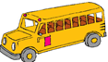 | 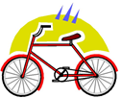 | 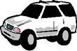
RESULTS
باص: _____ _
دراجة: _______
سيارة: ________
على الاقدام: _______

