Mural Capstone

Xu Quansai

I. Summary:
The DLI program in our school is growing. It needs support and understanding from the local community. And our mural program met the needs in two different ways. One is training the chosen ones to practice Chinese calligraphy for the mural, the other is using the mural to inspire the interest of all the 472 students in our school in learning Chinese or Chinese culture. Besides, it gives extra support for the DLI program by being a complement of culture learning for all the 103 DLI students. They learn more about the Chinese language, writing, and culture by the project. Cooperation between the 6 DLI teachers and other 42 teachers increased too. Now more teachers understand and support the DLI program. And as multiculturalism is better understood through the mural, we draw more students into the DLI program, and now the community get more involved with DLI program and more people know our school and choose to send their children here.

In order to select some students for the mural program, we had the introductory classes for the basic, then the afterschool calligraphy club to learn more and finally the morning training session for 23 mural students. They practiced a certain character in the Chinese poem On the Stork Tower 《登鹳雀楼》for the mural with instruction videos and papers from me. Meanwhile I tutored them during the whole period of time to help them improve their calligraphy writing.

The students surprised me a lot by progressing so much in calligraphy. The first work and the last one are quite different. I am so happy to see all the differences. And they are really interested in practicing calligraphy and still want to learn more after the training. Since the mural is done now, the students feel really proud of themselves and they are admired and envied by their peers. Teachers, school and the community all feel proud of them too.

II. Project Impact:

Individuals benefit:
The 23 students involved benefit directly and the most. And all the other 449 students and 47 teachers in our school as well as the 6722 citizens in Batesville benefit indirectly from the mural project as they can see the unique culture here by the murals.

Accomplishments:
People get to know more about the DLI program and our school, as well as the multi-culture characteristic in our school as the Chinese culture is so well expressed in it. Therefore, our entire school and community benefit from this too. We get more understanding from the community while the community gets more attention from other places of the states.

III. Success and reason:
The mural is a great success. There are so many kids involved directly in the project and they practiced more about Chinese calligraphy and learnt more about the Chinese culture. Besides, those who are not in the project also get deeply impressed by their peers too. The community seems to understand and support more about the DLI program in our school. Because the mural is so well done! It impressed us all a lot.

IV. Lessons learnt:
The lesson learnt in the process is that I should plan things even earlier and more detailed each time and tell the students much more about the importance or impact of the project, so more brilliant students can join in the project and we can finish it more fluently.

V. Attachments

Agendas:
# | Name and Description of Project Activity | Responsible Persons | Due Date
1 | Secure the event location (complete).  5 words counted. Maximum of 300 words allowed. | Olivia Branch | Oct 21, 2021
2 | Invite students from calligraphy clubs to join morning calligraphy practice sessions.  11 words counted. Maximum of 300 words allowed. | Quansai Xu | Dec 03, 2021
3 | Complete morning calligraphy training for 5th grade students (December 6 - 17)  12 words counted. Maximum of 300 words allowed. | Quansai Xu | Dec 17, 2021
4 | Complete morning calligraphy training for 4th grade students (January 10 - 21)  12 words counted. Maximum of 300 words allowed. | Quansai Xu | Jan 21, 2022
5 | Complete morning calligraphy training for 3rd grade students (January 24 - February 3)  13 words counted. Maximum of 300 words allowed. | Quansai Xu | Feb 03, 2022
6 | Arrange the characters into one digital image and send design to Rowland Graphics.  13 words counted. Maximum of 300 words allowed. | Olivia Branch | Feb 11, 2022
7 | Install the Mural (date contingent on weather - anticipated to be installed during Spring Break March 11-18)  17 words counted. Maximum of 300 words allowed. | James Rowland | Mar 18, 2022
8 | Host mural unveiling for students and families after returning from Spring Break.  12 words counted. Maximum of 300 words allowed. | Quansai Xu, Olivia Branch | Mar 21, 2022

Pictures:

the mural picture:
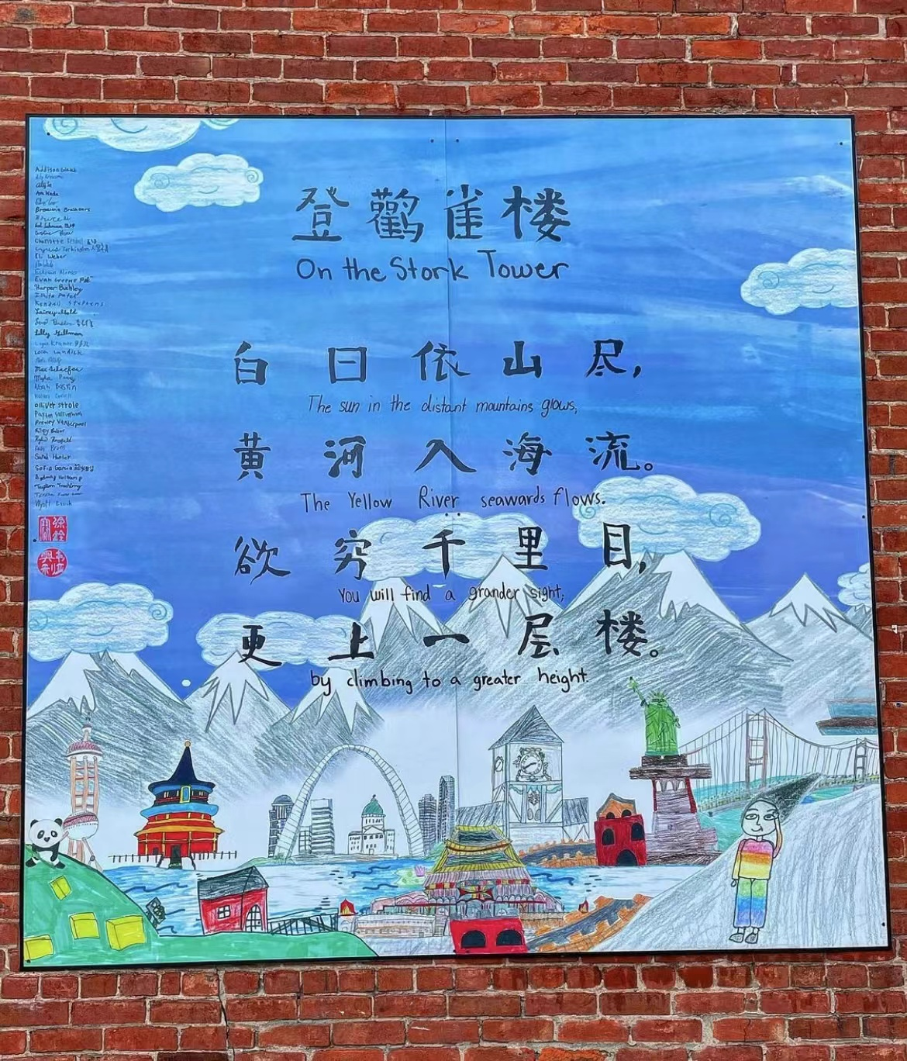

Pictures of their first works and last ones (in the order of the poem):
Attention: Among the 24 characters of the poem, one character is repeated. In order to make it complete here, I repeat that picture twice too.

At the beginning | Training result | Notes
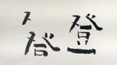 | 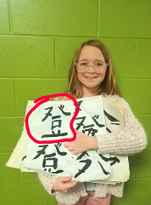 | Presley worked really hard on it. She worked longer hours than her peers in fifth grade. And finally, she made it. I still remember her smile when I told her she’s done that day.  Look at her characters before and after! What a sharp comparison!
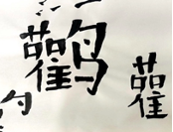 | 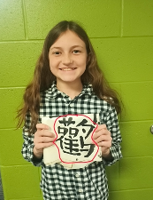 | Sarah is a lucky girl who finished her character rather fast. And it looks so good. I like it!
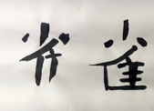 | 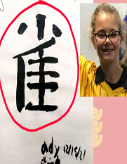 | Ady is so good at learning calligraphy. Look at her characters before and after! What a sharp comparison! And it was in a really short period of time!  (She was not here when I took pictures of the mural group so I used a picture of her here)
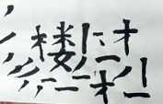 | 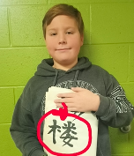 | Levi is very good at learning calligraphy so I gave him the most difficult character in the poem and he did it! Actually I was hosted in his parents’ house when I first arrived America. At that time, I told him some basic strokes in writing calligraphy and he kept practicing and it really helped. He seemed have made even better improvement during the morning training session. Again, look at his characters before and after! What a sharp comparison!
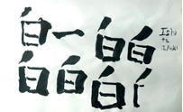 | 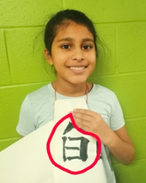 | Ishita was originally not in the plan for calligraphy at first because I planned to invite the other “Ishita” originally then a coincidence. (Shh, don’t tell her)But I am very happy with her. She did so well in her character. And I knew that she definitely likes her character and her role in the mural program! She feels so proud of herself!
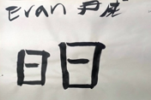 | 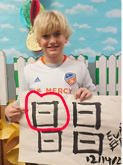 | I think Evan has some talents in calligraphy. He learnt fast and his first try was so good too, tough he would try to “paint” the character and was stopped by me immediately. Later he made big progress. When his character finished, he still asked for more.
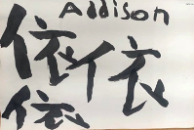 | 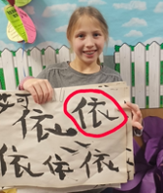 | Adison practiced for two days and then was quarantined for two weeks. At that time she was so worried about whether her character would be assigned to others and Dojoed me about it. Of ourse I kept it for her and she worth the opportunity. Tough it took her a long time to finish it when she came back to school(longer than her peers in third grade), I was happy to see her done. And she was so happy too.
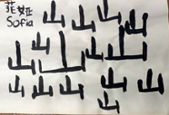 | 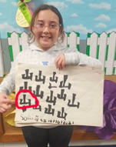 | Sophia does really like calligraphy, just like Evan. They kept asking whether they can still do more characters during their training period. And Sophia always thanks me for the calligraphy training on different festivals. I still have several of her thank-you letters. She is cute and grateful.
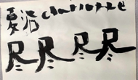 | 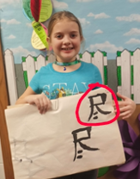 | It is a little hard to get Charlotte done on her character. This character was difficult and she practiced it for a long long time. Though at first she may try to “paint” the character well which was the common problem for the beginners. I noticed it and stopped her immediately. Through more than two weeks’ training, she finally did it. At that time I could feel that she was relieved and felt proud of her self.
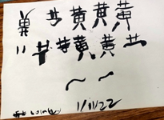 | 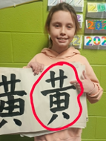 | Lola was enrolled by coincidence too. Same as Ishita(Shh again. Don’t tell them). But things were worse for her. She got her characters upside down when she first wrote it which shocked me a lot. But after more than two weeks’ training(she got more time training than her peers in fourth grade), she did it. Yes, I tutored her alone for some time though. But the effect was quite obvious. Look at her characters before and after! What a sharp comparison! It’s really amazing!
 | 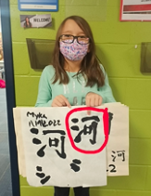 | Myka is a quiet girl who I was a little worried about at first. Look at the character on the left column, she was week in it at first. But later, her hard work impressed me a lot. She did it ! Look at her characters before and after! What a sharp comparison!
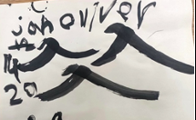 | 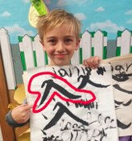 | Olliver enjoyed his character very much and enjoyed the training session too. Again, he also asked for more characters to write when he finished his own.
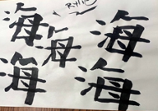 | 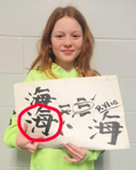 | Rylie has some talent in writing calligraphy too. This character is rather difficult. But she didn’t disappoint me. Indeed, she did a great job!
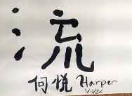 | 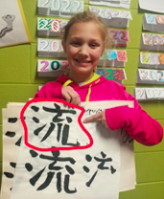 | Harper enjoyed the training a lot. She finished her character rather quick. And look at her characters before and after! What a sharp comparison!
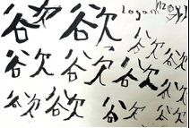 | 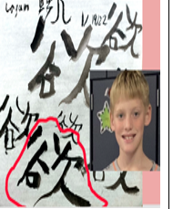 | Just like some other kids above, Logan is one who was not so good at calligraphy or art at first. But he worked really hard on it. Unfortunately, when I plan to tutor him alone, his teacher told me he had just left earlier that day and would be quarantined for a long time. So if he got more time, his work would be much better. But I am still proud of him and his work. This character was really good and had the soul of 欲---desire. When he came back in around a month later, his character helped win him big confidence in his study.  (He was not here when I took pictures of the mural group so I used a picture of him here)
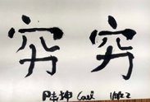 | 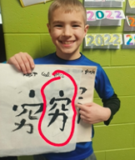 | Cael did a great job! Look at his characters before and after! What a sharp comparison! And his character made it by giving the real feeling of being 穷 in recent Chinese which means poor. Though in ancient Chinese it means endless. I really like his character.
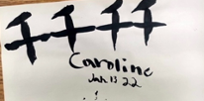 | 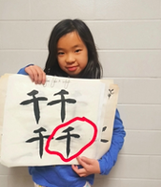 | Caroline is a quiet girl but she listens really carefully and attentively. She really did a great job. Look at her characters before and after! What a sharp comparison! Her mother noticed her progress everyday and was really happy about it. So she posted pictures about her characters several times.
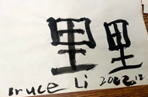 | 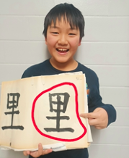 | Bruce is really happy in the picture. Yes, indeed he is. He is happy about the improvement he made. What a sharp comparison! Just like Caroline’s parents, Bruce’s mother was also very happy about her son’s improvement. She posted this picture proudly and thanked me. I feel so happy too.
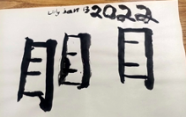 | 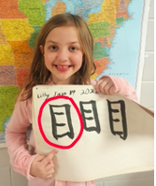 | Lily is a quiet girl too. But for the quarantine of COVID-19, she would have done a better job. She ended her training much earlier than other kids in third grade group. However, I was still satisfied with her work done at that time. She did it great! They are of sharp contrast too.
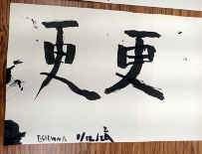 | 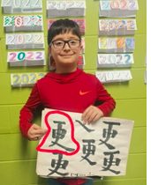 | Estevan is a quiet fourth grader. He always came first in the morning and began to practice his character. His improvement was so big that his last characters really surprised me. It makes me feel that he is destined to learn calligraphy. Great job!
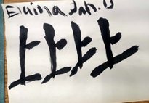 | 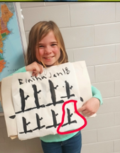 | Elaina, a quiet girl with talent. Just compare her first characters and the last ones ! Her improvement was amazing and in a short period of time. She was among the quickest ones to finish their own characters. And I do really like the character she’s pointing to in the picture. It is so beautiful with a special sense of art.
 | 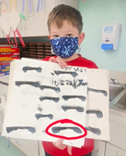 | I would say Cyrus is of talent too. He finished his character rather fast and of course his character was comparatively easy too. Though he was kind of slow and his writing was not tidy( it really took time to clean this), I still enrolled him in the program. I knew he is really interested in doing it. He was the guy who told me he imagined himself holding a magic brush in his hand when he was on the road walking home. I want to help him make his dream come true.
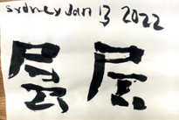 | 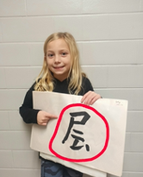 | Sydney really wants it. She asked me so many times about the calligraphy program and so did her parents. (of course some other kids also did it, though not as obviously) And considering she is good at learning, I gave her a challenging one. After her hard work, she did it and was so proud of herself! Look at her characters before and after! What a sharp comparison!
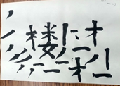 | 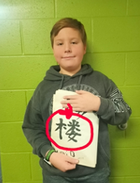 | Levi is very good at learning calligraphy so I gave him the most difficult character in the poem and he did it! Actually I was hosted in his parents’ house when I first arrived America. At that time, I told him some basic strokes in writing calligraphy and he kept practicing and it really helped. He seemed have made even better improvement during the morning training session. Again, look at his characters before and after! What a sharp comparison!

