Lesson Plan
TCLP teacher’s name: Chen Hui Grade level: High School
Language level: Level 3
Lesson title: Write a Diary Entry according to a Schedule

Step 1—Desired Results
Lesson goals
Students can talk about their daily schedules in Chinese and write a simple diaries
Lesson Objectives
Students will be able to:
- Remember words about daily actions and time
- Can talk about their daily life.
- Write a diary

Step 2—Assessment Evidence
Performance task — A game for action words and some sentences, write a diary at the end of the class.
Performance criteria:
Guess the words actively, talk about your daily life clearly, write the diary well
Step 3—Learning Plan
Materials needed
PPT, computer ,handouts
Learning procedures
- Review words about daily actions
上课，打电话，写字，打球，看电视，唱歌，跳舞，看书，看电影， 听音乐，洗澡，吃饭，起床，睡觉、做体育运动等
- A guessing competition among the students.
- Oral practice
Talk about the daily schedule with a partner based on pictures and words in the handout (See Attachment 1)
- Talk about your own schedule with another partner
- Write a diary about your daily schedule
Step 4—Reflection
Students enjoy guessing game for the action words that will be used in the diary. Talking about their daily life according to the pictures needs improving. The most difficult part for them is writing Chinese character when they want to finish their diary.

忙,累。 | 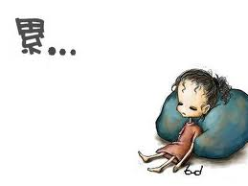
六点半，起床
洗澡,吃早饭。 | 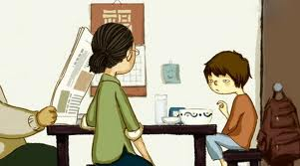
七点半，去教室
第一节，中文课
第二节，电脑课
餐厅，吃午饭
晚上，做功课
十点，睡觉

