Wangling’s Capstone Project in Chariho Regional High School

What is our Project:
Our capstone project is to build and sustain program viability through a sister school relationship between Chariho Regional High School and my home school, No.1 High School of Liuyang, Hunan province, China. This relationship will allow the exchange of students and educators to build capacity in both schools to support language learning and the appreciation of other cultures.

An updated abstract with some accomplishments:
1.A good Start with a nice gift.
As soon as I came to Chariho High School, I presented a gift from my home school in China to Chariho. It is a piece of gorgeous Hunan Embroidery Art Work and it is one of the symbols of my Province. The Principal, Craig MacKenzie, expressed his great thanks and it is now hung in the wall of the main office. It is a very good start for our friendship.
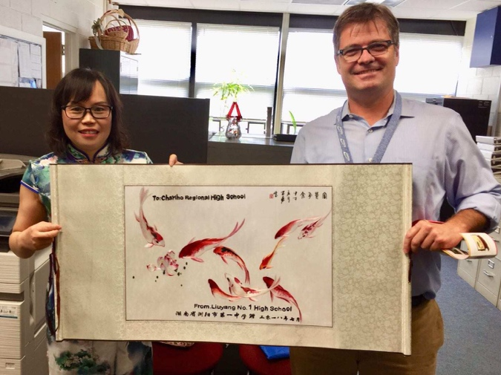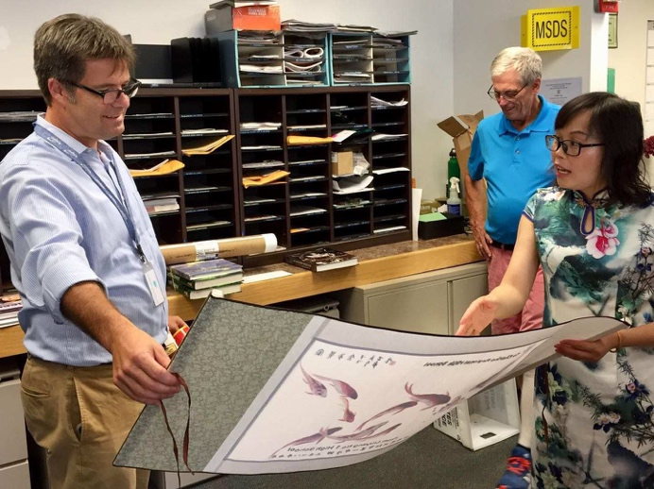

2.Several meetings and a decision made in the fall workshop in Philadelphia.
I have had several meetings with John and Craig here and with my principal and colleagues on WeChat in China about developing the sister school partnership. In the fall workshop in Philadelphia, John and I made a final decision of our Capstone Project on it and we reported it to TCLP in the meeting as well.
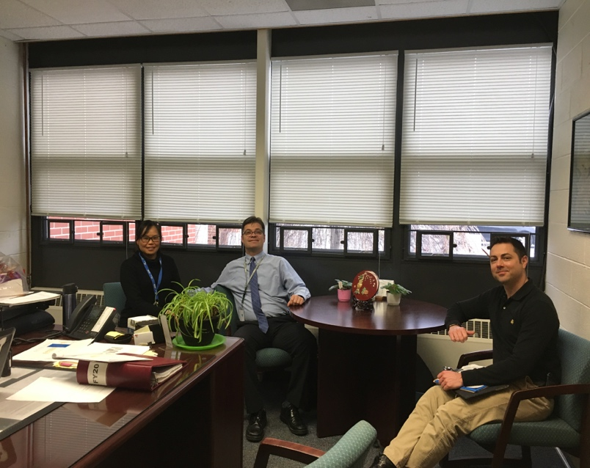

3. Email Contacts between two principals.
Before March 2019, the two principals in both schools have written emails to each other with the translation of me and my Chinese colleague, which has helped them develop a friendship and know more about each other’s schools by email.
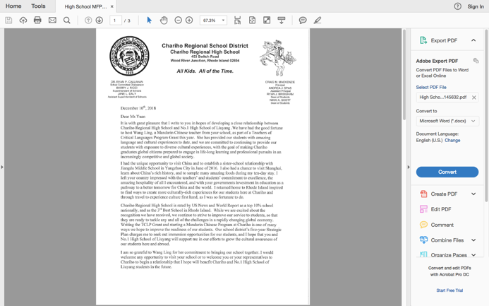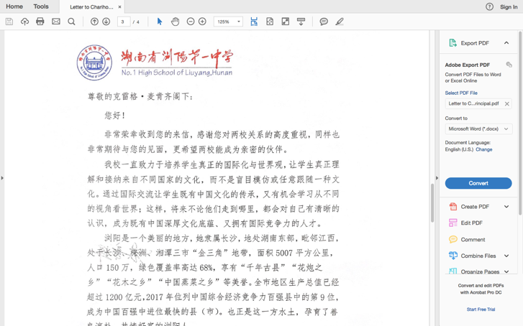

4. Students Video Class
On March 8,2019, we had a students’ video class between the students in the two schools. I had my high school class in Chariho have a one-hour video class with one of the Grade 11 classes in my home school in China and it’s a great success. Some administrators including the two principals Mr. Craig MacKenzie and Mr.Yuan Zhangjun attended it, who greeted each other in person in the video for the first time and reporters in both schools’ Newspaper and TV Station were present covering the event too.
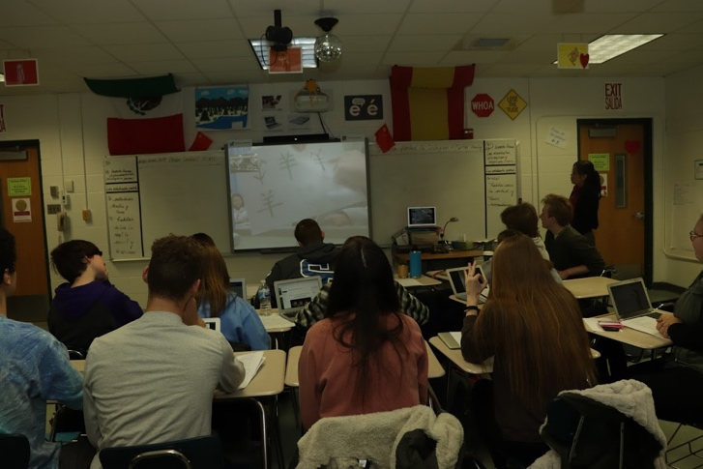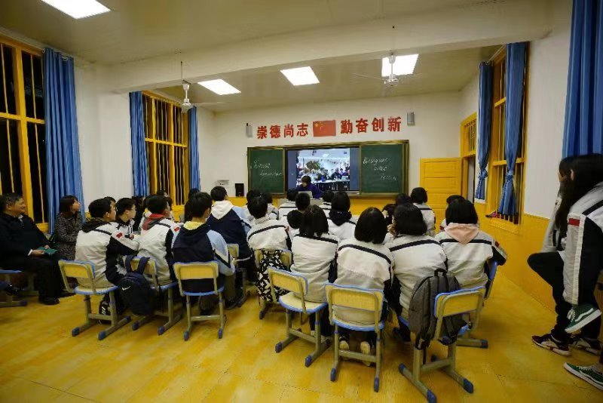

5. Principals Video Conference
On March 13,2019, we had a one-hour Principals’ Video Meeting between the two schools. I had helped bring together the two principals and the conference was very productive! Through a small screen, two principals introduced to each other their school and city; they shared each other's educational ideas and talked about the prospect of the sister schools’ cooperation! It’s a productive hour and through it we reached agreements on the goals and ways to cooperate with each other and we had a detailed discussion about the partnership agreements.

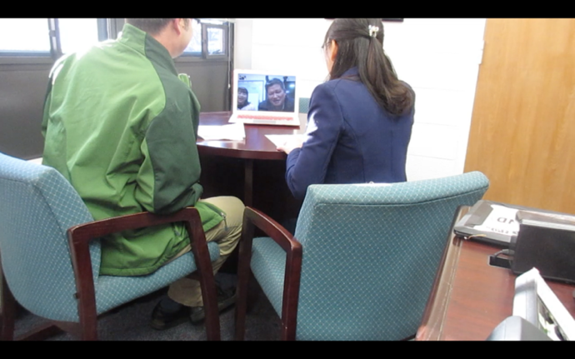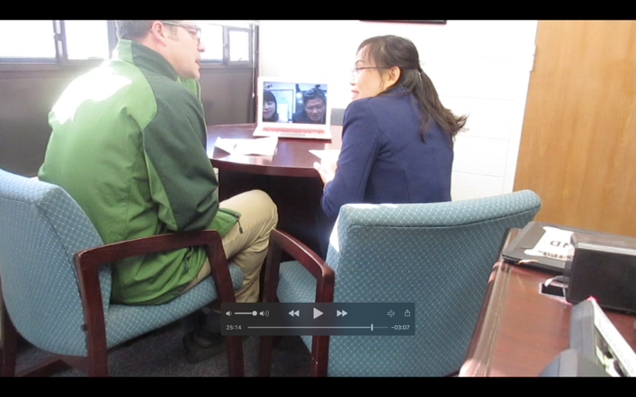

Events coming soon:
- Regular Video Classes between Chariho High School Students and students in a class in Grade 11 in my home school.
We have decided to have regular classes between the two schools through video calls. Contents can be both in Chinese and English to help each other improve the language learning and the appreciation of each other’s cultures.
- Works Exchange between Art Students in both schools in April
We are planning to ask the arts students in Chariho High School and No1. School draw on the same topics such as “Love”, “nature” and “friendship” and they will share and exchange their works through email or WeChat.
- Mr. Craig Mackenzie’s visit to No.1 High School in China
Mr.Craig Mackenzie is planning a visit to No.1 High School in China from late June to early July,2019. We hope it can work out smoothly and we are looking forward to two principals’ meeting in person and discussing the cooperation face to face.

We are so glad that everything goes on very well and we have had some achievements on our sister school Capstone Project. We are very positive that we will have a deep and lasting friendship between the two schools and we will have deeper cooperation with each other which will benefit both of the two schools.

