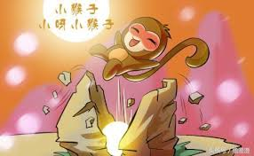  - The monkey was born from a stone. | 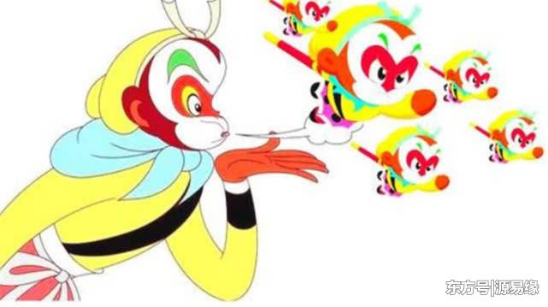  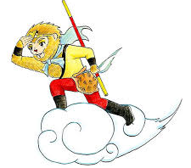  - He was born with magic skills.
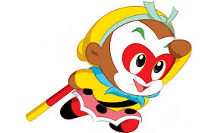  3. He gave himself the name Sun Wukong. | 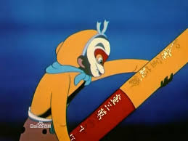  4.The monkey stole the needle, namely, the magic stick from the sea.
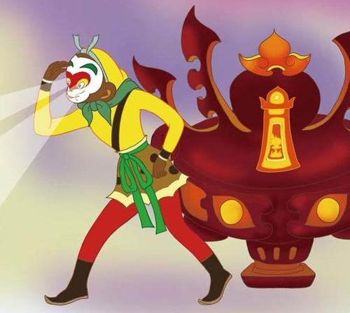  5. The monkey was burnt for 49 days and was expected to die. Instead, he accidently acquired penetrating eyesight which enables him to recognize those well disguised monsters. | 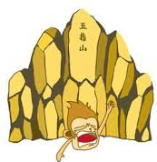  6. The money was trapped under the Huaguo Mountain by Buda.
 | 7. The monkey wears the head band because it’s a symbol of glory.

