TCLP capstone project description
Feili Zou Bodine High School for International Affairs
My TCLP capstone project is to build up a whole year around’s unit plans and lesson PPT slides and worksheet exercises for Chinese Level One. As students in Bodine High School don’t own any textbooks, a teacher needs to spend a lot of time in preparing the teaching material, including presentation slides, clips of videos, teaching aids, word cards, flash cards, worksheet and classwork. It usually takes me three hours to prepare PPT slides, copy worksheets, word cards or teaching aids every day. So I started to think since the beginner level is the starting point of learning and is always required to teach at the first place, it would be much better if some fundamental resources were available for the next coming teachers, so that he or she could focus on how to improve the curriculum or the better way to carry out the lesson plan or seek better classroom management, or spare more efforts to enhance communication with certain types of students, or spend more time to observe other teachers’ class in order to reflect how to improve their own.
Moreover, I know the principal from my host school is eager to boost the Chinese Program and keep continuing to offer Chinese language learning to their students. It is hopeful that Bodine can gain another grant from Confucius Institute from Temple University. Therefore, I find my capstone project is meaningful, because it will be beneficial to the next coming teacher.
For each quarter of the academic year, I wrote down the unit plan. For each lesson, I prepared the PPT slides. And sometimes, I handed out worksheets. So all of these teaching materials make up of my capstone project. I am saving all my teaching files. When I finish teaching, I will copy a version to my mentor teacher Bela. She will hand down my capstone project files to the next teacher.
The following sample screen shots represent the diversity of my resources contributing to the capstone: Pic One Unit plan; Pic Two: PPT slides; Pic Three: worksheet; Pic Four: syllabus; Pic Five: online resources plus my Kahoo login and password.
Pic one: Unit plan

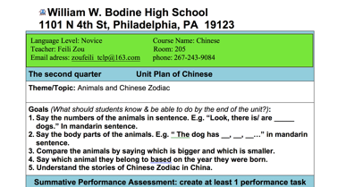

Pic Two: PPT slides
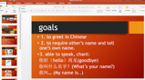

Pic Three: worksheet

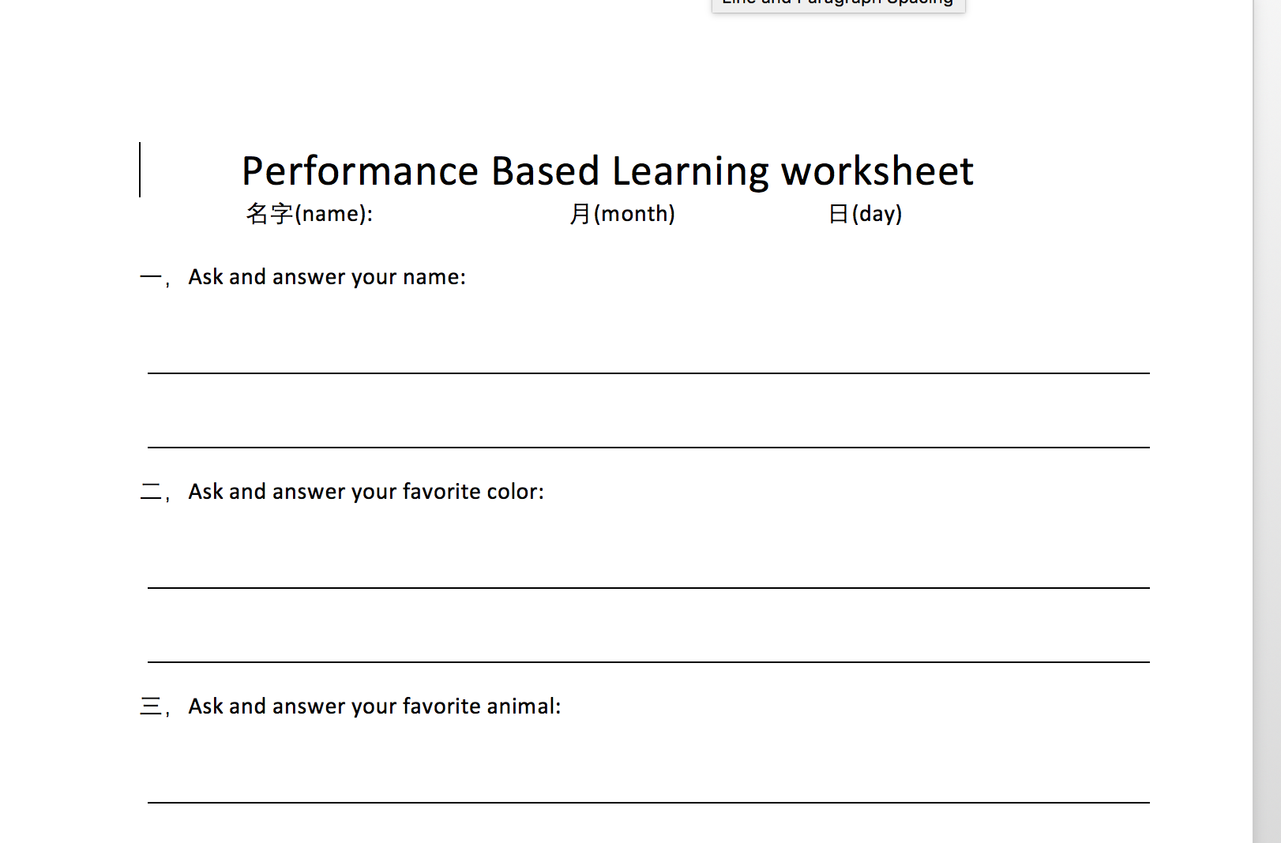
Pic Four: syllabus
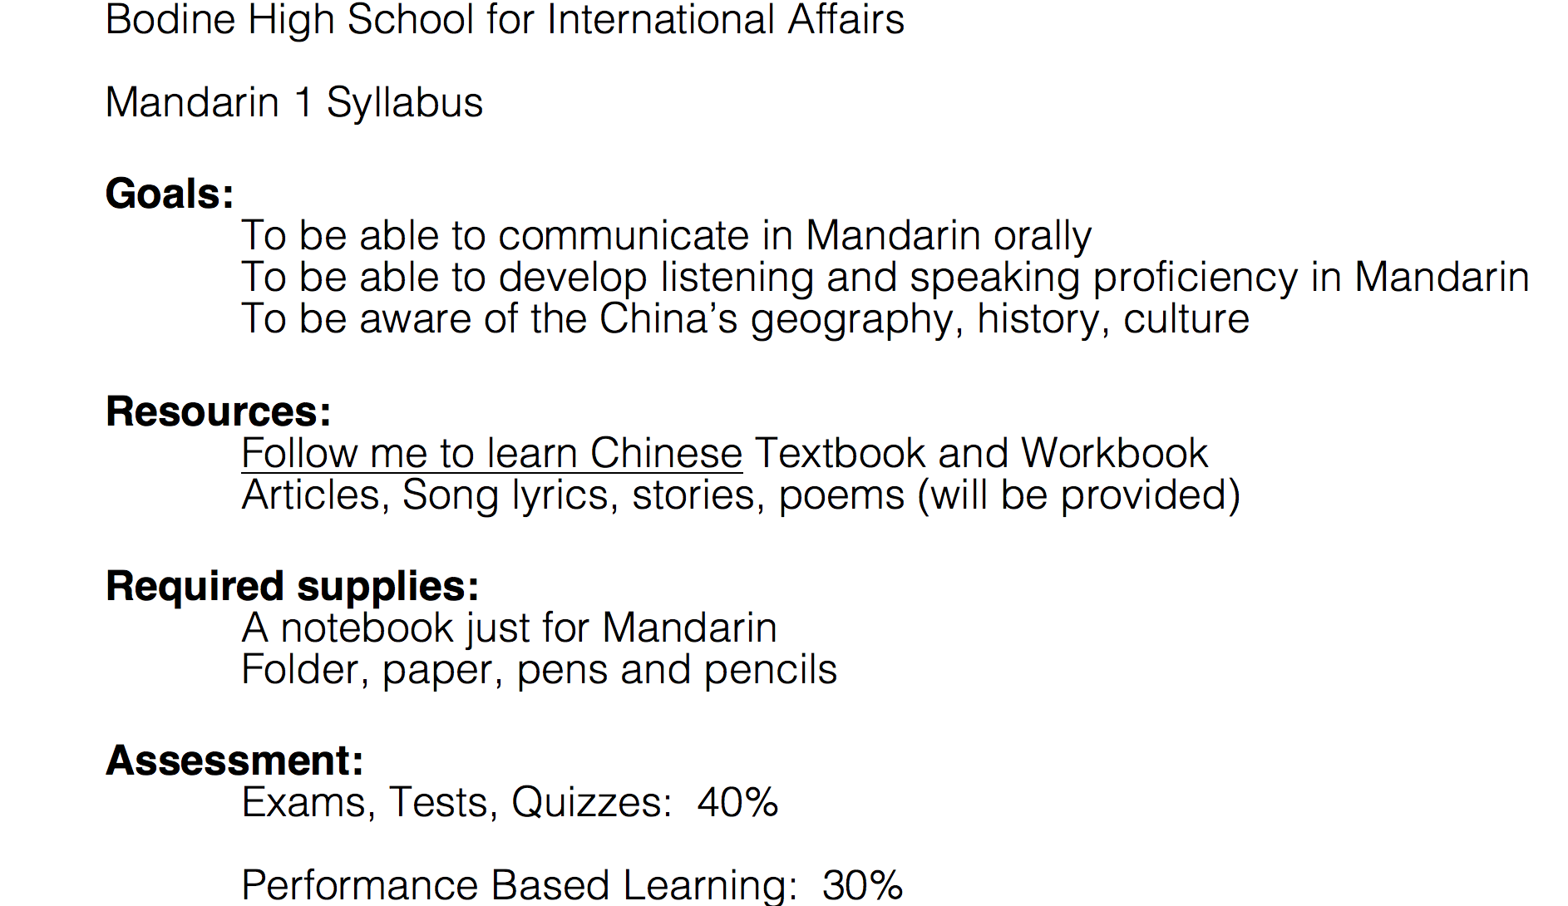

Pic Five: online resources
