2013 Sprint festival Crafts options:

1. Snake with patterns.

Materials needed: snake pattern, crayons, scissors.

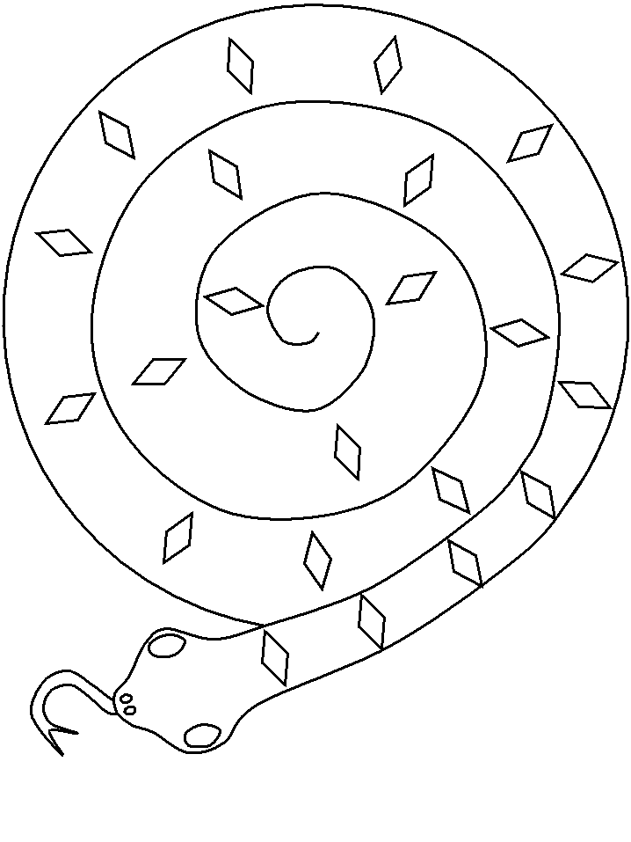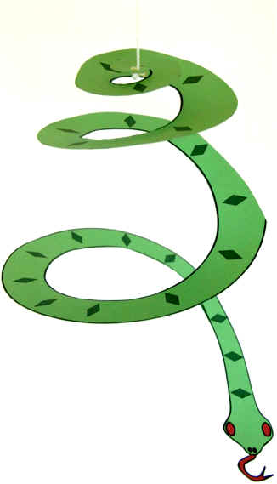

1. Auspicious message picture frame:

Materials needed: Popsicle sticks, Chinese auspicious characters, glue, yarn and crayons.

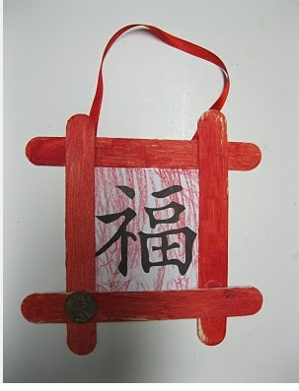

1. Chinese New Year Lantern:  
   Materials needed: Construction paper:A4 size and half A4 size, Yarns, stapler, and instruction

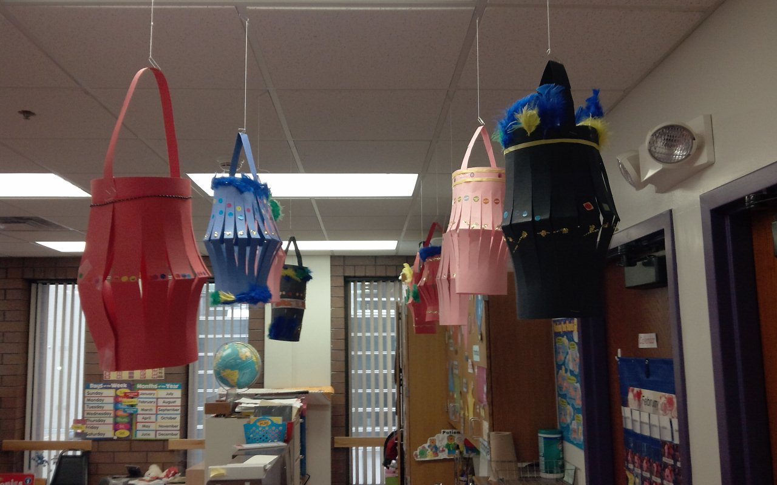

1. Chinese New Year Fan:

Materials needed: Construction paper, stapler, crayons

