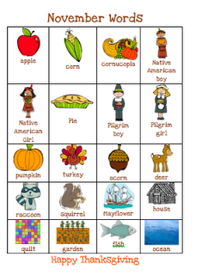
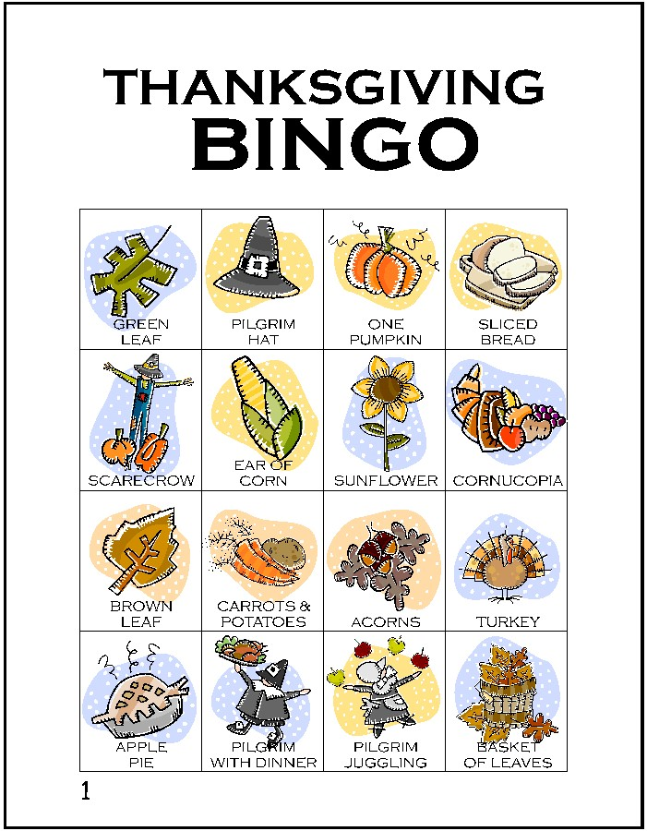

Jigsaw:

Group 1: General introduction of Thanksgiving :

_________________________________________________________________________________________________

_________________________________________________________________________________________________

_________________________________________________________________________________________________

_________________________________________________________________________________________________

_________________________________________________________________________________________________

_________________________________________________________________________________________________

_________________________________________________________________________________________________

_________________________________________________________________________________________________

Group 2: History of Thanksgiving:

_________________________________________________________________________________________________

_________________________________________________________________________________________________

_________________________________________________________________________________________________

_________________________________________________________________________________________________

_________________________________________________________________________________________________

_________________________________________________________________________________________________

_________________________________________________________________________________________________

_________________________________________________________________________________________________

Group 3: Food of Thanksgiving :

_________________________________________________________________________________________________

_________________________________________________________________________________________________

_________________________________________________________________________________________________

_________________________________________________________________________________________________

_________________________________________________________________________________________________

_________________________________________________________________________________________________

_________________________________________________________________________________________________

_________________________________________________________________________________________________

Group 4: The way of celebrating :

_________________________________________________________________________________________________

_________________________________________________________________________________________________

_________________________________________________________________________________________________

_________________________________________________________________________________________________

_________________________________________________________________________________________________

_________________________________________________________________________________________________

_________________________________________________________________________________________________

_________________________________________________________________________________________________

I. Origins

1. The First Thanksgiving in America
The first interesting thing to point out is that the feast shared with the Wampanoag Indians and the first mention of Thanksgiving are really not the same event. During the first winter in 1621, 46 of the 102 pilgrims died. Thankfully, the following year resulted in a plentiful harvest. The pilgrims decided to celebrate with a feast that would include 90 natives who helped the pilgrims survive during that first winter. One of the most celebrated of those natives was a Wampanoag who the settlers called Squanto. He taught the pilgrims where to fish and hunt and where to plant New World crops like corn and squash. He also helped negotiate a treaty between the pilgrims and chief Massasoit.
This first feast included many fowl, though it is not certain that it included turkey, along with venison, corn, and pumpkin. This was all prepared by the four women settlers and two teenage girls. This idea of holding a harvest feast was not something new to the pilgrims. Many cultures throughout history had held feasts and banquets honoring their individual deities or simply being thankful for the bounty. Many in England celebrated the British Harvest Home tradition.

The first actual mention of the word thanksgiving in early colonial history was not associated with the first feast described above. The first time this term was associated with a feast or celebration was in 1623. That year the pilgrims were living through a terrible drought that continued from May through July. The pilgrims decided to spend an entire day in July fasting and praying for rain. The next day, a light rain occurred. Further, additional settlers and supplies arrived from the Netherlands. At that point, Governor Bradford proclaimed a day of Thanksgiving to offer prayers and thanks to God. However, this was by no means a yearly occurrence.
The next recorded day of Thanksgiving occurred in 1631 when a ship full of supplies that was feared to be lost at sea actually pulled into Boston Harbor. Governor Bradford again ordered a day of Thanksgiving and prayer.
How did Thanksgiving became a National Holiday
You are probably well aware of the first Thanksgiving and how the Pilgrims and the Indians go together and gave thanks for the bountiful harvest. That was in 1621. However, the first Thanksgiving did not lead to a traditional holiday and certainly not to a national one since the nation didnt exactly exist. It did play a role, however, in what would come. Eventually Thanksgiving began being celebrated more and more as the country grew and people wanted to give thanks. A real American Thanksgiving was first celebrated by the entire country just after the Revolutionary War. But still, it was not a national holiday.
Then, when Abraham Lincoln was in office he declared the last Thursday of November Thanksgiving Day in 1863. That is when it finally became a national holiday. Every president since Lincoln has also declared Thanksgiving a national holiday.
In 1941 Congress set the national holiday of Thanksgiving on the fourth Thursday of every November. This reversed a decision by President Roosevelt to celebrate Thanksgiving on the third Thursday of November to give people more time to shop for Christmas.
Today, we all look forward to Thanksgiving and the beginning of the holiday season. We celebrate friends, family, and prosperity and thank God for His blessings. Many families have different takes and traditions for Thanksgiving, but the overall theme is a family meal and giving thanks for all of lifes blessings.
Now you know how Thanksgiving became a national holiday. Most people think after the Pilgrims first Thanksgiving they continued giving thanks in this fashion each and every year and the tradition spread and eventually became a national holiday. But, it didn’t happen that way. It was many years after the first Thanksgiving that Lincoln declared a national holiday and then many years after that when it became permanently celebrated on the fourth Thursday of each November.

II. Food

What food was served at the first harvest feast? Historians aren’t completely certain about the full bounty, but it’s safe to say to say the Pilgrims weren’t gobbling pumpkin pies or mashed potatoes.

The modern Thanksgiving repast is centered around the turkey, but that certainly wasn’t the case at the Pilgrims’ feasts. Their meals included many different meat. The term “turkey” was used by Pilgrims to mean any sort of wild fowl. But the feast did include fish, berries, watercress, lobsters, dried fruits, clams version, and plums.

Vegetable dishes, one of the main components of the modern celebration, didn’t really play a large part in the feast mentally of the seventeenth century. Depending on the time of the year, many vegetables weren’t available to the colonists.

Another modern staple at almost every Thanksgiving table is pumpkin pie, but the Pilgrims probably didn’t have pies or anything sweet at the harvest feast. They had brought some sugar with them on the Mayflower but by the time of the feast, the supply had dwindled. Also, they didn’t have an oven so cakes and breads were not possible at all. The food was eaten at the harvest feast would have seemed fatty by 1990’s standards, but it was probably more healthy for the Pilgrims than it would be for people today. The colonists were more active and needed more protein. Heart attack was the least of their worries. They were more concerned about the plague and pox.

III. Celebrations

1.How People Celebrate the Thanksgiving
1) The Big Meal
The pattern of the Thanksgiving celebration has never changed through the years. The big family dinner is planned months ahead. On the dinner table, people will find apples, oranges, chestnuts, walnuts and grapes. There will be plum pudding, mince pie, other varieties of food and cranberry juice and squash. The best and most attractive among them are roast turkey and pumpkin pie. They have been the most traditional and favorite food on Thanksgiving Day throughout the years.

Everyone agrees the dinner must be built around roast turkey stuffed with a bread dressing to absorb the tasty juices as it roasts. But as cooking varies with families and with the regions where one lives, it is not easy to get a consensus on the precise kind of stuffing for the roast turkey. Some people like fruit soup, green salads and baked potatoes with their turkey. Other like baked squash, creamed onions, creamed spinach and corn pudding.

Let’s talk a little more about cranberry and other Thanksgiving food, corn, which is also a symbol representing Thanksgiving. The use of corn meant the survival of the colonies. “ Indian corn” is often used as a table or door decoration to represent the harvest and fall season. Sweet-sour cranberry jelly, was on the first Thanksgiving table and is still served today. The cranberry is a small and sour berry. It grows in bogs, or muddy areas, in Massachusetts and other New England states. The Indians used the fruit to treat infections. They used the juice to dye their rugs and blankets. They taught the colonists how to cook the berries with sweetener and water to make sauce. The Indians called it “ibimi” which means “bitter berry”. When the colonists saw it, they named it “crane-berry” because the flowers of the berry bent the stalk, and it resembled the long-necked bird—crane. The berries are still grown in New England.

Many Thanksgiving tables also are heavy with other dishes, often brought by guests. And if the guests eat all that is served, they too will feel heavy. Many people eat more at Thanksgiving than any other time of the year.

However, not all families share the same menu. Later groups of immigrants to North America often varied the traditional holiday menu to suit their own tastes. For example, many Italian American Thanksgiving meals include Italian specialties, such as pasta and wine. And not everyone cooks a Thanksgiving turkey. Some families like other meats. Or, in recent years, a number of American homes have vegetarian Thanksgiving dinners. This means no meat will be served.

2) Thanksgiving Parade
Many people also like to watch Thanksgiving Day parades on television. Thanksgiving pageants and parades often feature children dressed in Pilgrim costume, complete with bonnets or tall hats, dark clothes, and shoes with large silver-colored buckles. Huge balloons will float high above the street. The balloons are in the shape of children’s best-loved cartoon characters.

Many of the images commonly associated with Thanksgiving are derived from much older traditions of celebrating the autumn harvest. For example, the cornucopia is a typical emblem of Thanksgiving abundance that dates to ancient harvest festivals. Many communities also decorate their churches with fruits, flowers, and vegetables at Thanksgiving, much as European communities have done for centuries during the autumn harvest season.

During the 20th century, as the population of the United States became increasingly urban, new Thanksgiving traditions emerged that catered to city dwellers, one of which is the Macy’s Thanksgiving Day Parade in New York City. Employees of the huge Macy’s department store on Herald Square organized the first parade in 1924. Many of them wanted to hold a big parade like the ones in Old World Europe. So they dressed in costumes and borrowed some animals from the zoo. They also carried small balloons that floated just overhead.

A few years later came big balloons, the kind that the parade is famous for. But they burst. The parade planners soon learned better ways to control the balloons.

In nineteen thirty-four, a big Mickey Mouse balloon made of rubber appeared in the parade for the first time. Mickey Mouse remains a popular character in the parade.

But for three years during World War Two, the Macy’s Thanksgiving Day Parade had to be cancelled as the military needed rubber for the war effort.

More than two million people watch the parade on the streets of Manhattan these years. Millions more see it on television. And, there are lots of things to see, including hundreds of performing clowns and the huge balloons which capture the most attention. Many of the balloons are based on popular cartoon and game characters.

It’s a tough job to handle the huge balloons. Workers have to control the balloons with ropes, but that can be difficult. They have to make sure that winds do not blow the balloons into buildings or parade-watchers. In spite of their caution, accidents still happened. There have been two in recent years. Two sisters and a woman were injured respectively. The woman was so badly injured that she was in coma for almost a month. But she survived.

3) Watching Football Games

Many Americans digest their holiday meal while watching football games on television. Traditionally, two National Football Leagues (NFL)
teams, the Detroit Lions and the Dallas Cowboys, host games on Thanksgiving Day. High viewership of these holiday games has made football an American Thanksgiving tradition.

4)Prayers and Songs

Religious ceremonies are an important part of Thanksgiving Day for many Americans. People join in prayers and songs of Thanksgiving. One of the most famous song is called “Prayer of Thanksgiving”. The words and music tell of the traditional meaning of Thanksgiving. We gather with our family. We share what we have. And we give thanks for the good things of the past year.

5)Charity

Thanksgiving also is a time when Americans share what they have with people who do not have as much. All across America, thousands of religious and service organizations provide Thanksgiving meals for old people, the homeless and the poor. Many Americans give turkeys or other food to these groups. Some people spend part of the day helping to prepare and serve the meals.

