Moos Elementary Capstone Project
1.What we have done for the project?
On Jan.24th ,Moos elementary has a Spring festival showcase which involved around 100 parents and students from Pre-K to K6.Principle was invited to be an MC in the traditional Han dynasty clothes and other two students from the third grade was invited to be the assistant MCs.
In December, The exchange teacher had a meeting with principle and came out the idea of holding a Spring festival showcase and during the preparation who can exchange ask for help.
From December to January ,Moos teachers made lots of preparations before the show. Mandarin teacher get great help form Gym teacher for training the martial arts, the art teacher helped decorate the auditorium with man-made lanterns which create an alive Spring Festival atmosphere and a big dragon for dangon dance parade. The art teacher helped with the sound and video equipment.
On Jan 17th, The exchange teacher designed the advertisement for the show and the principle shared on the class Dojo.
On Jan.20th, we designed and printed out the program for parents who will come to the show.
From Jan.20-Jan23, the exchange teacher leads all the students do rehearsls in the auditorium.
The first program for the show was from the 6th grade, they are not learning mandarin this year but they are very interested in Chinese culture so they request a presentation for all the moos students introducing Chinese New Year traditions and Chinese Zodiac.
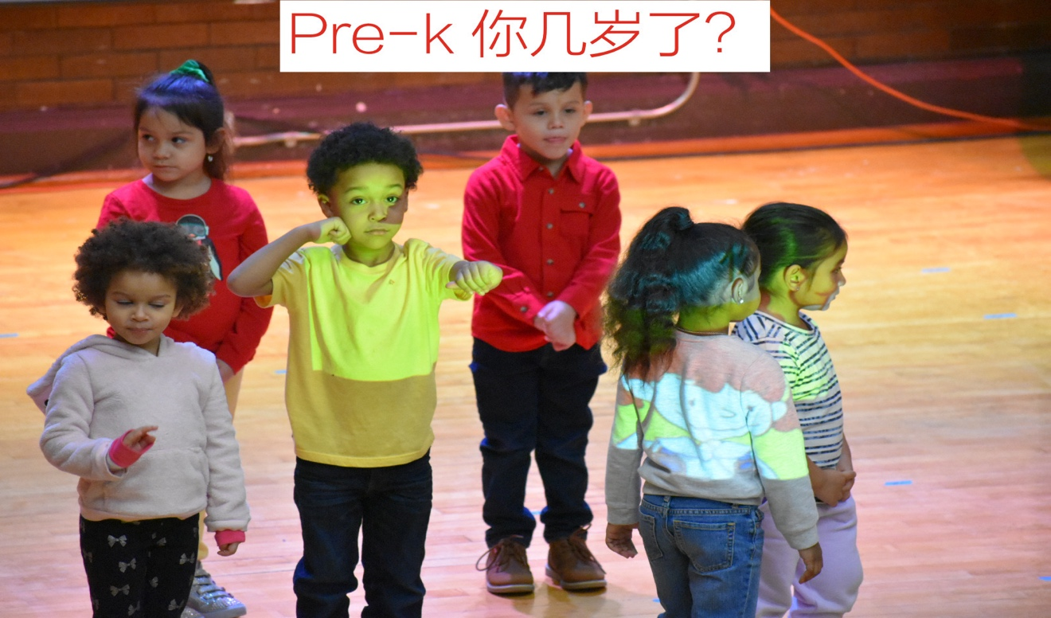

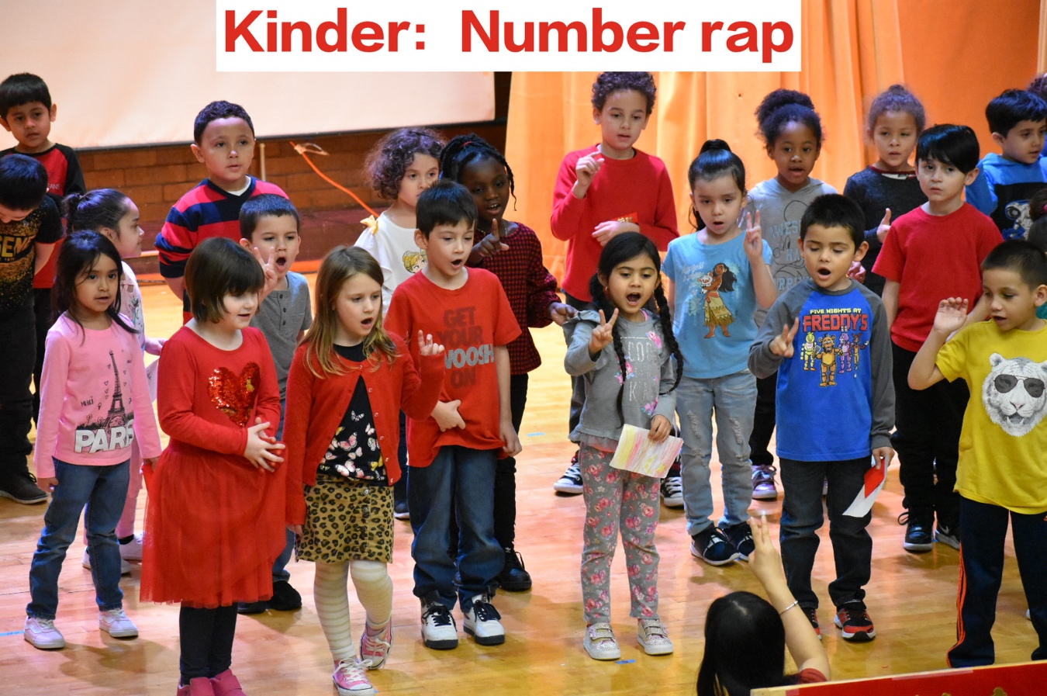
Pre-k perform the traditional Chinese poem “An Ode to Goose” with martial arts dance and the Chinese chant “How old are you”. “An Ode to goose” is also the first poem that most Chinese children learn so it is very meaningful.
Kinder performed a rap about numers and they show how to present numbers in a Chinese way.

The first grade performed the “Hello song” .
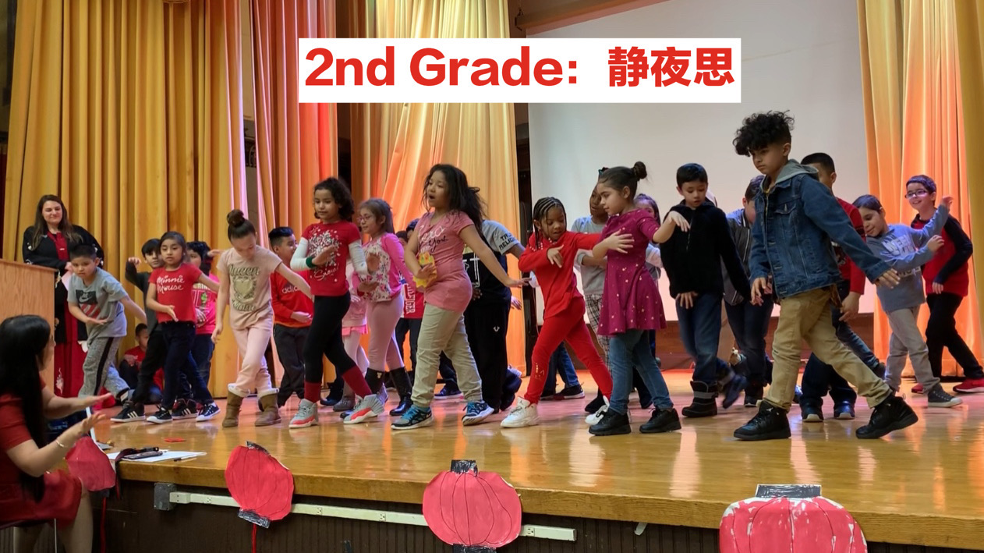
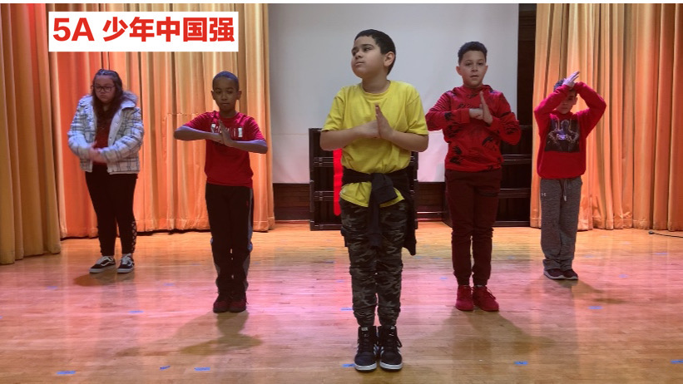
the second grade performed the poem “the silent night” with traditional Chinese dance which won a lot of applause. The third grade performed the “fruit song” which is most challenging since it has a lot of vocabularies but they did a good job ,the fourth grade show how to be polite and show your kindness by performing the song “Find a friend”.

The fifth grade performed the martial arts show with gym teacher “Junior China strong” which show their strength and hard-working and they also in charge of the dragon dance parade for the program transaction .
2.The objectives of our project:
Our school is an IB school so lots of students are from different backgrounds , our Spring Festival showcase help spread the impact and help increase their interest in Mandarin After the showcase ,the students will be more acknowledge with what efforts they have done in Mandarin class.
The Have students get to know more culture about Chinese New Year Celebration traditions.
All the Chinese learners in moos have got a chance for students to show their improvement in Chinese.

