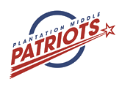

***Student’s Name*** :………………………………………

***Class/Grade*** : …………………………………….…..

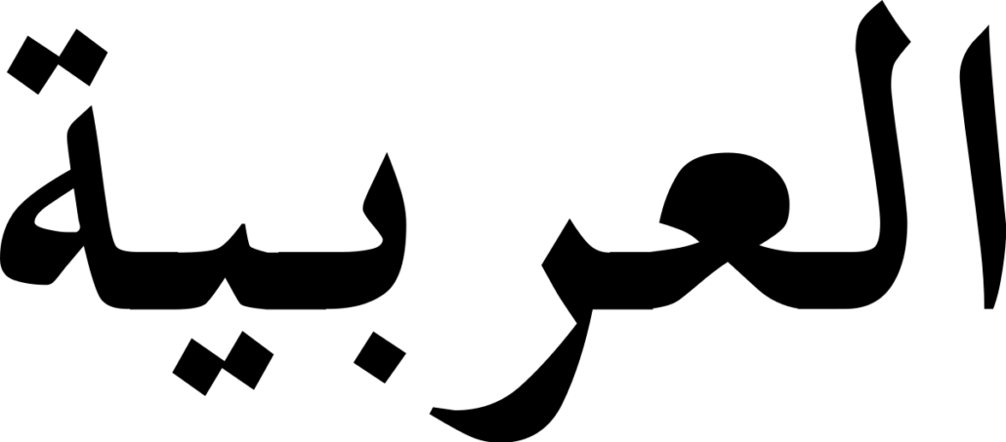

May 27th, 2021

1. **COMPLETE THE FOLLOWING DIALOGUE: أكمل الحوار التالي**

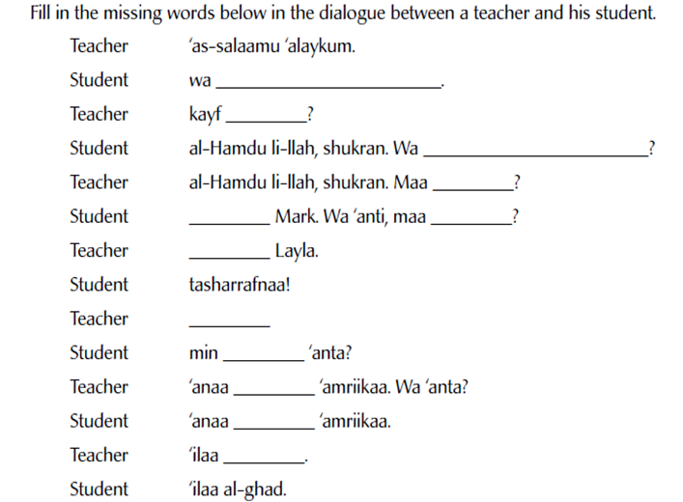

Haluka

Ismukaa

liQa’

LiQaa

liQa’

1. **CIRCLE THE CORRECT ANSWER:اختر الجواب الصحيح**

**1.** When you meet someone what do you have to say:

**a.** Ahlan **b.** Afwan **c.** Marhaba **d.** Tasharafna

**2.** When somebody says **Marhaba مرحبا-** , you should respond with:

**a.** Ana Ismi **b.** Salam **c .** Shukran **d.** Ahlan

**3.**When somebody asks you - **ما اسمك**؟**Ma Ismuka,** youshould respond:

**a.** Wa Anta? **b.** Ana Ismi ALI **c.** Marhaba **d.** Assalamu Alikum

**4.** When someone helps you, you have to say:

**a.** Ahlan **b.** Afwan **c.** Shukran **d.** Tasharafna

**5.**When somebody says **Shukran شكرا-,** youshould respond:

**a.** Afwan **b.** Ahlan **c.** Marhaba **d.** Ila LiQa’

**6.** Before you leave the class**,** youshould say:

**a.** Marhaba **b.** Ahlan **c.** Ma’a Salama **d.** Alikum Assalam

**7.**When somebody says **Ma’a Salama مع السلامة-,**youshould say:

**a.** Shukran **b.** Ahlan **c.** Marhaba **d.** Ila LiQa’



***Student’s Name*** :………………………………………

***Class/Grade*** : …………………………………….…..

**Subject : Arabic 1**

**Teacher : Mohamed El Ouardi**

**End of Term Exam**



May 27th, 2021

1. ***Table

   Description automatically generated with medium confidence*MATCH THE CORRECT PRONOUN:**  **صل بخط**

1. ***A picture containing text

   Description automatically generated*IDENTIFT THE FOLLOWING BODY PARTS:اختر الجواب الصحيح**

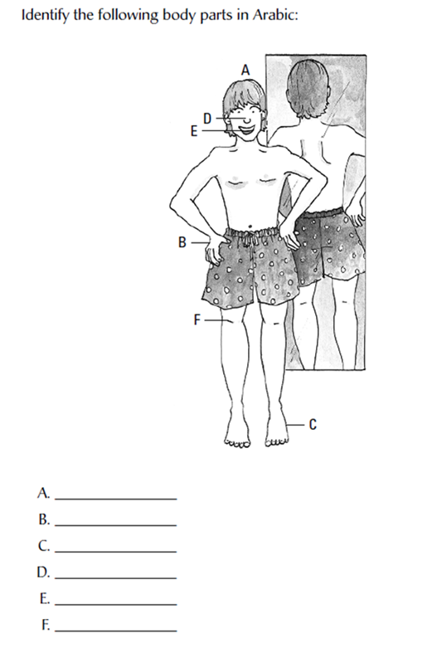

Qadam

liQa’

1. **CIRCLE THE CORRECT ANSWER:اختر الجواب الصحيح**





May 27th, 2021

1. A picture containing graphical user interface

   Description automatically generated**CIRCLE THE CORRECT ANSWER:اختر الجواب الصحيح**

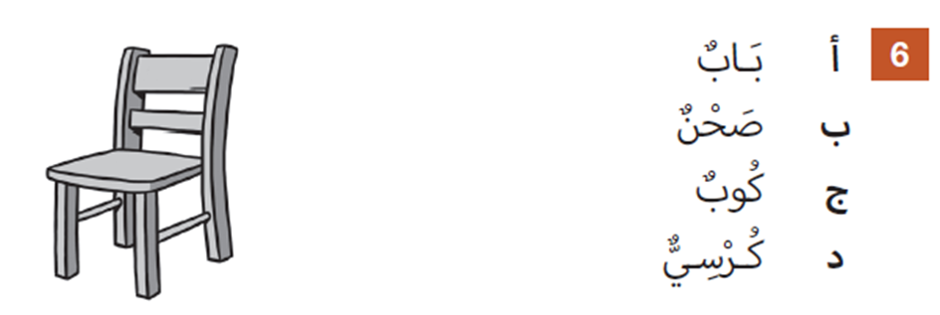

1. **CIHOOSE THE CORRECT ANSWER:اختر الجواب الصحيح**

**3**

**liQa’**

1. **كمبيوتر - Computer**
2. **- Saboura سبورة**
3. **~~دفتر - Daftar~~**
4. **كرسى - Korsee**
5. **كرة – Kura**
6. **Sa’aa - ساعة**

**MATCH THE FOLLOWING COLORS:اختر الجواب الصحيح**

|  |  |
| --- | --- |
| 1. **Blue** 2. **Black** 3. **Red** 4. **White** 5. **Green** 6. **Yellow** | 1. **Abyed أبيض** 2. **Asfer أصفر** 3. **Akhder أخضر** 4. **Azreq أزرق** 5. **Aswed أسود** 6. **Ahmer أحمر** |



  May 27th, 2021

1. **CHOOSE THE CORRECT ANSWER:اختر الجواب الصحيح**



**Ukht أخت**

**liQa’**

1. **IDENTIFT THE FOLLOWING SEASONS:** **أكتب الفصل المناسب**

