Columbus Int. High School Arabic Lesson Plan

Teacher Mohamed Abouraya Grade level Arabic 1

Lesson title Telling the time

Step 1—Desired Results
Standard Outcomes for Learning (ACTFL Standard 1.1)—Answer’s the question, what should students know, understand, and be able to do as a result of the lesson?
- The students will be able to review numbers from 1 to 12
- The students will be able to ask and tell the time in Arabic.
What is the time, now? - It’s nine
من فضلك ، كم الساعة الآن؟ - الساعة التاسعة
- The students will be able to tell the time of their daily activities.
- The students will be able to learn the words, ( clock, watch, time, half, quarter, past, to, hour, minute, second)

Step 2—Assessment Evidence
Performance task—What will students do to show what they have learned?
- The students will say the numbers from 1 to 12
- Students will ask and answer about the time they do some activities during the day.
- The students will use the words learnt to express different times through their day.

Step 3—Learning Plan
Learning activities - Answer’s the question, how do I teach it?
1. Warm up:
I draw a big circle on the board asking students to elicit what we are going to have today.
2. Presentation:
- I start writing the numbers from 1 to 12 asking them to tell me the numbers in Arabic. Now, they know we will talk about telling the time.
- I draw the two hands ( hour/minute) and start to tell the time.
- Now I present the question, “What’s the time, please?”
كم الساعة من فضلك؟

3. Practice:
- What time you do these activities
I give each student a worksheet where he/she write down what time they do these activities. They will draw the two hands and write the time. In this activity, I would go around as they may ask how to say certain times so that I can help them.
- Now, ask and answer
After they finish last activity, now they will ask and answer each other about the activities they do. Here, they practicing a conversational Arabic asking and telling the time.

What time do you do these things?
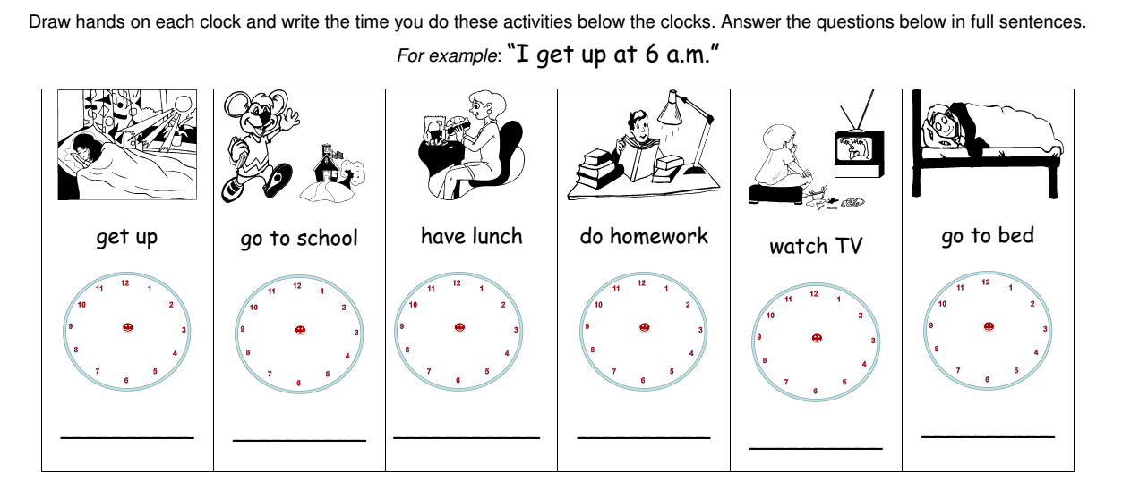

Step 4—Reflection
What happened during my lesson? What did my students learn? How do I know?
What did I learn? How will I improve my lesson next time?

At the end of the lesson,

I will teach them two proverbs that are famous in the Arab world,

“Time is gold”

الوقت من ذهب

“Time is like a sword. If you did not cut it, it will cut you.”

الوقت كالسيف إن لم تقطعه قطعك

