Lesson plan ---- Peking Opera
School: Vista Heritage Global Academy
Name: Gu Lin
Students are supposed to answer the following questions after watching the video.
1. What is the Chinese words and Pinyin for Peking Opera?

2. What is the significance of Peking Opera in China?

3. What are the main four roles of Peking Opera? (write the Chinese words, Pinyin and English)
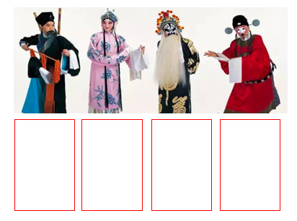
4. What do the colors in painter faces indicate?
红色
紫色
黑色
白色
绿色
黄色
蓝色
金/银色

Make a painted face of Peking Opera脸谱

