Notre Dame Catholic School Chinese Lesson Plan
Teacher Wang Liuqing Grade level Pre-K to G7
Lesson title Chinese Food Project
Step 1—Desired Results
Standard Outcomes for Learning (ACTFL Standard 1.1)—Answer’s the question, what should students know, understand, and be able to do as a result of the lesson?
- The students are able to say “noodles, roast duck, hot pot, toufu, fish and sugar coated haws on a stick” in Chinese and
- The students are able to show their appreciation by using “xi huan” or “bu xi huan”(like or don’t like) and can talk about the price of Chinese food in Chinese.
- The students are able to make a post for their Chinese restaurant and make a presentation with the Chinese words and sentences they have learned.
Step 2—Assessment Evidence
Performance task—What will students do to show what they have learned?
- The students will answer the question “Do you like…?” in Chinese by using 喜欢/不喜欢.. and ask about the price of Chinese food by using这个多少钱？
- The students will introduce their Chinese restaurant’s food menu in Chinese.
Step 3—Learning Plan
Learning activities - Answer’s the question, how do I teach it?
1.Revision and warm up:
Review Chinese food names we have learnt.
Show the flash cards of American foods we have learnt –hot pot, noodle, roast duck, toufu, fish, tea and sugar coated haws on a stick in Chinese

Then review sentence patterns :
This is … 这是…
Show the word cards of food and ask the question “Do you like…?”.你喜欢…吗？
Ask and answer to practice 喜欢and 不喜欢.

Review numbers from 1-20 in Chinese.

2.Presentation:
Show every kind of Chinese dish we have learnt, and ask: How much is it? 这个多少钱？Answer: It is … 这个… 块钱。
3.Practice: Have students practice the sentence pattern about the price of Chinese food.
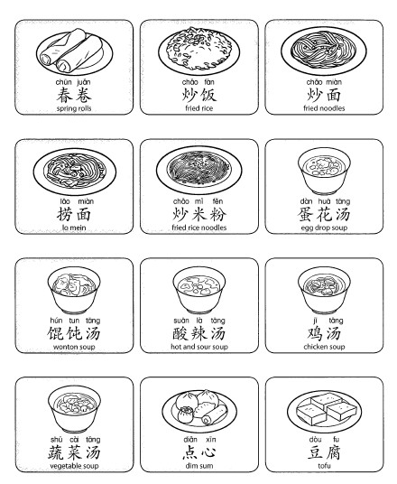
4.Project: Make a post for Chinese restaurant with the menu and Take Out Box and each group will make a presentation to introduce their Chinese food.
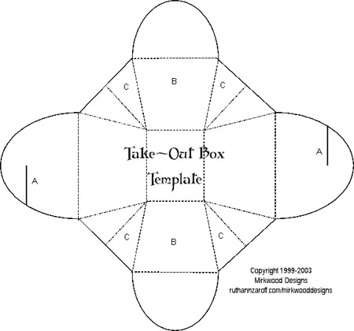

Step 4—Reflection
What happened during my lesson? What did my students learn? How do I know?
What did I learn? How will I improve my lesson next time?
When talking about Chinese culture, we must mention Chinese food. In this class, we have learned vocabulary of some famous and popular Chinese food and talked about the table manners. And we have also learned some sentences to talk about our favorite food. My students showed great passion for the topic. So I had them have plays about their Chinese restaurants. They have created the name and menu for their restaurants. From their wonderful performance, I could tell they have mastered the language and culture in this class. I will show them more videos about real Chinese restaurant next time.

