Roosevelt Elementary School Chinese Lesson Plan
Teacher Chen Fangfang Grade level Pre-K to G5
Lesson title Lesson28 Chinese Food
Step 1—Desired Results
Standard Outcomes for Learning (ACTFL Standard 1.1)—Answer’s the question, what should students know, understand, and be able to do as a result of the lesson?
- The students are able to know the differences between American Chinese Food and real food in China.
- The students are able to say “noodles, roast duck, hot pot, toufu, fish and sugar coated haws on a stick” in Chinese and show their appreciation by using “xi huan” or “bu xi huan”(like or don’t like) .
Step 2—Assessment Evidence
Performance task—What will students do to show what they have learned?
- The students will answer the question “Do you like…?” in Chinese by using 喜欢/不喜欢..
- The students will get familiar with names of some American Chinese foods and real Chinese foods.
Step 3—Learning Plan
Learning activities - Answer’s the question, how do I teach it?
1.Warm up:
Review some Chinese songs we have learnt.
Show the flash cards of American foods we have learnt – cheese, sausage, sandwich, salad, bread, hamburger and turkey in Chinese and ask the question “Do you like…?”.
Show the word cards of “xi huan” (like) and “bu xi huan” (don’t like).
Ask and answer to practice 喜欢and 不喜欢.
Then sentence practice—use the pattern I like… wo xi huan…, for example, 我喜欢汉堡包。Ask 2 students to try. Practice the pattern I don’t like…wo bu xi huan….
Ask one student to come to the front to pick up 2 pictures of the foods, one is the favorite and the other one is the opposite. Let students guess which one is the favorite one to review the words about American foods again. And the student with the 2 pictures practices the 2 sentences and show the answer.
2.Presentation:
Let the students talk about their favorite Chinese food and discuss if they are real Chinese food. Show the video about 10 no-Chinese foods.
https://www.youtube.com/watch?v=nhpnfeN2vRE
Introduce the real Chinese food.
1)Mian tiao 面条 noodles
Read the words and watch the video about noodles.
https://www.youtube.com/watch?v=cBmhnmD47I8
- nĭ xĭ huān miàn tiáo ma
- 你 喜 欢 面 条 吗？
- Do you like noodles?
- wŏ xĭ huān miàn tiáo wŏ bù xĭ huān miàn tiáo
- （我）喜欢（面条）。/（我）不喜欢（面条）。
- (I) like (noodles)./ (I) don’t like(noodles).
(The students can also show the answer by gesture—thumb up/down/maybe.)
2) Kao ya烤鸭 Roast duck
https://www.youtube.com/watch?v=FkjcC6qJj-w&index=62&list=PLCFDD3F76245D00A9
3) huo guo 火锅 Hot Pot
https://www.youtube.com/watch?v=qmz28Q4ycbc&index=64&list=PLCFDD3F76245D00A9
4) dou fu 豆腐 toufu
https://www.youtube.com/watch?v=wUhlVnaBlds&index=65&list=PLCFDD3F76245D00A9
5) tang hu lu 糖葫芦 sugar coated haws on a stick
https://www.youtube.com/watch?v=pdfHf7ZbE6Q&index=63&list=PLCFDD3F76245D00A9
6) cha 茶 tea
https://www.youtube.com/watch?v=XVMg8JSEEu0&index=75&list=PLCFDD3F76245D00A9
7) yu 鱼 fish
https://www.youtube.com/watch?v=Tf_b8lGk_CA&index=68&list=PLCFDD3F76245D00A9
(According to the students’ interest to show the videos and ask the question before and after the video to see if they change their mind about Chinese food. And we also do the survey then count the number of people who like the food to review counting in Chinese. )
3.Practice: Repeat the names of the foods and choose the favorite one then say it out.
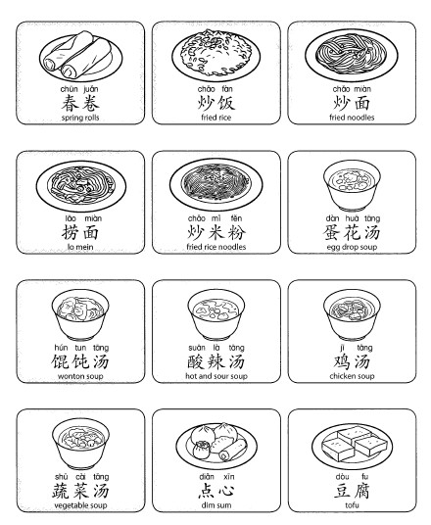
4.Project: Chinese Food Take Out Box and put the favorite food above into the take out box.
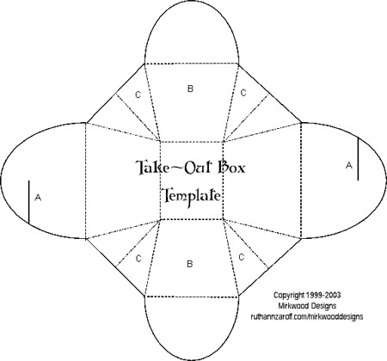

Step 4—Reflection
What happened during my lesson? What did my students learn? How do I know?
What did I learn? How will I improve my lesson next time?
This lesson really made us all feel so hungry. Some young kids might not accept some foods they are not familiar but I am very happy to see after introduction, most of them are open to try. And some of them even want to go to China for the real Chinese foods.

