Roosevelt Elementary School Chinese Lesson Plan
Teacher Chen Fangfang Grade level Pre-K to G5
Lesson title Lesson 27 Happy Mother’s Day!
Step 1—Desired Results
Standard Outcomes for Learning (ACTFL Standard 1.1)—Answer’s the question, what should students know, understand, and be able to do as a result of the lesson?
- The students are able to use “I love you, mom!”and “Thank you, mom!” in Chinese.
- The students are able to repeat “Happy Mother’s Day!” in Chinese .
Step 2—Assessment Evidence
Performance task—What will students do to show what they have learned?
- The students will use different tones of the hand puppets to say “I love you, mom!” and “Thank you, mom!” in Chinese.
- The students will finish the flower, certificate or the paper necklace project for moms.
Step 3—Learning Plan
Learning activities - Answer’s the question, how do I teach it?
1.Warm up:
Review some Chinese songs we have learnt.
Use puppets from Journey to the West to practice 2 sentences for moms.
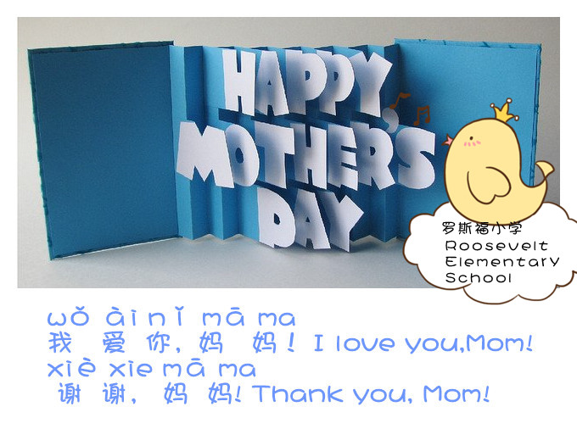
Imitate different tones of the characters.
Monkey King—Naughty and Funny
Pigsy—Lazy and Sleepy
Monk Sha—Shy and Quiet
Monk Tang—Just Be You
The student chooses the character and the tone then role play.
2.Presentation:
Ask the students what they will do for Mom on Mother’s Day. Show the basic things in China kids may do for Mom.
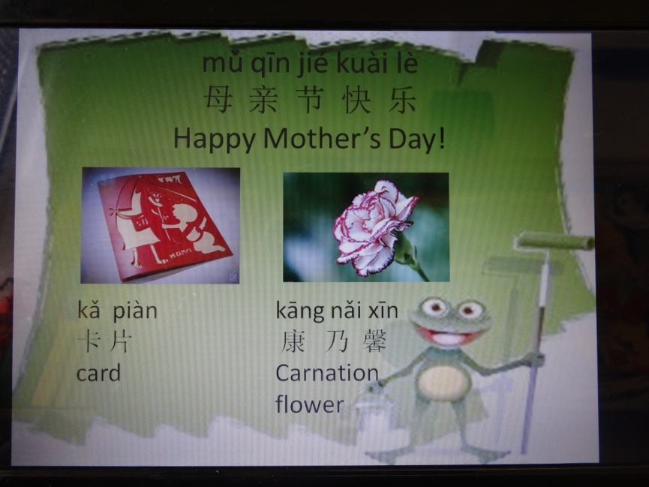
3.ProjectTime:
1) Make a flower.
2) Make a happy card.
3) Write a certificate.
4) Make bracelets.
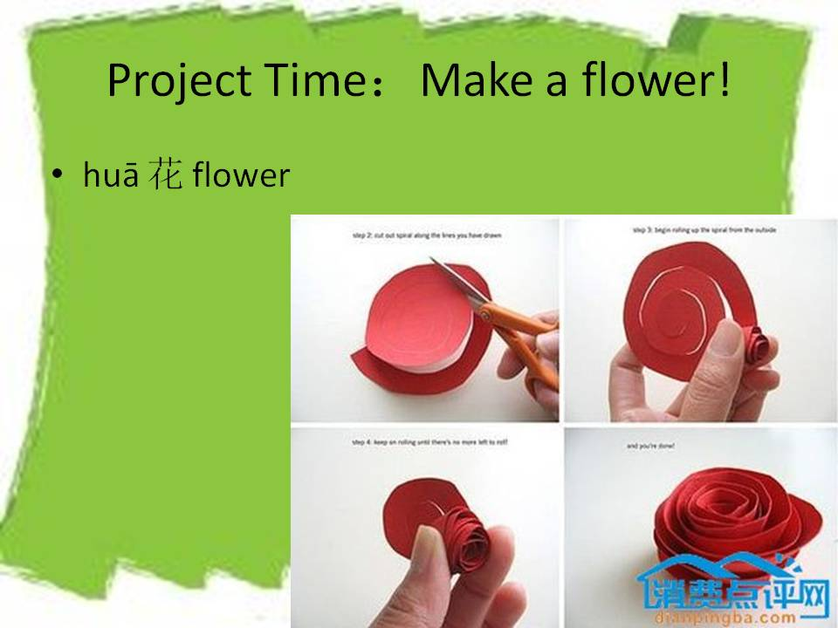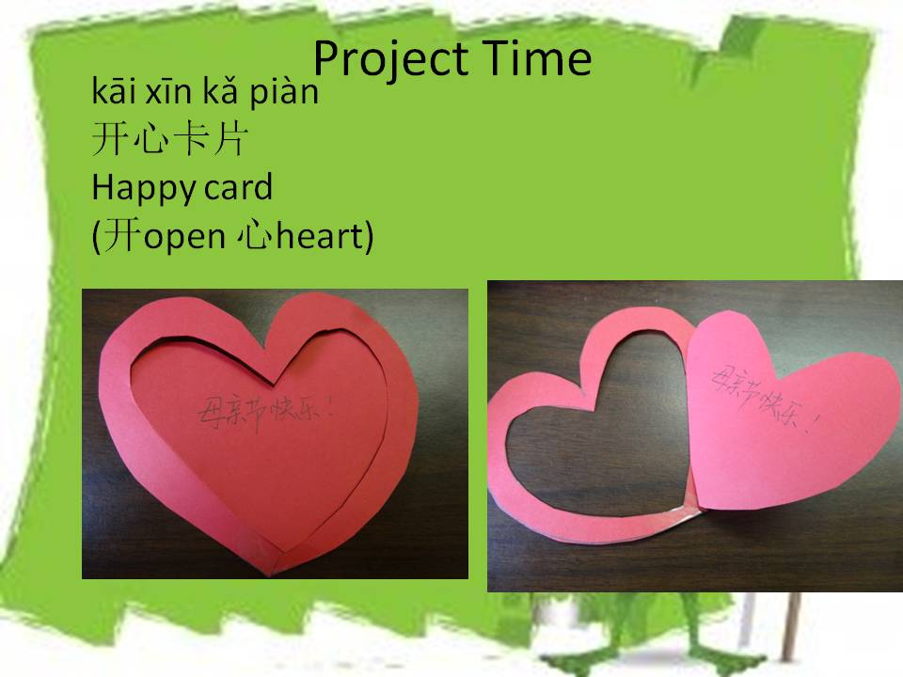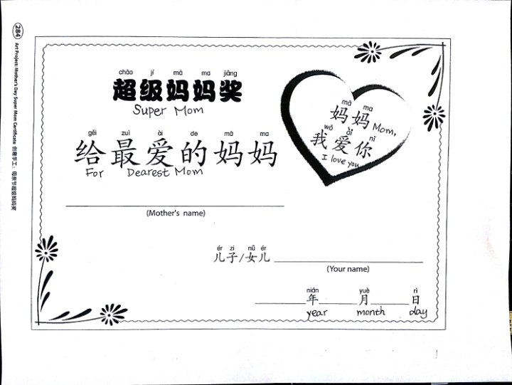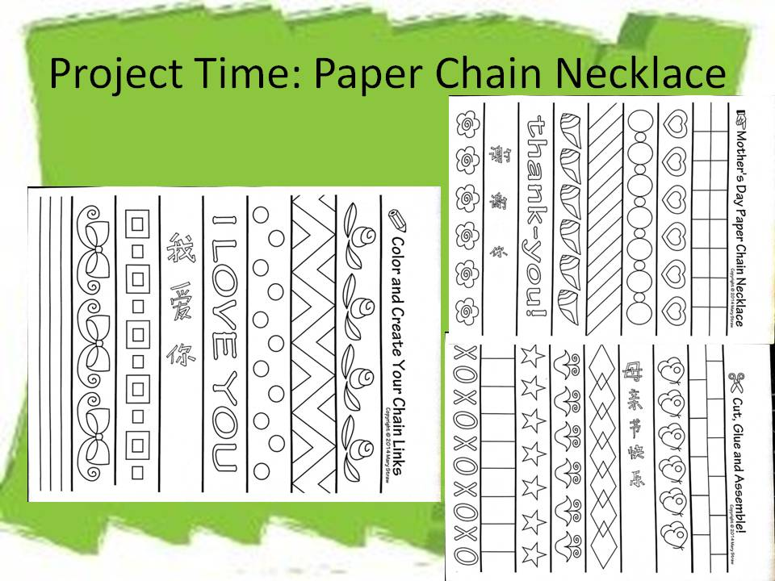
4. Song Appreciation:
If time is allowed, appreciate a song—Listen to Mom’s Words by Jay Chow who is a famous singer in China.
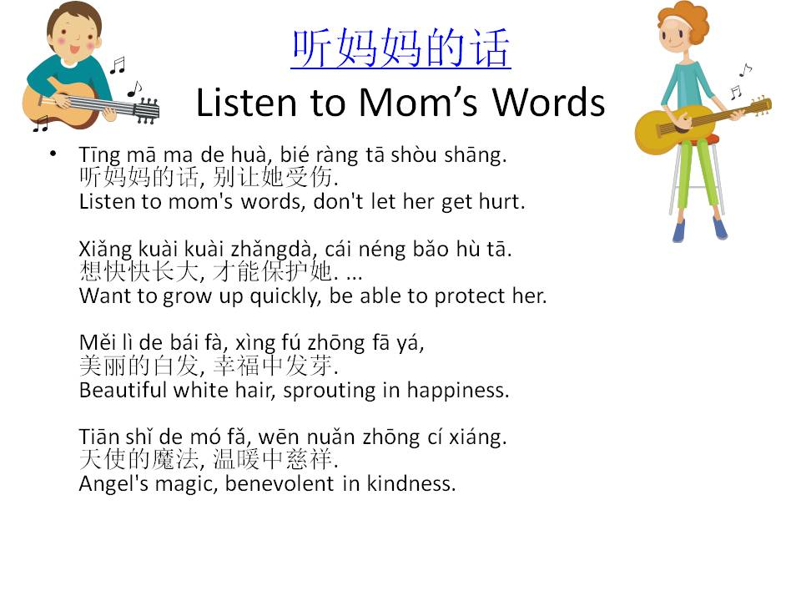

Step 4—Reflection
What happened during my lesson? What did my students learn? How do I know?
What did I learn? How will I improve my lesson next time?
The kids did great in imitating the tones and gave fantastic puppet show. Then, the project really got their full attention. Everybody wants to do something nice for Mom. We didn’t have time to learn the song which is for extended learning about Mother’s Day.

