Roosevelt Elementary School Chinese Lesson Plan
Teacher Chen Fangfang Grade level Pre-K to G5
Lesson title Lesson 26 Journey to the west
Step 1—Desired Results
Standard Outcomes for Learning (ACTFL Standard 1.1)—Answer’s the question, what should students know, understand, and be able to do as a result of the lesson?
- The students are able to know the short story and say the names of the main characters in Journey to the West—sun wu kong(monkey king), zhu ba jie(Pigsy), sha seng (Monk Sha) and tang seng(Monk Tang).
- The students are able to review and practice the dialogue about asking names about the four main characters.
Step 2—Assessment Evidence
Performance task—What will students do to show what they have learned?
- The students will say the Chinese names of the 4 main characters in the Journey to the west when they see the pictures.
- The students will use the puppets to practice the dialog—what’s your name? My name is …in Chinese.
Step 3—Learning Plan
Learning activities - Answer’s the question, how do I teach it?
Cultural legends and folktales always inspire young children and help develop their imagination and creativity. The story of Sun Wukong is certainly among the best of all.
1.Warm up:
Review Chinese songs and watch the video clip of Journey to the west in Hello, China series.
https://www.youtube.com/watch?v=pfGHyXcIKZs
Questions: 1. Why is it called Journey to the West but not East? (From China to India)
2. What does Xi mean? (West)
2.Presentation:
Explain Xi You Ji and the character of Sun Wu Kong(Monkey King), esp. its magical power—72 transform and the golden rod which he stores in his ear. Use TPR to teach big and small (da and xiao) when explaining the golden rod.
Teach the four main Characters in Journey to the West.
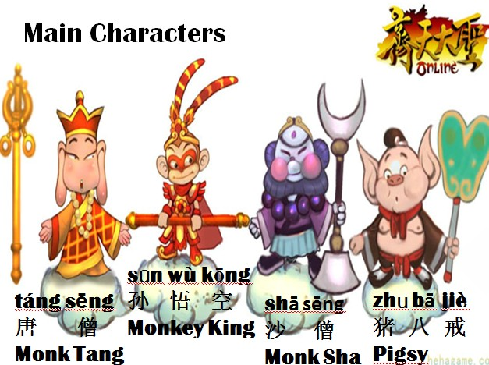
3.Consolidation:
Short story time—Xi You Ji (Journey to the West).
4.Practice:
Use hand puppets to practice the dialogue.
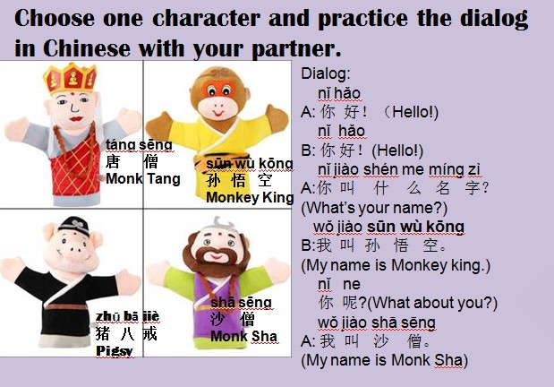
After practicing in pairs, use name sticks to pull out one student with his or her partner to practice the dialog in the front and show a Chinese song then say Xie xie da jia(Thank you, everybody!).
The students in Gr.3-5 will have the chance to use shadow puppets to give the shadow puppet show.
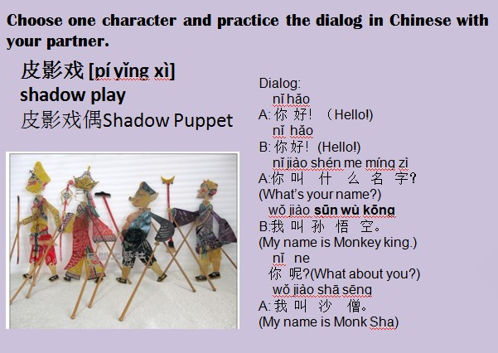
(Video about Chinese shadows puppet theatre
https://www.youtube.com/watch?v=IazfPhHS1dc
Also if it is possible, enjoy a song about Journey to the West.
https://www.youtube.com/watch?v=64pitvZaJ0M)
Step 4—Reflection
What happened during my lesson? What did my students learn? How do I know?
What did I learn? How will I improve my lesson next time?
The video caught the students’ eyes. They want to know more about the story. So I downloaded the audio book about it in the classroom ipads.
(The Journey to the West - Part 1: The Birth of the Monkey King -by Rye Studio™
https://itunes.apple.com/us/app/journey-to-west-part-1-birth/id416753327?mt=8
Part 2:
https://itunes.apple.com/us/app/from_topapp.net/id533046971?ign-mpt=uo%3D4
Part 3:
https://itunes.apple.com/us/app/ryebooks-journey-to-west-part/id549796503?mt=8 )
The students love the puppet show. We used the hand puppets to practice the dialog and the students in Gr. 3-5 tried the shadow puppets. It was a lot of fun.
To make it more interesting, I designed the puppet show into 3 parts—dialog, Chinese song and unexpected disappearing.
Because of business trip, some classes have a plus lesson—Journey to the West project class—the kids in Gr.1-3 have the coloring project and the kids in Gr.4-5 have the monkey king paper doll project.

