Teacher’s name : Khalil I. Nasr Hellgate High School May 2013
Lesson Title : Daily Routine
Language Level : Arabic 1 & Arabic 2 Grades 8-12

Desired Results
Lesson goals:
Students will be able to talk about a day in their life .
Essential Questions:
- 1-Do you get up early ?
- 2-Do you come to school by car ?
- 3- Do you have breakfast at home ?
- 4- What do you do in the morning?
- 5 - What do you do after school?
- 6-When do you have dinner ?
- 7-When do you go to bed ?
Lesson Objectives: Students will be able to:
- Learn verbs about daily life routine
- Say what they do from morning till they go to bed .
- Learn how to talk about a fiend’s activity using : He …or She …..
Assessment Evidence
*Students can talk about different times of the day when they are shown the pictures of the PowerPoint Presentation
Learning Plan
Materials needed:
PowerPoint presentation – handouts –worksheets - flash cards.
Learning activities:
Warm up
- I ask students yes or questions about what they do everyday . For example :
- 1-Do you get up early ?
- 2-Do you come to school by car ?
- 3- Do you have breakfast at home ?
I revise times of the day in Arabic. I tell the students that we revise the times of the day as they are connected to Daily Routine.
فى الصباح – فى الظهر – بعد المدرسة – فى المساء – فى الليل
Introduction to Lesson:
1.Greeting the students
- 2. I ask students more yes and no questions related to daily activities and what they do in the morning- in the evening …..etc
- Do you have lunch at home ?
- What do you do in the morning?
- What do you do after school?
When do you have dinner ?
When do you go to bed ?, ................etc
Then with pictures, I go through daily routine and ask them to repeat after me to pronounce the sentences correctly.
Activity 1
Guided Practice:
I show students photos of different times of the days written in Arabic and have students repeat and ask among themselves.
Activity 2
I show students power point slides about daily activities .
Pair work :
Students work in pairs, one ask “what do you do in the morning?” Another student replies “I wake up, wash my face, eat my breakfast and go to school”.
ماذا تفعل فى الصباح؟
ماذا تفعل فى المساء ؟

استيقظ / اصحو من النوم.
اغسل / اتوضأ واصلى .

Day one :
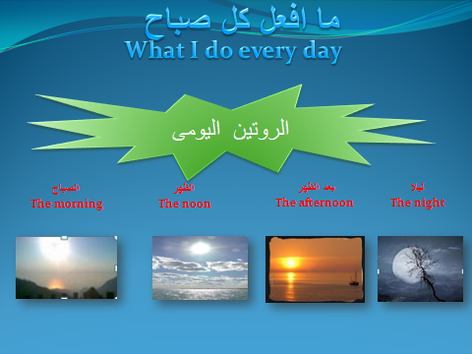
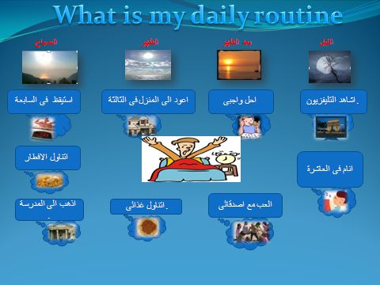
Day 2:
Activity 3

This lesson will cover the daily routine and vocabulary related to every day life.
Firstly, read the following short story about Ahmed's morning (with the translation.) Verbs are highlighted in red.

يستيقظ أحمد الساعة السادسة صباحا.
Ahmed wakes up at 7am .
يذهب إلى الحمام ويغسل.
He goes to the bathroom and washes .
يلبس ثيابه.
He dresses in his clothes.
يتناول الفطور مع أخته في المطبخ.
He has breakfast with his sister in the kitchen.
يأكل., ويشرب القهوة
He eats, and he drinks coffee.
يغادر أحمد في الساعة السابعة.
He leaves at 8:30.
يذهب إلى العمل بالسيّارة.
He goes to work by car.
وتذهب أخته إلى المدرسة.
and his sister goes to school .
أحمد مسرورٌ بحياته.
Ahmed is happy with his life.
ويشكر الله على كلّ شئ .
And he thanks Allah for everything .

Day 3
Activity 4:
Use the the same sentences to talk about yourself
Begin the sentences with I .
For Example :
انا استيقظ فى السابعة صباحا .
Activity 5:
Pair work : Now work in pairs talk about your daily routine with a friend and then tell us what your friend does everyday
Day 4:
Activity 6 :
Pair work : Read the following verbs .Then work in pairs add suitable words to form meaningful sentences .
For example
انا احب السباحة انا احب كرة القدم
Verbs الأفعال
Oheb-Love - أنا أحب
La Oheb –don’t like - لا احب
Aakol-Eat - آكل
Ashrab-Drink - أشرب Alaab-Play - ألعب
Agry-Run - أجري
Anam-Sleep - أنام
Aqef-Stand اقف -
Aghsell-Wash اغسل -
Atakalem-Speak - أتكلم
Azoor-Visit - أزور
Astaiqeth - wake up استيقظ--
Albess – wear / dress /put on البس --
Day 5
Activity 7:
Now work in groups talk about your daily activities and then choose one of the group and talk about a day in his or her life . Robert ……or Kathy ……..
Activity 8:
Homework
Use the following verbs to form at least 5 meaningful sentences at home .
Aamal-Work أعمل
Oreed-Want أريد
Othaker-Study أذاكر
Ataalam/Adross-Learn أتعلم \ أدرس
Aktob-Write أكتب
Aqraa-Read اقرأ
Oshahed-Watch أشاهد
Anathef – clean / brush انظف
Reflection
Most students could do well in this topic . It was really difficult for them in day 1 but in the following days they could successfully express what they do everyday in Arabic.

