Lesson Plan

Teacher: Hu Qian |  | Class: Chinese 2  Ordering Food |  | Date: May, 18th
Background Information:
As the first lesson in this unit, the vocabularies and languages are all new to the student, which might pose a challenge for the students. But on the other hand, the topic of ordering food is set in daily life background, making it a highly engaging and interesting topic for the students to participate.
Objective(s): By the end of this lesson, students will be able to (SWBAT)…
- (content) describe various kinds of food and drinks in Chinese;
talk about how to order food and how to ask others’ preference within two choices in Chinese;
pay attention to the courtesy when ordering food..
- (language) translate sentence “ni hao, ni yao dian shen me?”(Hello, what food would you like to order?)
“ni yao he shen me?” (What drinks do you want to order?)
“ ni yao da bei hai shi xiao bei? (Do you want a big cup or a small cup?)

- (skills) use comprehensible pronunciation (inc. intonation) of the target language in speech to describe the names of different kinds of food and order food in a restaurant.
Assessment(s)  Diagnostic  Formative  Summative | What will students do to show their progress towards or mastery of the objectives?  Students will be shown pictures of food and asked to name them in Chinese.  Students will answer the questions “What would you like to order? Do you prefer a big cup pr a small cup?”  Students will do a presentational speaking. They are required to do a role play with their partners to pretend to order food in Chinese. Besides, students are also required to do an interpretative writing to summarize their experience of ordering food in Chinese( what food/drinks they order, the conversation with the waiter)
Lesson Sequence
Activity Name | Activity Steps and Description |  | Time | Materials
Warm-up  (activate background) | What are your favorite foods? Name three of them. Do you know how to describe them in Chinese ? Now it is time to learn the names of foods and drinks in Chinese and learn how to order food in Chinese. |  | 3 mins
Activity 1  (encounter new material) | The teacher will present the following words one by one on the whiteboard along with pictures matching the words; the teacher will lead the students to try to pronounce the words by themselves before teaching the pronunciation.  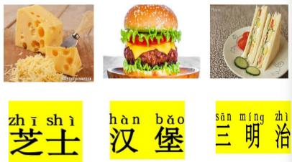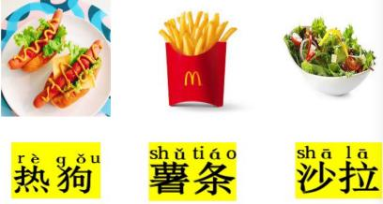  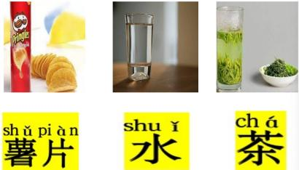 |  | 20 mins | Powerpoint, projector
Activity 2  (encounter with new material) | The teacher presents the following dialogue about ordering food in a restaurant.  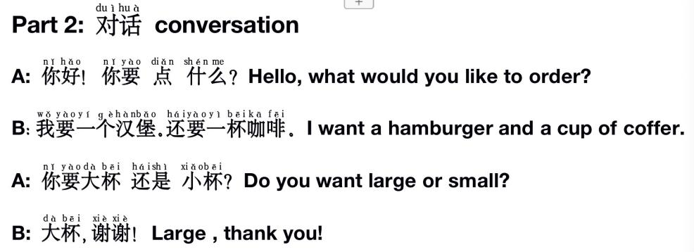 |  | 25 mins | Pictures and powerpoint  projector
Activity 3  (engage with new material) | - Game : Hot Potato  Students stand in a circle to pass a teddy bear, in the same time, the teacher is speaking “cold cold cold....warm warm warm warm....hot hot hot hot ..potato” then, the passing of the bear stops and the student who is the hot potato ( with the bear in his/her hand) is supposed to translate the new vocabularies of this lesson.  1.Task one: Interpretative Listening  The students will hear 5 people ordering some food and drinks from the items below. Say the letter and quantity of each item ordered.  - Task two: Interpersonal Speaking  With a partner, take turns playing the roles of a customer and a server at a restaurant. Use the conjunction 还是(hai shi) in forming your questions. Place the order according to the pictures. |  | 25mins | Powerpoint
Activity 4  (apply new material) | 1. Presentational Writing  You want to pick up dinner for your friends. Write a passage to introduce to your friends what food and drinks are on the menu and then ask him to choose drinks or food by using the sentence “ni yao ...hai shi ....?( Do you like...or ....)” |  | 12 mins
Closing  (reflect on learning) | The teacher reviews what are taught in this class and answers questions from the students if there’s any. |  | 5min
Teacher’s Notes and Reflections | The students liked the game “Hot Potato” to enhance memory about food and drinks. They also show great enthusiasm in the “role play” part. The listening task and the presentational writing are a little challenging for some of the students, since this is the first lesson of the unit, the output might be difficult.

