Lesson Plan
Teacher: Hu Qian |  | Class: Chinese 2  Classroom Objects and Location |  | Date: Mar. 13th
Background Information:
As the first lesson of the Unit about School Life, students’ previous knowledge about this part in regard to Chinese is almost blank. However, classroom objects are what they see and use on a daily basis, making it an interesting and engaging topic for the students to learn since the teaching content is closely connected to their daily school life.
Objective(s): By the end of this lesson, students will be able to (SWBAT)…
- (content) identify and describe classroom objects;
explain the location of something;
read and use target words to introduce classroom objects and their locations
- (language) translate and use sentence “ zhe shi shen me?” (What’s this?)
“zhe shi bai ban bi.” (This is the whiteboard pen.)
“bai ban bi zai na li?” (Where is the whiteboard pen?)
“bai ban bi zai ke zhuo shang mian.” (It’s on the top of the desk.)
- (skills) use comprehensible pronunciation (inc. intonation) in speech to introduce the classroom objects and their corresponding locations.
Assessment(s)  Diagnostic  Formative  Summative | What will students do to show their progress towards or mastery of the objectives?  Students will finish a Quizlet of vocabularies about classroom objects in Chinese to test their previous knowledge as regard to this topic.  Students will answer the questions “...zai na li (Where is ...)?”in Chinese by observing the teachers’ movement.  Students will draw a picture about the items described in a small paragraph, which includes some of the classroom objects and their positions.
Lesson Sequence
Activity Name | Activity Steps and Description |  | Time | Materials
Warm-up  (activate background) | “look around you, what are the objects in the classrooms? Do you want to know how to introduce these objects and describe their positions in Chinese?” |  | 3 mins
Activity 1  (encounter new material) | The teacher will present the following words one by one on the whiteboard along with pictures matching the words; the teacher will lead the students to try to pronounce the words by themselves before teaching the pronunciation.  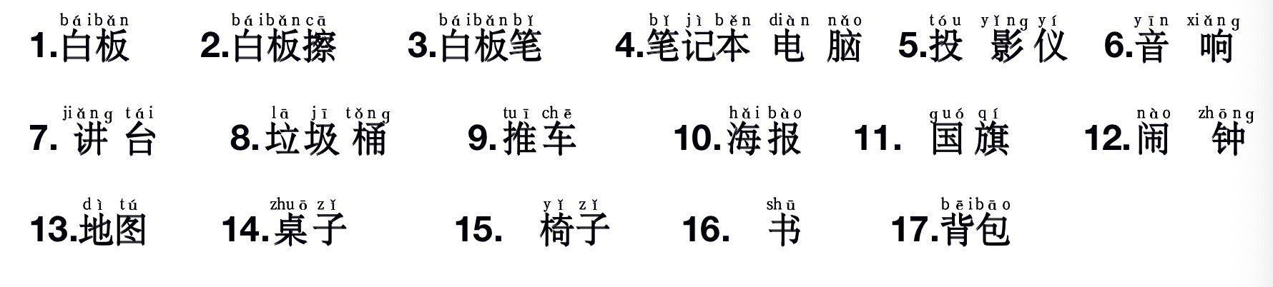 |  | 20 mins | Powerpoint, projector
Activity 2  (encounter with new material) | The teacher presents the following target language describing locations of classroom objects.  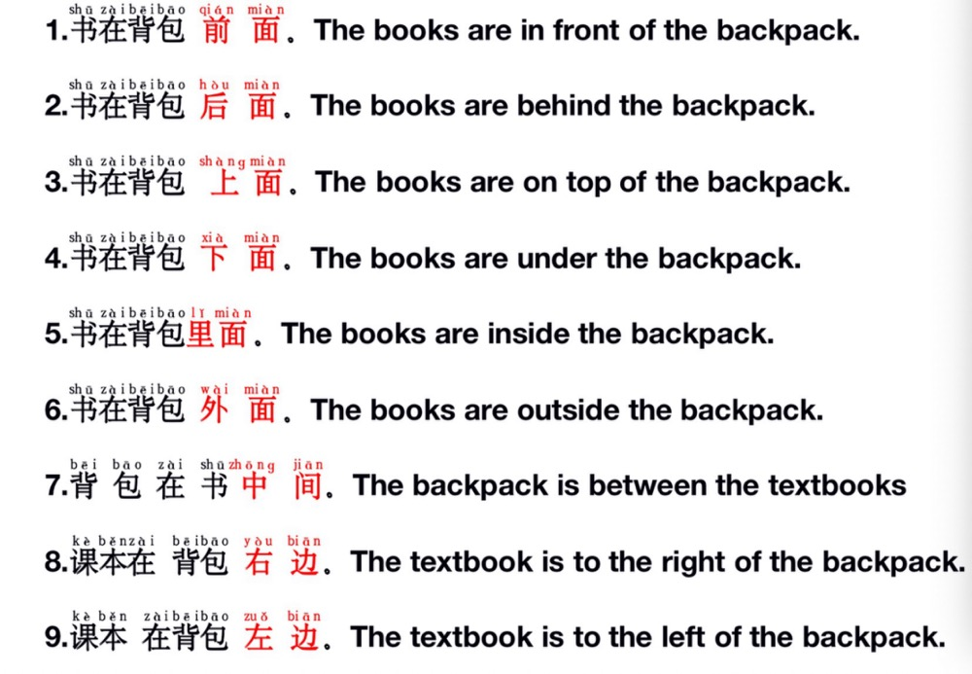 |  | 25 mins | Pictures and powerpoint  projector
Activity 3  (engage with new material) | - Game 1: Bingo !  Students are asked to play a game: Bingo ! Put the 16 words of classroom objects in a 4*4 table in a random order and let's play Bingo!  - Game 2: Matching the Chinese words with its corresponding English translation.  There are 20 pieces of paper. 10 with pinyin or hanzi, another 10 with English translation. put the paper face down.  Two students from each group will play “scissors, stone, cloth” to decide the first one to turn over the card,.  The winner turn over two cards. If the two cards( one English, one pinyin) match each other, then the group gets 1 points.  - I do you say!  The students are required to speak out the names of the classroom objects in Chinese and describe its right position by observing the teacher’s movement. |  | 25mins | Powerpoint
Activity 4  (apply new material) | - The teacher will ask the students to write a paragraph about six imaginary items on a teacher’s desk. Indicate the relationship of each object to another object. Then the students need to exchange their paragraph with that of his partner, who will draw what they have described. |  | 12 mins
Closing  (reflect on learning) | The teacher reviews what are taught in this class and answers questions from the students if there’s any. |  | 5min
Teacher’s Notes and Reflections | The students liked the three game about classroom activities and locations. It is challenging and interesting. When we finished playing two rounds, they still asked for more. The game of “I do you say” which is targeted to use the words of classroom objects in talking about location is also fascinating and the students are fully engaged.

