Lesson Plan
Teacher: Hu Qian |  | Class: Chinese 2  Sports, Activities and Future Plans |  | Date: Apr. 18th
Background Information:
As the last lesson of the Unit about School Life, students have already learned parts of vocabularies of leisure activities, which can help boost their confidence of learning the new activities in this lesson. For the other, discussing varieties of activities and talking about what they are going to do in the future is closely connected with the students’ daily life, stirring their interest in engaging in the class.
Objective(s): By the end of this lesson, students will be able to (SWBAT)…
- (content) describe various sports activities and typical living places;
talk about what they are going to do in the future;
read and use target words to introduce their weekend plans.
- (language) translate and use sentence “ ni xiang zuo shen me?” (What would you like to do?)
“wo men zai gou wu zhong xin.” (We are in the shopping mall.)
“ni yao qu da lan qiu ma?” (Are you going to the basketball court?)
“zhou mo ni yao qu na li” (Where are you going this weekend.)
- (skills) use comprehensible pronunciation (inc. intonation) in speech to describe sports activities and talk about future plans.
Assessment(s)  Diagnostic  Formative  Summative | What will students do to show their progress towards or mastery of the objectives?  Students will finish a Brooket of vocabularies about leisure activities in Chinese to check their previous knowledge as regard to this topic.  Students will answer the questions “ni yao zuo shen me?” (What would you like to do?) in Chinese according to the pictures displayed by the teacher.  Students will do a presentational speaking. They are required to show a picture or drawing of a favorite weekend and prepare a presentation to describe what they did in the photo( where, when, with whom, what he did, his opinion on the activity)
Lesson Sequence
Activity Name | Activity Steps and Description |  | Time | Materials
Warm-up  (activate background) | Two weeks ago, we have learned some words of leisure activities in Chinese. Do you still remember them? Let’s do a translation task to retrieve the words. |  | 3 mins
Activity 1  (encounter new material) | The teacher will present the following words one by one on the whiteboard along with pictures matching the words; the teacher will lead the students to try to pronounce the words by themselves before teaching the pronunciation.  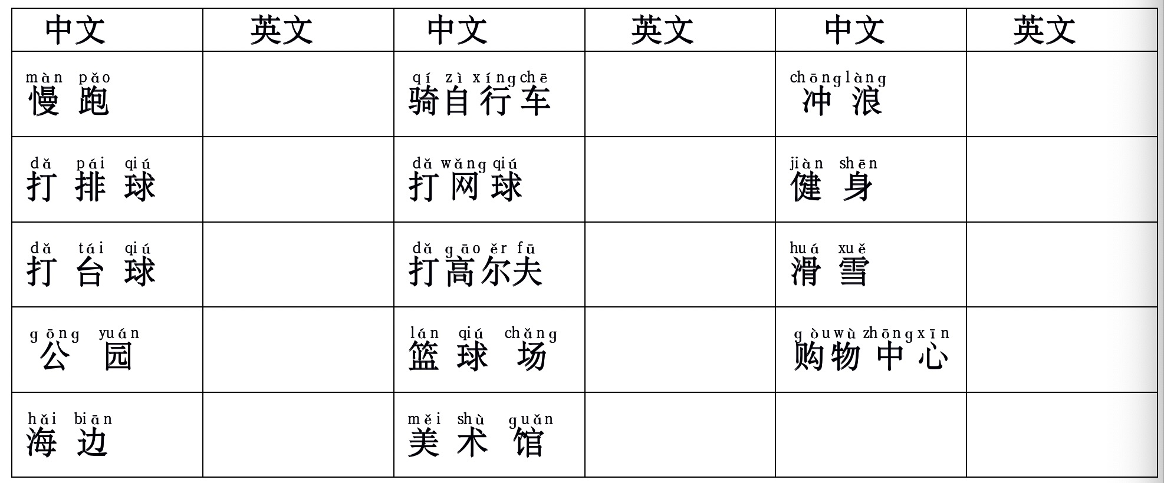 |  | 20 mins | Powerpoint, projector
Activity 2  (encounter with new material) | The teacher presents the following target language describing locations of classroom objects.  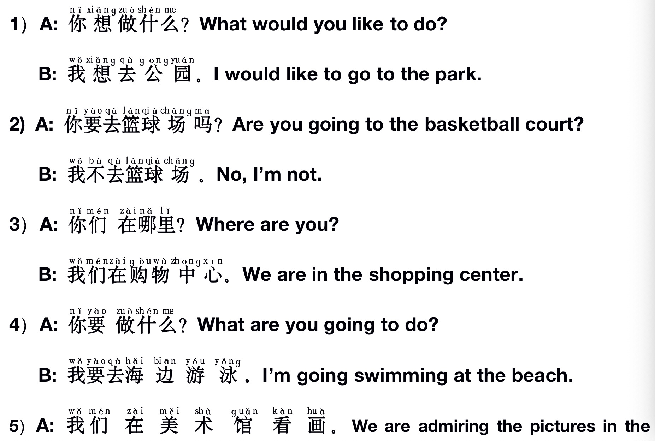 |  | 25 mins | Pictures and powerpoint  projector
Activity 3  (engage with new material) | - Game 1: Bingo !  Students are asked to play a game: Bingo ! Put the 16 words of classroom objects in a 4*4 table in a random order and let's play Bingo!  - Game 2: Matching the Chinese words with its corresponding English translation.  There are 20 pieces of paper. 10 with pinyin or hanzi, another 10 with English translation. put the paper face down.  Two students from each group will play “scissors, stone, cloth” to decide the first one to turn over the card,.  The winner turn over two cards. If the two cards( one English, one pinyin) match each other, then the group gets 1 points.  - I Perform and You Guess!  competition between two groups  divide the class into two groups, group 2 take out a picture for the delegate of group 1 to do the performance, while the rest of the group 1 members should guess the activity and write the answer on the whiteboard. the performer is not allowed to speak. |  | 25mins | Powerpoint
Activity 4  (apply new material) | - The teacher will ask the students to do a presentational speaking. They are required to show a picture or drawing of a favorite weekend and prepare a presentation to describe what they did in the photo( where, when, with whom, what he did, his opinion on the activity) |  | 12 mins
Closing  (reflect on learning) | The teacher reviews what are taught in this class and answers questions from the students if there’s any. |  | 5min
Teacher’s Notes and Reflections | The students liked the three game about classroom activities and locations. It is challenging and interesting. When we finished playing two rounds, they still asked for more. The game of “I perform you guess” which is targeted to use the words of leisure activities is also fascinating and the students are fully engaged.

