Lesson Plan of September-----Foundation
Teacher: Hu Qian |  | Class: Chinese I/ Chinese II | Lesson title: General Introduction about China
Objective(s): By the end of this lesson, students will be able to (SWBAT)…
- (content) 1）Point out the exact place of China in the world map by comparing the position of America in the world map and know China’s neighboring countries.
2）Know the capital, special administrative regions, four municipalities under the direct administration of the Central Government of China.
3）Know the 22 provinces of China and their places on Chinese map and some famous scenic spots in these provinces.
4) know the features about four municipalities and the five autonomous regions.
- (language) Learn to read the names of Chinese places.
- (skills) Use comprehensible pronunciation (inc. intonation) in speech, correct spelling & punctuation in describing Chinese map.
Assessment(s)  Diagnostic  Formative  Summative | What will students do to show their progress towards or mastery of the objectives?  Students will complete a short listening comprehension quiz to find out places on the Chinese map that the teacher described.（the teacher speak put a scenic spot and ask the students to find put the place on the map.)  Students will do a matching activity, a listen-and-point activity and a catch-and- describe activity.  Students will complete making a Chinese map and write down the exact places of each province and other places.
Lesson Sequence
Activity Name | Activity Steps and Description |  |  | Time | Materials
Teaching procedures | 1. Show the students world map and circle out America and China on world map and ask the students to describe where the two countries locate on world map.  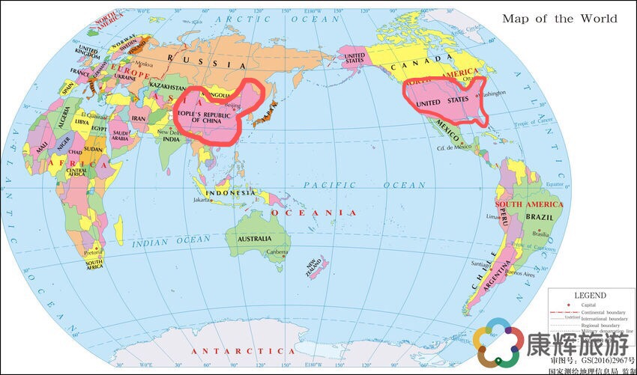  By comparison ,students will know that  China is in the east of Asia；  The United States is in the central North America.China lies in the east of the North Semisphere；  The United States is in the west of the North Semisphere.  2. show Chinese map and find out the capital, special administrative regions, four municipalities under the direct administration of the Central Government of China. The two longest rivers(Yellow River---Yellow Sea  Yangtzi River---East China Sea) and the mountain range on China-Nepal border that includes the world's highest peak (Mount Himalayas)  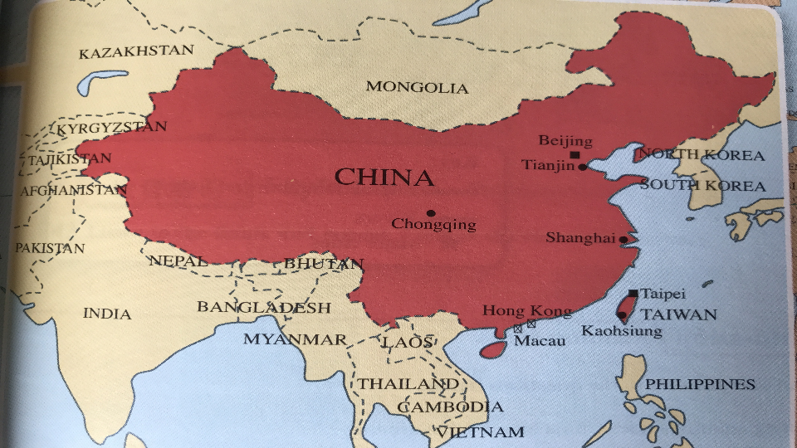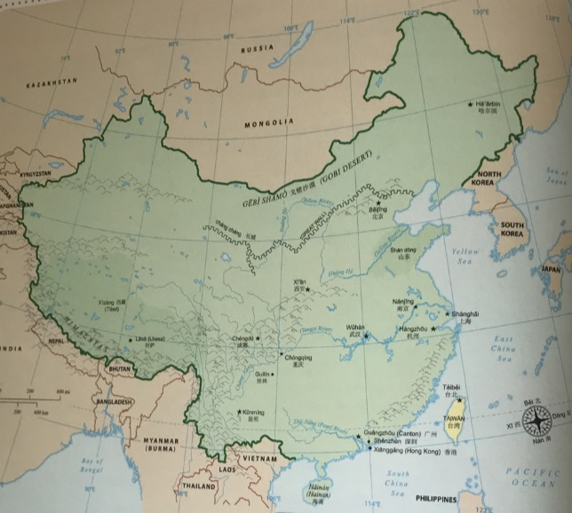  3.learn more about China by comparing it to America.  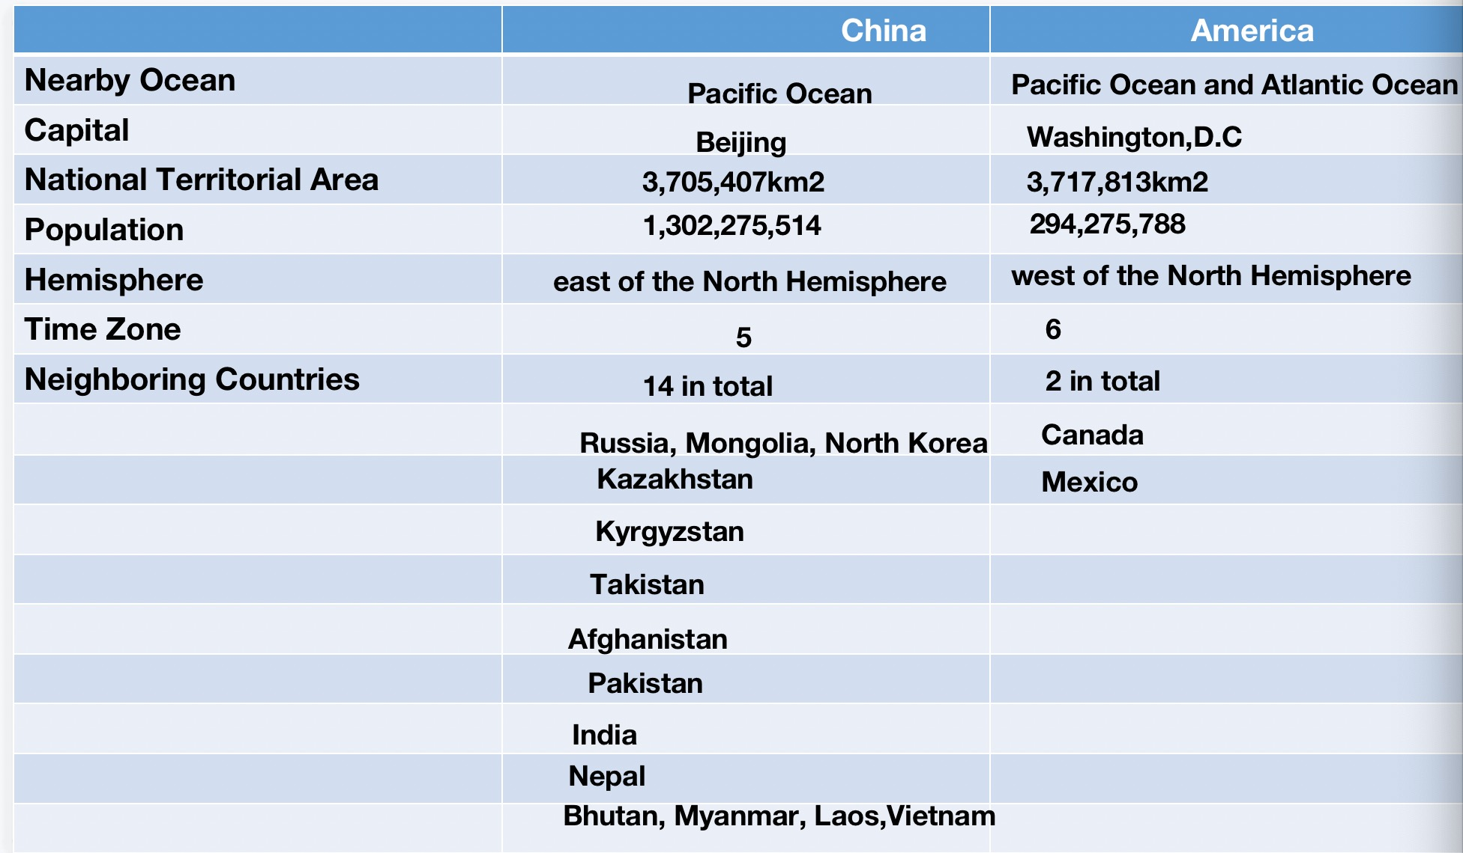  4. game time:  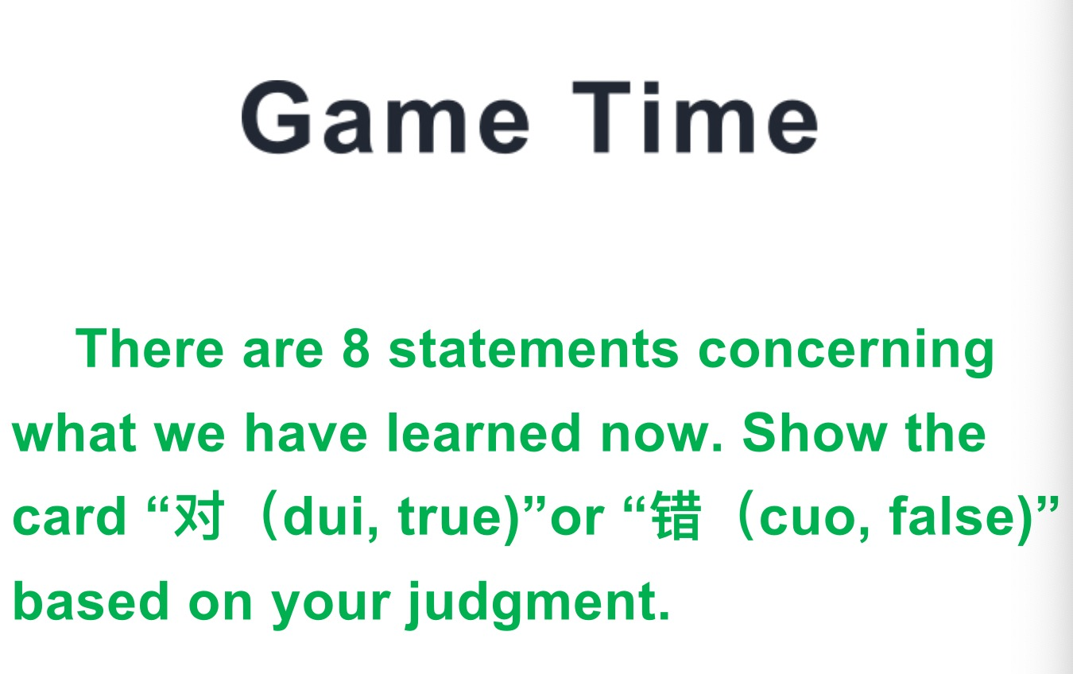  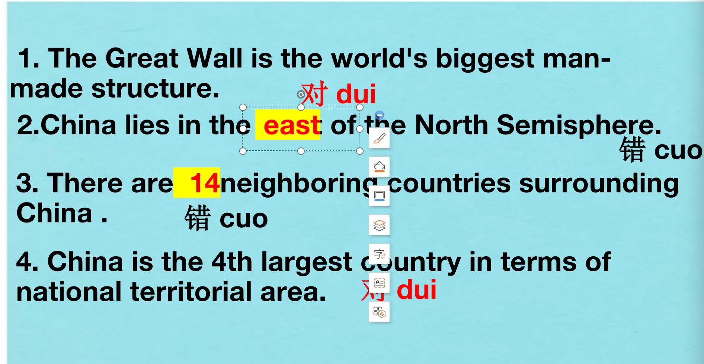  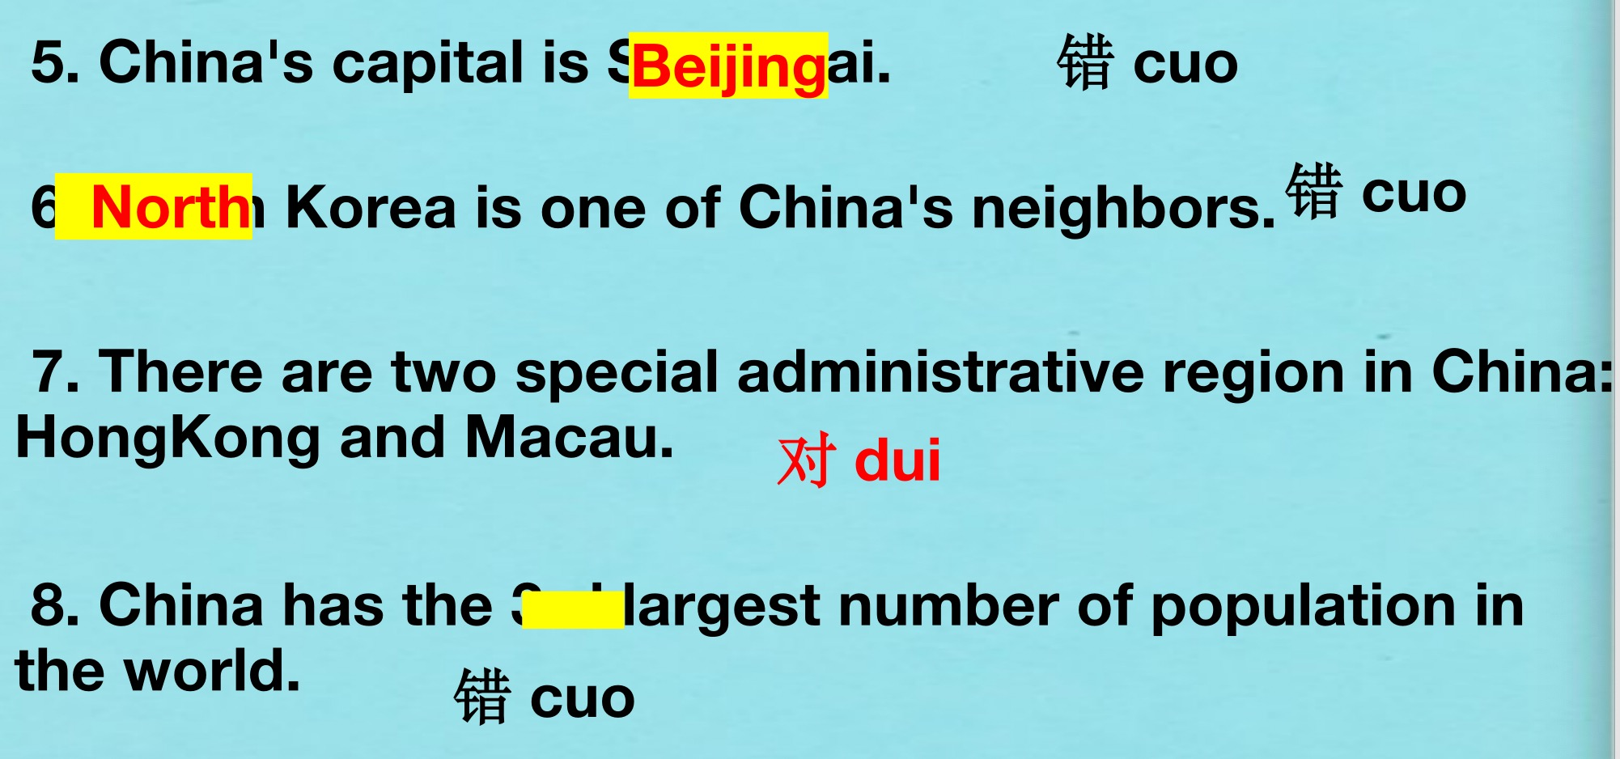 |  |  | 80 mins | A world map, a projector and powerpoint
Closing  (reflect on learning) | - Have students return to their seats and clean up their things and collect their written work to check whether they have mastered the target language point in this lesson. |  |  |  | A map  Pens or pencils  Camera
Teacher’s Notes and Reflections | There are a LOT of activities in this lesson, and some of them may be too simple for some students, depending on their background, so check in with students regularly to see how they are feeling. If they are bored, skip to the more productive activities, but if they are struggling or taking a long time, you can save time but changing the talking circles activity into a turn-and-talk (to a partner) activity.

