- PINYIN
Each Pinyin consists of two parts: the letters(initial + final )and one tone
Initials(sheng mu): b p m f d t n l g k h j q x
zh ch sh r z c s
Finals(yun mu): single a o e i u ü
double ai ei ui ao ou iu ie üe er an en un ang eng ing ong
4 tones ― ∕ ˇ \

Practice: Listen to the teacher reading and order the following Pinyin from 1 to 15.
ao _______ a:___________ ou___________ ei:___________ e:_________
jie________ que_____________ xiu__________ tang__________ zhang:______
zǎo shang hǎo !______________ wǎn ān !_______________ xiè xiè !_______________
duì bù qǐ !______________ nǐ jiào shén me?______________

II. All the Characters We’ve Learned This Term

Numbers & Family members
一 | 二 | 三 | 四 | 五 | 六
七 | 八 | 九 | 十 | 我 | 我的
爱 | 家 | 爷爷 | 奶奶 | 爸爸 | 妈妈
叔叔 | 阿姨 | 哥哥 | 姐姐 | 弟弟 | 妹妹
Practice: Translate the following sentences into English
- 我爱我的家：______________________________________
- 我的弟弟爱我的爷爷：______________________________
Write down the following number in Pinyin
12__________________ 20:_______________ 37:___________________ 56:________________

III. Time and Date

1. YEARS – in the date, the year comes first.
To say and write the year in Chinese, first write the numbers and then the word “year.” Year: 年
Practice:
2009 ______________________________________________

1995 ______________________________________________

1776 ______________________________________________
2. MONTHS – in the date, the month comes after the year.
To say the name of the month, write the number of the month and then the word “month.” Month: 月
Practice:
 |  | 
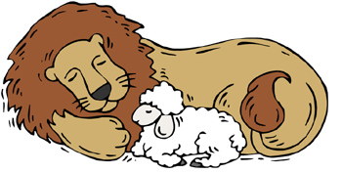 |  | 
 |  | 
 |  | 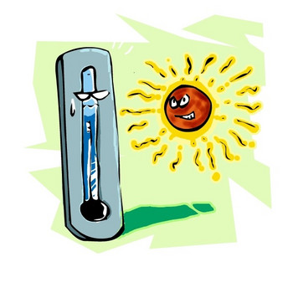
 |  | 
 |  | 

3. DAY OF THE MONTH – in the date, the day of the month comes after the month.
To say the day of the month, write the number followed by “号 – hào”
Practice:
September 6, 1492 ____________________________________________

May 18, 1804 ________________________________________________

November 24, 1859 ____________________________________________

June 23, 1914 ________________________________________________
4. DAY OF THE WEEK – in the date, the day of the week comes after the day of the month.
To say the day of the week, write “xīng qī - 星期” followed by the number of the day – EXCEPT FOR SUNDAY!!
Practice:

Monday _____________________
Tuesday _____________________
Wednesday _____________________
Thursday _____________________
Friday _____________________
Saturday ________________________

Sunday ______________________
5. TIME OF THE DAY – the time of the day goes after all the BIG TIME elements in a sentence
Hour
The hour of the day is followed by minutes, just like our culture. The word “diǎn 点” comes after the hour. The word “fēn 分” follows, indicating the number of minutes that have passed since the hour.
Practice:
1:10 _________________________________________

3:27 _________________________________________

12:20 ________________________________________
Just like in our language, when there is a zero and then a number in the minutes of time, Chinese people add an “oh”, which they write as ○ (ling).
Practice:
12:07 ________________________________________

6:05 _________________________________________
6. USING 几
In order to ask the time or the date, we use our old friend “几 jǐ – how many.”
THE TIME OF THE DAY
To ask the time of day, we say,
jǐ diǎn? (literally, “how many hours?”)
or we could ask,
xiàn zài jǐ diǎn? (literally, “now, how many hours?”)
THE DAY OF THE WEEK
To ask the weekday, we say
今天 星期几？（Literally, “today, what weekday?）
THE DATE
To ask the date, we say,
jǐ yuè jǐ hào? (literally, “what number month, what number day?”
Or you could ask,
jīn tiān jǐ yuè jǐ hào? (literally, “today what number month, what number day?”
Practice:
Practice:
What’s the date tomorrow?__________________________________
What’s yesterday’s date?____________________________________
THE BIRTHDAY:
To ask about somebody’s birthday, the question will be: sb.+的+生日+是+几月几号？
Practice:
When is your birthday?_________________________________________
When is his birthday?__________________________________________
THE AGE
To ask for people’s age, we say: sb+ 几岁？
Practice:
How old is he?___________________________________________________________
How old are you?_________________________________________________________
Write down your age in Pinyin sentence:______________________________________
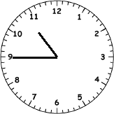
Review Exercise for Time Telling Test
Q: _________________________________? A A: ________________________________.
Dates Practice
Tomorrow is Sunday, Dec 24, 2009 _____________________________________
Today is Wednesday, December 9, 2006_________________________________
Yesterday is Friday, August 19, 1945____________________________________
IV. Ask for names and Nationality
1. NAMES

To ask for names, we say:
你叫什么？（literally, you are called what?）
他叫什么？ (Literally, he/she/it is called what?)
Write down the question to ask for your name and give an answer accordingly
Q: ________________________________________________________?
A:_________________________________________________________.
2. NATIONALITY

we also learned how to ask and answer questions about nationality. Remember! Nationality questions translate literally to “You are which country person?” Where “which” is the question word.

Nǐ shì nǎ guó rén? ___________________________________________

Wǒ shì měi guo rén. ___________________________________________

Nǐ shì nǎ guó rén? ___________________________________________

Wǒ shì zhōng guó rén. ______________________________________

Tā shì nǎ guó rén? ___________________________________________

Tā shì ying guó rén. ______________________________________

Tā shì mò xī gē rén。 ______________________________________

As with identity questions, we can ask if a person is a certain nationality and then have them answer.

Nǐ shì měi guó rén ma? ______________________________________

shì ，Wǒ shì měi guó rén. Nǐ ne?______________________________________

Nǐ shì yīng guó rén ma? ______________________________________
Bú shì，Wǒ bú shì yīng guó rén ______________________________________
What nationality is he? ___________________________________________
Cathy is American. _____________________________________________
Is Sylvester American? ______________________________________________
Yes, Sylvester is American.________________________________________________

V. Colors
Write down the color according to the given pictures
 |  | 
 |  | 
 |  | 
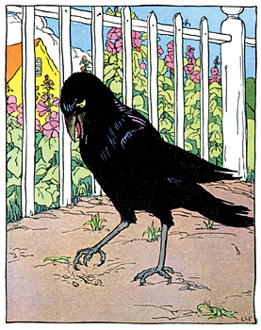 |  | 
 |  | 


VI. Zodiac animals
Write the animal names in pinyin accordingly
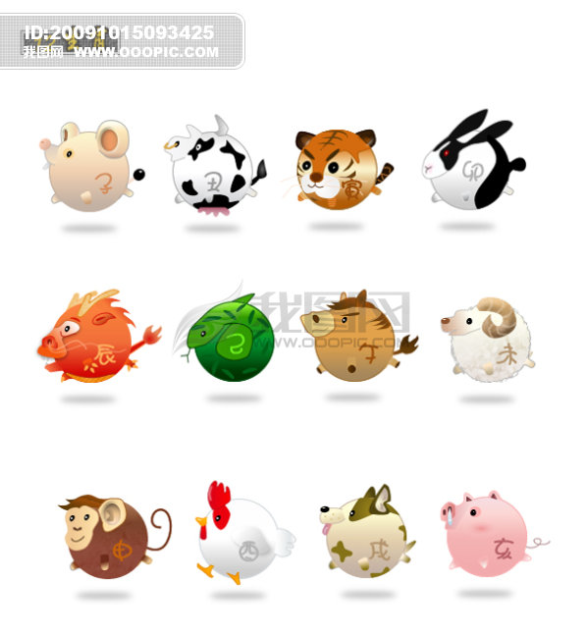
To tell people what animal we are, we say “ I +属+animal name”
Practice:
I am a tiger( by Chinese zodiac):_____________________________________________________
I love rabbits:___________________________________________________________________
He loves monkeys:______________________________________________________________
VII. About our bodies

1. Names of the body parts
1.________________________________(head)
2.________________________________(hair)
3._________________________________(shoulder)
4.________________________________(knee)
5._________________________________(feet)
6._________________________________(eye) 7._________________________________(nose)
8._________________________________(ear) 9._________________________________(mouth)
10．______________________________(hand)
2. Adjectives to describe people
To say someone is REALLY/very tall, we say “ Sb. + 很（really/very）+adj,”; To say someone
is NOT tall, we use “不(not)”in front of the adjective.

 | Adj. in Pinyin | opposite | Practice Making sentences
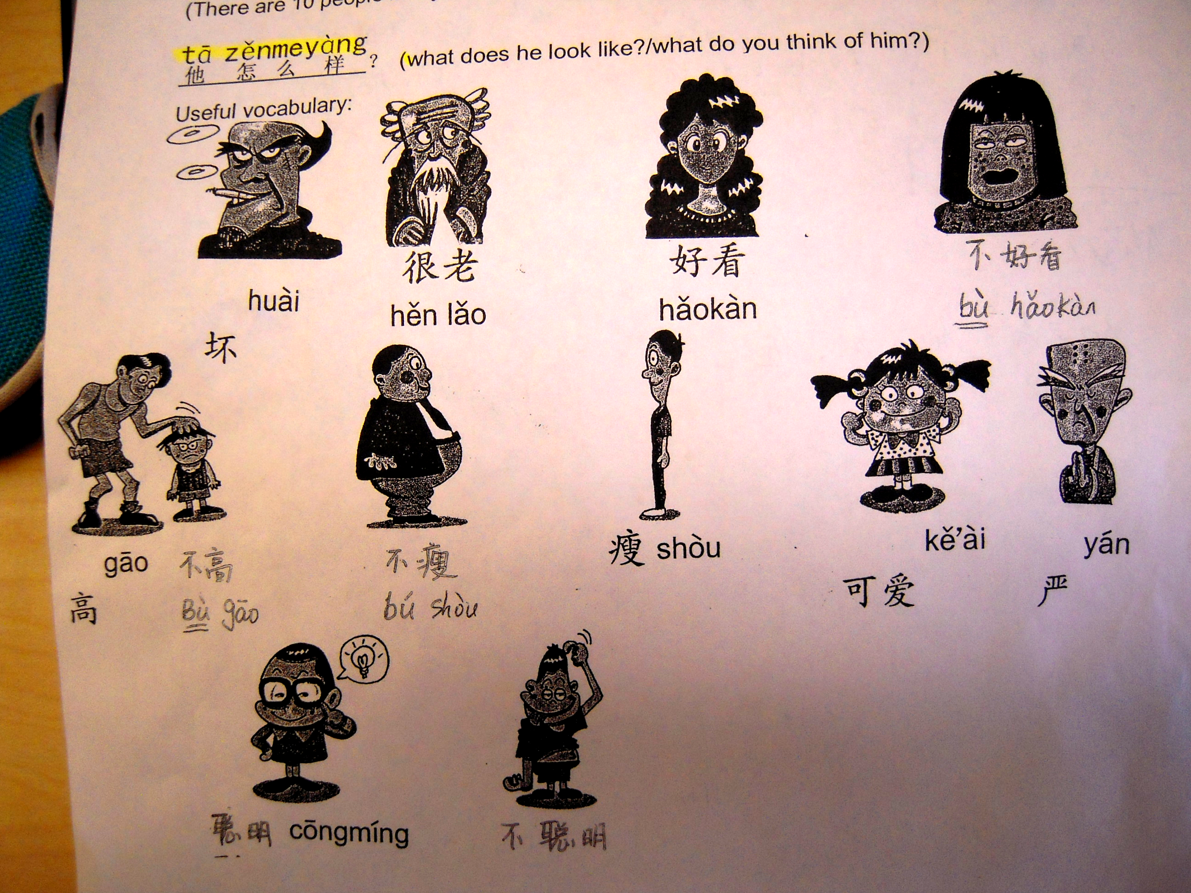 |  |  | 1. He is very bad
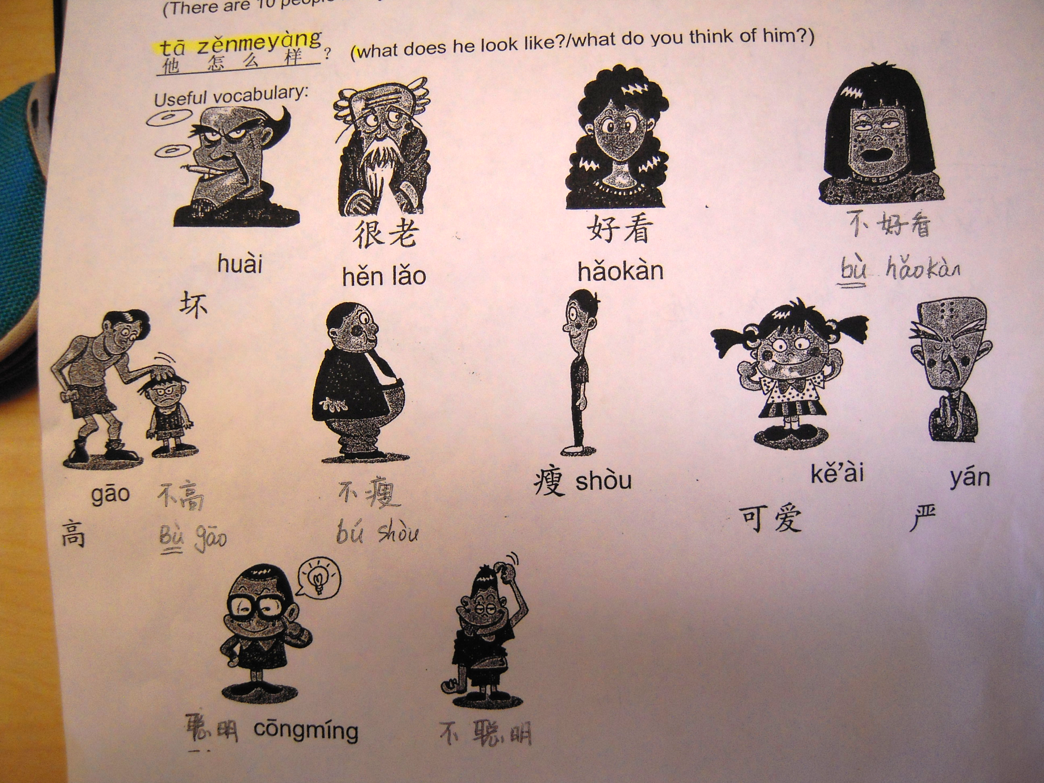 |  |  | 2. she is really beautiful
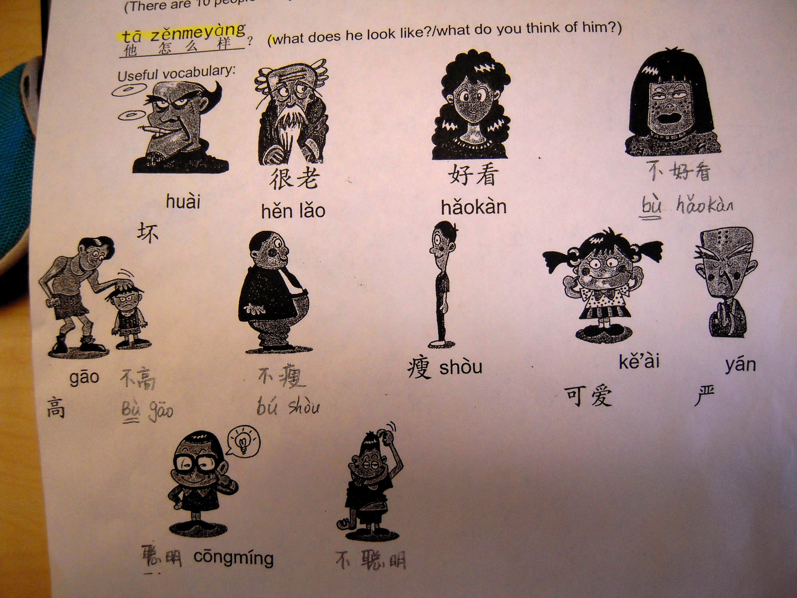 |  |  | 3. “He is NOT thin
 |  |  | 4. He is very clerver/smart
 |  |  | 5. Yaoming is very tall
 |  |  | 6. He is NOT strict
 |  |  | 7. It is very cute
 |  |  | 8. He is very old
3. Adjectives to describe People’s feelings:
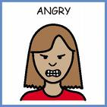 |  |  | 9. She is very angry
 |  |  | 10. It is very happy
 |  |  | 11. she is very sad
 |  |  | 12. He is very tired
 |  |  | 13. He is NOT confident
 |  |  | 14. It is very scared
4. USE OF怎 么 样
We can use “怎 么 样” to ask about people’s appearance , people’s feelings or ask about what’s wrong with somebody.
Practice:
How is he?________________________________________________________________________
He is very old._____________________________________________________________________
How are you feeling?_______________________________________________________________
I am (very)happy.__________________________________________________________________
To answer what’s wrong with someone, we say “sb+body part+痛（be in pain/painful）”
What’s wrong with you?_____________________________________________________________
I have a headache.________________________________________________________________
She has an earache:_______________________________________________________________

VIII.CONVESATIONAL CHINESE:
Please write down the English besides the Chinese sentences !
GREETINGS
早上好！
下 午 好！
晚 安！
你 好！

wǎn shang hǎo !
晚 上 好！

你 好 吗？
我 很 好.
再 见！

对 不 起！
DAILY CHINESE
谢 谢！
没 关 系！
不 客 气！

请 安 静！
请坐！

老师好！
明 天 见！
CLASSROOM CHINESE
同学们好！
上 课！
下 课！

