First Assessment Test (October 2015)
Ana Esmi ……………………………. Arabic Elective A / B Date: Teacher: Ms Kasab
1-listen and number the pictures as you hear:

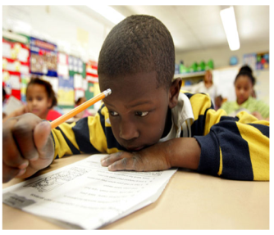
(2) Look, listen and circle the right picture:
1-

3-

4-

3- Match the question to its answer:
- Maza ta’mal? a- Ana Amerikia
- Ma esmoki? b - Fi Staten Island
- Ma Gensitaki? c - Ana Telmiza
- Kam Omork? d -Ana Esmi Kia
- Aina Ta’aish? e - arbat ashr aam
f- Ana Telmiz

4- Handwriting (Write your name in Arabic, start from right to left)
……………………………………………………………………………………………….
5-Translate the questions into Arabic (You can write in English letters)
- How old are you to a female?
………………………………………………………………………………………
- What is your nationality to a boy?
………………………………………………………………………………………
- Where do you live to a girl?
…………………………………………………………………………………….
- What is your name to a boy?
…………………………………………………………………………………….
- Hi or Hello
…………………………………………………………………………………….
6 – Translate the following sentences into Arabic:
- You are Ms Kasab.
…………………………………………………………………..……..
- He is a student.
……………………………………………………………………...
- She is a child.
…………………………………………………………………….
- I am American.
…………………………………………………………………………
- I live in the United States.
………………………………………………………………………….

