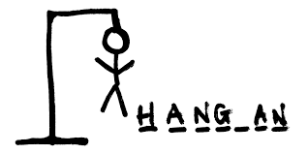 Finish the Pinyin of the hangman sentence and write down the characters.
名字： 月： 日：
1. about places at school
z s e s g n
Chinese characters:

2. about subjects:
s g u
Chinese characters:

3. about subjects:
w h z n
Chinese characters:

Finish the Pinyin of the hangman sentence and write down the characters.
名字： 月： 日：
1. about places at school
z s e s g n
Chinese characters:

2. about subjects:
s g u
Chinese characters:

3. about subjects:
w h z n
Chinese characters:

