Chinese Language and Culture Lesson Plan
Teacher: Liu Lina
Grade Level: 2nd and 3rd grade
Topic: Feelings and Emotions
Objectives :By the end of this lesson, students will be able to (SWBAT) describe their feelings and emotions by a short sentence, for example: 我很开心；我有点饿。

Student work
Interpersonal | Presentational | Interpretive
- Students can introduce their friends to others using the sentence: ___是我的朋友。  - Students can answer the question”你今天怎么样？” using the sentence with words of feelings and emotions, for example: 我很开心。 | - Students can write down the words of feelings and emotions on the “flower” that works as a vocabulary card.  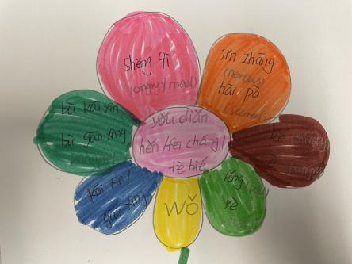  - Students can introduce their friends to others. | - Students can tell others their feelings and emotions with the help of the flower.

Domains of Language
Listening | Speaking | Reading | Writing
- Vocabulary:  Group1: 开心 高兴  Group2: 不开心 不高兴  Group3: 生气  Group4: 紧张 害怕  Group5: 渴 饿  Group6: 冷 热  2 sentences：  - 谁是你的朋友？  - ____实我的朋友。  - 你今天怎么样？  - 我很开心。 | 1.Vocabulary:  Group1: 开心 高兴  Group2: 不开心 不高兴  Group3: 生气  Group4: 紧张 害怕  Group5: 渴 饿  Group6: 冷 热  2 sentences：  (1)谁是你的朋友？  (2)____实我的朋友。  (3)你今天怎么样？  (4)我很开心。 | - Vocabulary:  Group1: 开心 高兴  Group2: 不开心 不高兴  Group3: 生气  Group4: 紧张 害怕  Group5: 渴 饿  Group6: 冷 热  2 sentences：  (1)谁是你的朋友？  (2)____实我的朋友。  (3)你今天怎么样？  (4)我很开心。 | 1. write down these vocabulary on their “flower”  (1) wǒ  (2) yǒu diǎn  Hěn  fēi cháng  tè bié  - gāo xìng kāi xīn  bù kāi xīn bù ɡāo xìnɡ  shēng qì  jǐn zhānɡ hài pà  kě è  rè lěng
Evidence of Learning – Assessment
Informal or Formal
- Students can answer the question: (1)谁是你的朋友？(2) 你今天怎么样？
- Students can introduce their friends to others in the sentence: __ 是我的朋友。
- Students can show their feelings and emotions with the help of the “flower”.
Teacher modeling of Communication followed by Student’s structured practice
Message Functions/Structures | Key Vocabulary/ Phrases | Strategies for Oral Practice
- -- 谁是你的朋友？  -- Leo 是我的朋友。  - -- 你今天怎么样？  -- 我很开心。 | - 朋友  - Group1: 开心 高兴  Group2: 不开心 不高兴  Group3: 生气  Group4: 紧张 害怕  Group5: 渴 饿  Group6: 冷 热 | - Ask and answer the questions;  - Make a short dialogue with desk-mates;  - Make the presentation with the help of the “flower” to show their feelings and emotions.
Technology:
Classroom Activities:
- Review: we will use some pictures for example a red apple to combine the words of color with the words of fruits together to describe some colorful things. And then we use the sentence that we have learned to share something with others: 我有...。For example: 我有红色苹果；我有黑色剪刀（I have an red apple; I have a pair of black scissor.）。
- Learn new words: (1) pictures: I will show pictures or meme to help the students know the meaning of the words;(2)Games: I will say the words in silence and the students will guess what I was saying and the students do this one by one.
- Practice: students write down these words and the sentences on the “flower” to help them connect these three parts into a short sentence to show their feelings and emotions.
Extend the Learning: School-Home connection
Students can color the flower with their favorite colors and show their feelings and emotions to their families with the help of the “flower”.

End with Closure Activities
Exit Slip:
The students can make a presentation to show their feelings and emotions and even more they can talk about others’ feelings and emotions with the help of the “flower”.

