Family Tree
Time:30 minutes
Renaissance Academy November 7 2011 2nd Grade

Objectives : | by the end of the lesson Ss. Will be able to:  - Identify all the family members.  - Introduce their family members.
Teaching Aids | The projector, a power point presentation of my own family tree
Warm Up (10 min.) | - I’ll ask them to sing ommi ommi song  - Then I’ll introduce the word tree in Arabic using a picture of a tree and say shagara and ask them to repeat…..i’ll show them a family tree and say the word shagarat al aela (family tree).  - I’ll draw a boy and a girl on the board…point to the boy saying haza walad, pointing to the girl saying hazehi bent…  - I’ll point to different boys and girls in the class and encourage them to say haza (name) or hazehi (name)
Key Structures and Vocabulary: | Haza, hazehi, ammi, amati, khali, khalati  Review: abai, ommi, akhi, okhti, ana
Presentation:  (10 min.) | - on the power point presentation I’ll show them my picture and say haz and pause for them to complete braise the ones who replies correct repeating hazehi ana…the next slide me and my father they will say haza abi, next hazehi ommi, haza gadi, hazehi gadati, haza akhi, hazehi okhti. Then I’ll introduce 3ami and 3amati, khali and khalati….i may stop by reviewing only the members of the family that they olready know and do an activity and I can introduce the new family members the next day according to my students level and participation
Practice (15 min.)

Activity 1 (5 min.) | I’ll show them a slide of the power point presentation that has my family members . I’ll play fly sweater with them…ask two students to come to the board and they will compete each other when I say haza (family member) they should hit it quickly and then another pair, and so on.
Activity 2 (5 min) | I’ll divide the class into 3 groups. Start with the first group asking one student to come to the front facing the board and looing to my family tree, I’ll stick a picture of one of my family tree members, he has three trials to guess by saying haza (and any one of the family members) each time he guess the other students say (na’am or la) according to the answer. His team wins a point only when one of his guessing is correct. And so on until the end of the period.  (Note: I won’t spend time explaining what we are going to do in the game because the students are already know this game from previous lessons)

Name:……………………………………………………….. grade: ……………. Mark:………………….
Activity 2:
Listen and circle the right fruit:
1-
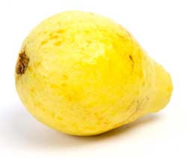
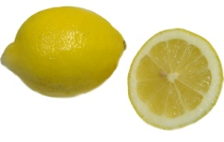
2-
3-
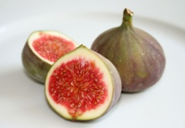
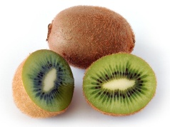
4-
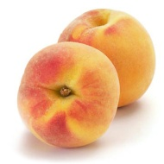
5-
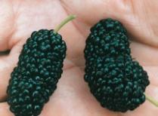
6-
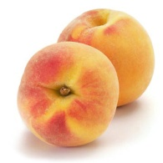
7-
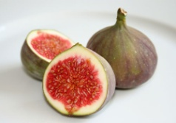
8-
9-
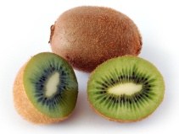
10
