Backward Design Lesson Plan Template

School: Learning Community Charter School

Teacher Chunxia Li Grade level 6th&7th grade

Lesson title 今天天气怎么样 What’s the weather like today?

Step 1—Desired Results
Standard Outcomes for Learning (ACTFL Standard 1.1)—Answer’s the question, what should students know, understand, and be able to do as a result of the lesson?
- Students master the basic vocabulary about weather phenomena.
- Students can talk about the weather and give a presentation of weather forecast.

Step 2—Assessment Evidence
Performance task—What will students do to show what they have learned?

- Ss say the weather phenomena that match the pictures.
- Ss work in pairs to prepare and give a presentation of the weather today, tomorrow, and the day after tomorrow.

Step 3—Learning Plan
Learning activities - Answer’s the question, how do I teach it?
- Teacher teaches students how to say basic words about weather. T uses pictures to represent different weather.
- Competition 1：Each student is allowed 1 minute to point at the pictures and say their meanings in Chinese. The one who does the most wins.
- Competition 2: Heads up
Ss work in pairs and take turns to translate what they see in Chinese into English. The pair that gets the most in 2 minutes wins.
- Students practice conversations by using the structure:
A：今天天气怎么样？
B：今天天气不好。今天有雪。

- Students work in pairs and make a weather forecast for today, tomorrow and the day after tomorrow. The format is as follows.

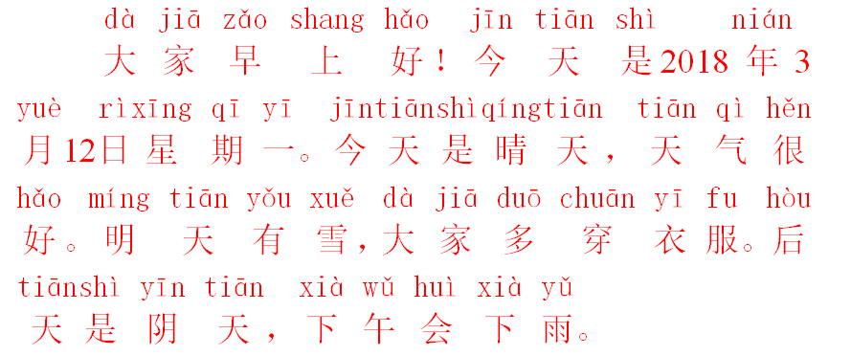

Step 4—Reflection
What happened during my lesson? What did my students learn? How do I know? What did I learn? How will I improve my lesson next time.
- Students learned how to talk about weather in Chinese.
- In order to use 有 and 下correctly in weather expressions, students need to have more practice.

Adapted from Tomlinson and McTighe, Integrating Differentiated Instruction + Understanding by Design, ASCD,

