Capstone Project of Scioto Darby Elementary School
The Capstone Project of Scioto Darby Elementary School was called Chinese Traditional Festival Curriculum. There are many traditional festivals during a year. Mid-Autume Festival, Spring Festival, Lantern Festival, Qingming festival and Dragon Boat Festival are the main ones. In the Curriculum designing there are many interesting activities.
For Mid-Autume Festival, firstIy students learned the story of Change and Houyi. Then they had a homework of finding the shadow of Change and Yutu from the sky. Lastly, I managed to get free moon cake as donation from an Asian Market. Every student and teacher and some parent volunteers tried a piece of moon cake on the very Mid-Autume day.
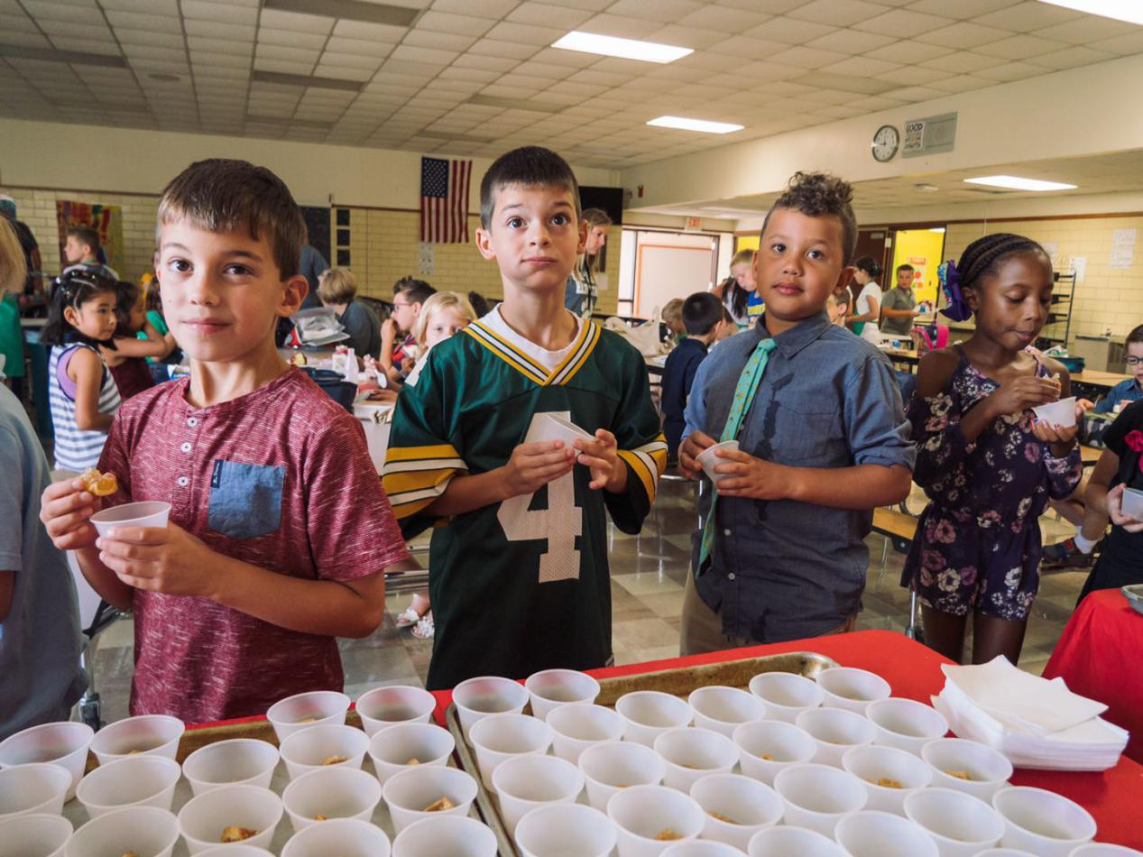
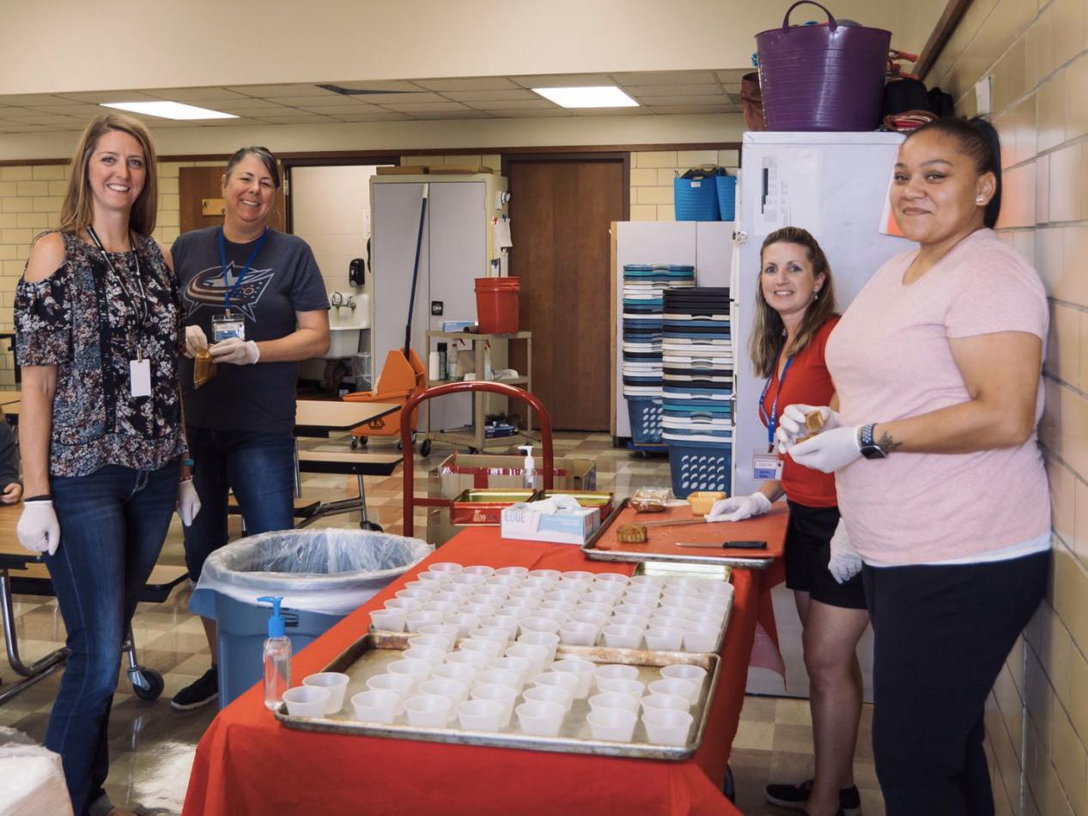
For Spring Festival, Firstly students had homework of finding information of the festival. Then they shared the information in the class. Students learned from each other. After that, they learned the traditions of food to eat, costume to wear, lucky money, 12 Zodiacs and so on. Then we played traditional games like Chinese jump rope and paper cutting.
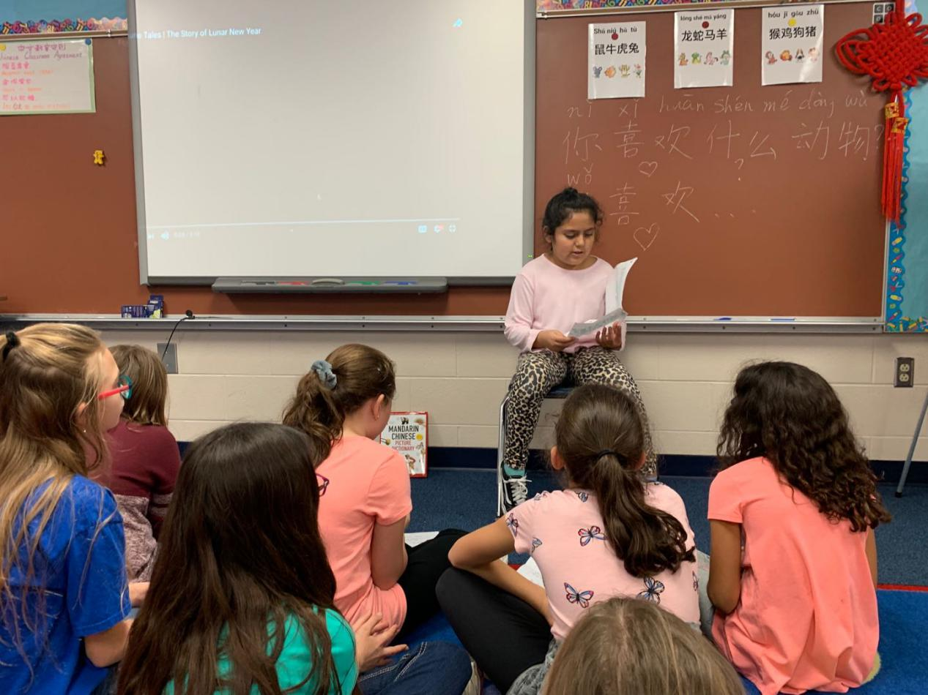
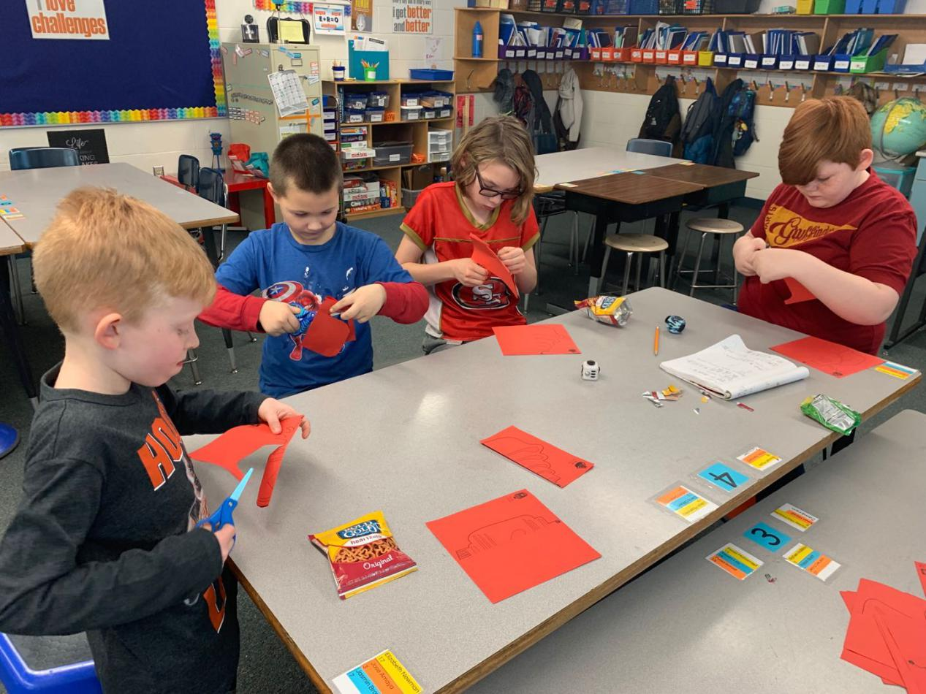
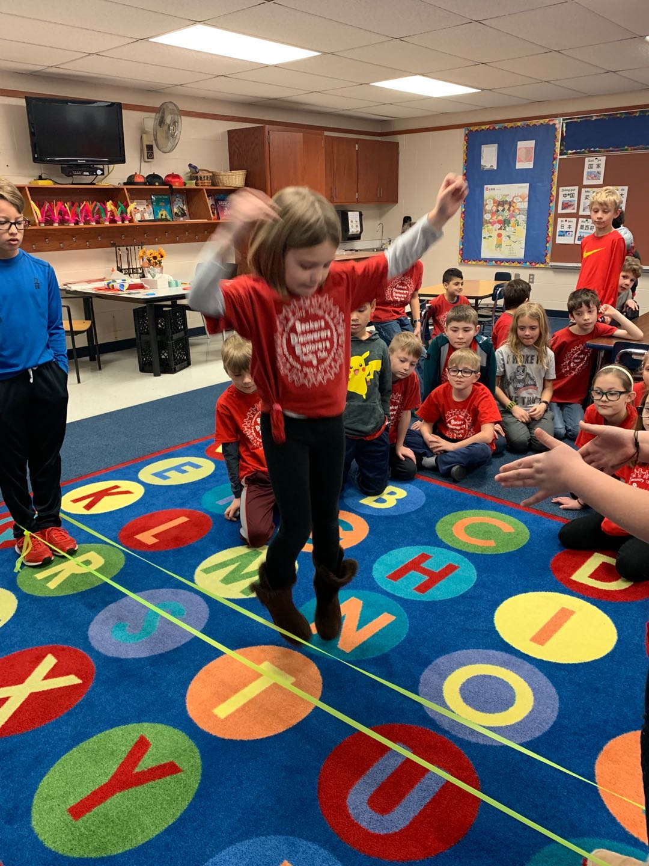
All the students and teachers in my host school were involved in the curriculum. I wrote some fortune Fu characters for teachers and students. They can put them on the doors or walls of their classrooms or houses. I believe they had deep impression of Chinese festivals.
