Capstone Project
Chinese Spring Festival Exhibition
Abstract：Festivals are the important part of the culture. Spring Festival is the most important festival in China and there are a lot of customs that helps the students learn more about the Chinese and Chinese culture. There are three sections about the project. Before the Spring Festival, students learn why the Chinese people celebrate the Spring Festival and how the Chinese people celebrate it. During the Spring Festival week, the students will make different handcrafts in groups. They will experience the Chinese traditional culture by making drawing, paper cutting and designing plates. The teacher collects and reorganizes all the works after that. The last session is the exhibition. We post all the works on the wall of the Chinese classroom. It is a good way for the teachers and students in Mesita to have a good knowledge of Chinese Spring Festival.

Section 1: January 1 --- January 28
Before Spring Festival, the students mainly learn traditions about the Spring Festival. We learn the Chinese zodiac animals, Chinese New Year songs, the paper cutting, the story of Nian and the story of dumplings. So the student have a good knowledge of why the Chinese people celebrate the Spring Festival and how the Chinese people celebrate Spring Festival.
During this part, the student can have overall idea of the Spring Festival.
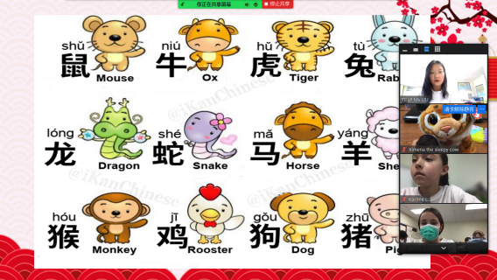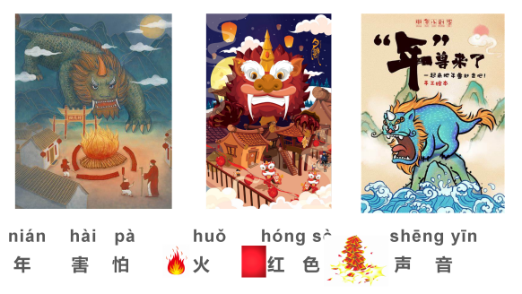

Section 2: January 31 --- February 11
During the Spring Festival week, the second graders drew tigers because of the year of the tiger. There are two projects for the third graders. The first project is the paper cutting. All the third graders make paper cutting by themselves. And the second project, all the third graders are divided into four groups and they have different work related to the Spring Festival to do. After the that, all the works from second graders and third graders are collected and reorganized to make the posters.
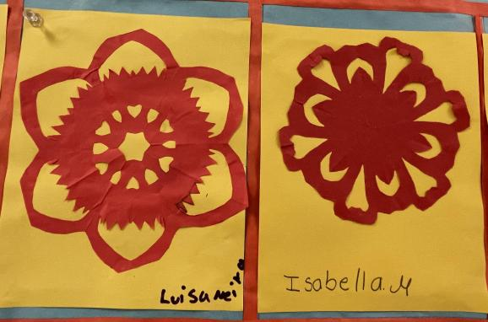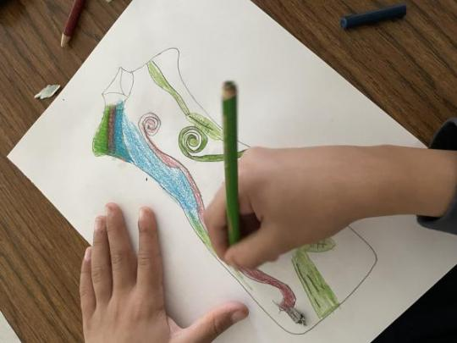
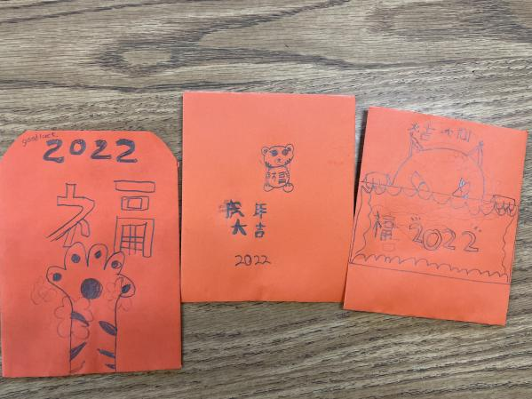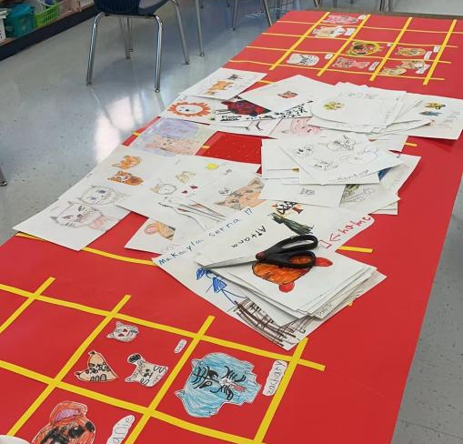

Section 3: February 15 --- March 31
All of the poster are posted on the wall of the Chinese class as a exhibition. It is a good way for the teachers and students in Mesita to have a good knowledge of Chinese Spring Festival.
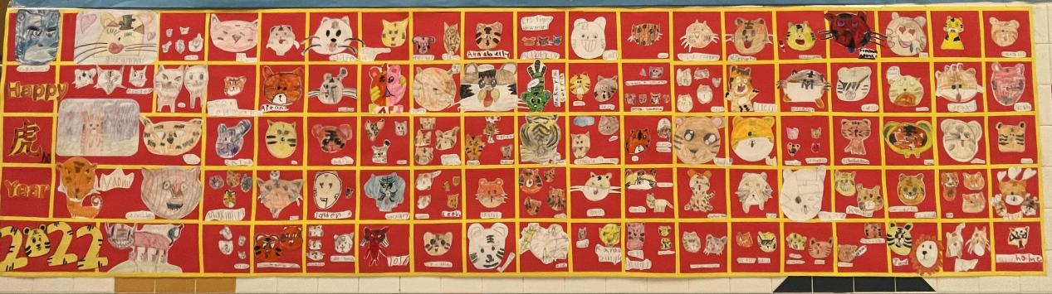
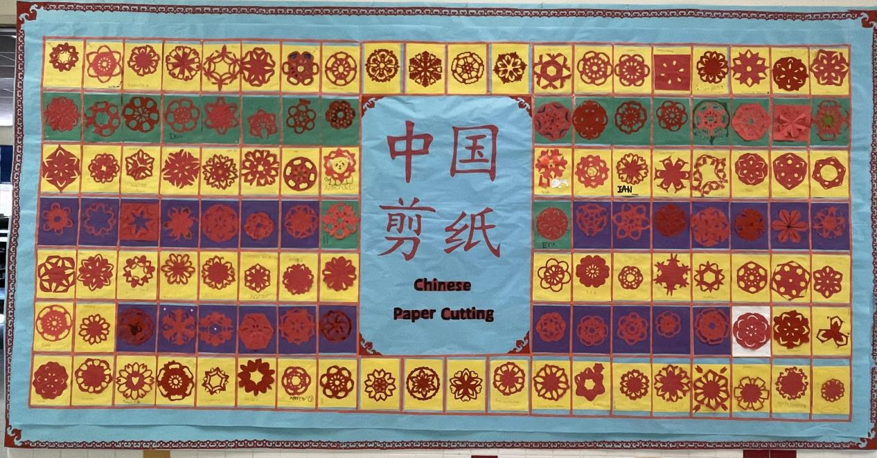
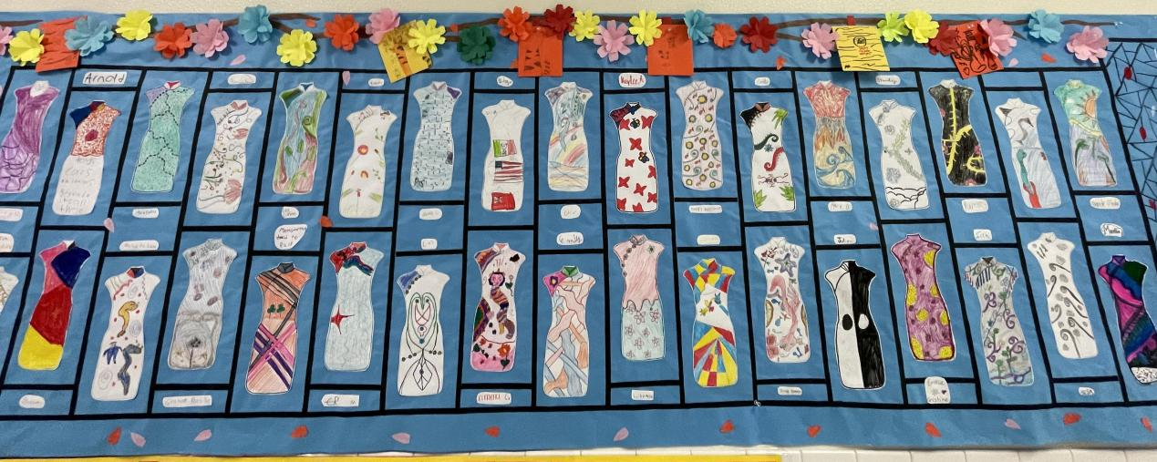
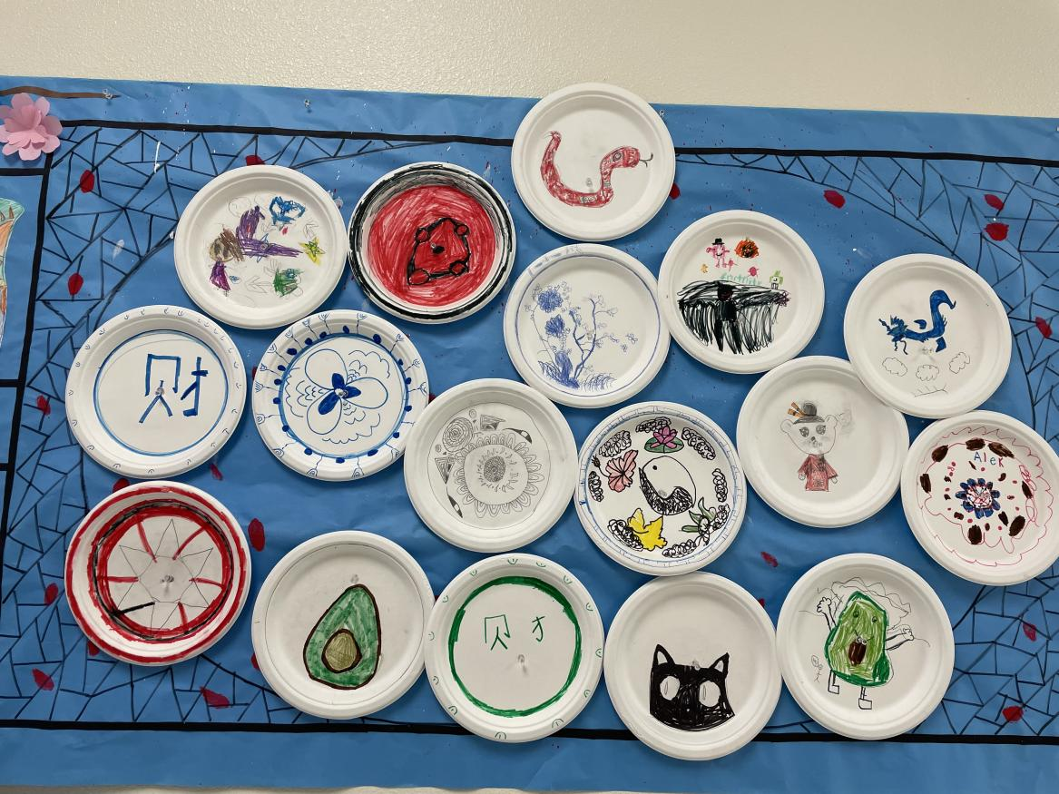

Reflection:
Spring Festival is the most important festival in China and there are a lot of traditions related to the Chinese culture. It is a little hard to introduce all the history, and the special meaning. Also, the are a lot of differences because of the development of the society. Due to the pandemic, we have classes on zoom, so I have to divided the students into different groups and each group finishes one part of the project. Not all the students have a good experience of making dumplings, designing Qipao. But all the students did a great job.
As for me, I was worried at first because I couldn’t go to class in person and we had to finish all the project on zoom. But it turned out that we could do it if there was a detailed plan.

