EMMS Chinese Class Yearbook
——Sun Quanfang
This project showed how well the students have learned about the critical language, Chinese, and students in the lower grades would get more motivated to learn the language. Also, the students’ good memory and experience of this year helped develop their interest in learning Chinese, thus leading to the increased number of students choosing Chinese as elective class in high school.
While conducting activities, I learned to conduct activities not only fun, interactive, but also culture and language-related so that students can learn through playing, which changed my concept of teaching from teacher-centered to student-centered. And while I helped students design the yearbook, I chose to let them do retrospect first, which laid a solid foundation for the outcome of the yearbook.
This project was an overall success. During the process of conducting different activities, students enjoyed a lot of fun. After the yearbook came out, students and teachers were excited to read the Chinese Yearbook and were very impressed that we made such a well-designed book to summarize the whole year.

Activity 1: 09/21/2021-09/22/2021 Mid-Autumn Festival Celebration
Dressed myself in Hanfu, I got the materials I bought in Chinatown ready and celebrated the Mid-Autumn Festival with the students in Chinese class the day before the festival and made mooncakes with culinary class students the day after. Activities conducted today included: writing greeting cards in Chinese, using Oreo to present the lunar phase,making mooncakes, making lanterns and enjoying the delicious mooncakes.
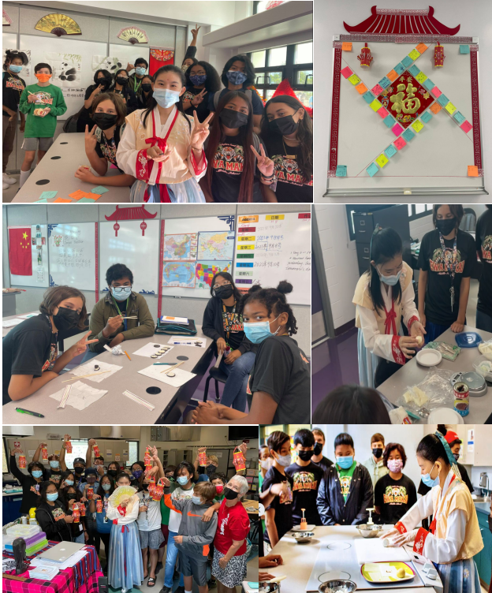

Activity 2: 11/19/2021 International Education Week
Students in my Chinese classes who have diverse cultural backgrounds like China, Philippines, Japan, Korea, Vietnam, Somoa, Jamaica, Germany, etc. taught their classmates some words and phrases in their cultures.
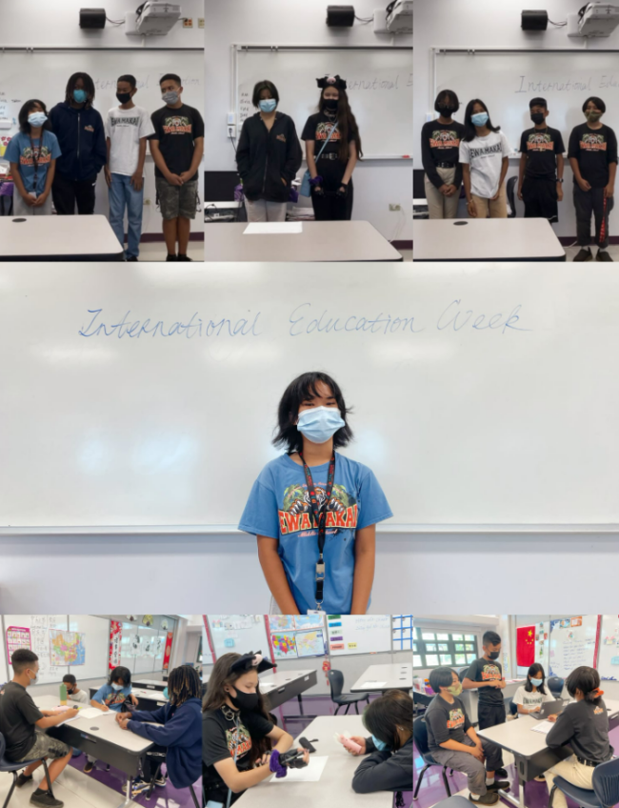
Activity 3: 02/02/2022 Chinese New Year Celebration
For the Lunar New Year celebration, we celebrated by making dumplings and decorated the whole classroom and put on performances for the whole school. 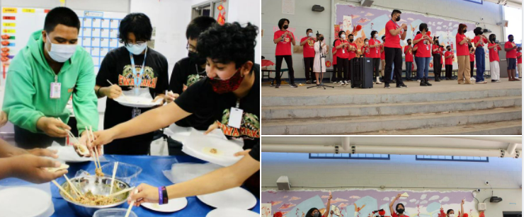

Activity 4: 02/15/2022 Lantern Festival Celebration
On the Lantern Festival, people usually celebrate it by eating Tangyuan or Yuanxiao (glutinous rice balls), guessing lantern riddles, and enjoying lantern shows. As a celebration, we made Tangyuan and lanterns.
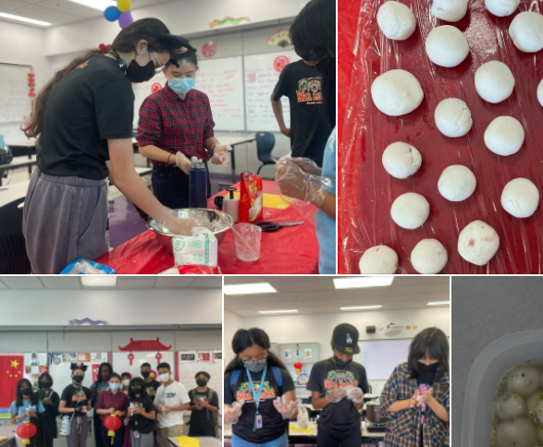
Activity5: 02/22/2022 HAMLE (Hawaii Association of Middle Level Education) 2022 conference
I presented with my mentor Ms. Leeann Manuel and three of my students(Dean, Jada and Erique) in the breakout session " Journey to the East and the West".
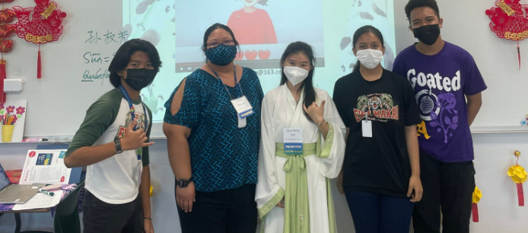

Activity6: 03/16/2022 Multicultural Festival to be held in virtually and globally by JCHS
The students, at the invitation of the World Language Department Head of James Campbell High School, came up with ideas and did a presentation about China by wearing Chinese traditional clothes and showed how well they understand China from different aspects.
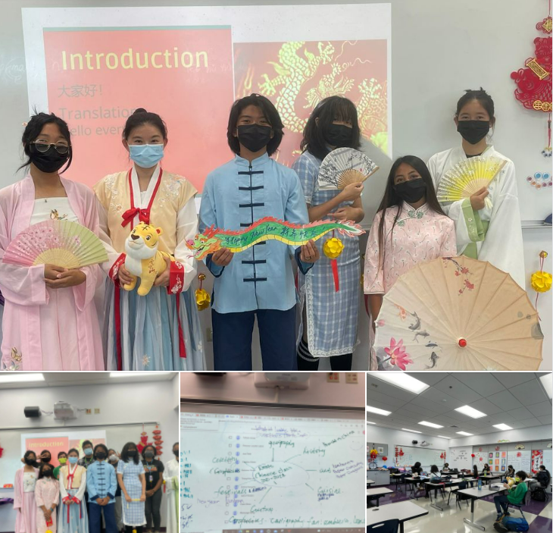
Activity6: 04/20/2022 Culture Appreciation Week & International Chinese Day
My excellent students dressed in Chinese traditional costume put on the show including singing, classical & modern dance, guitar playing and Kung fu.
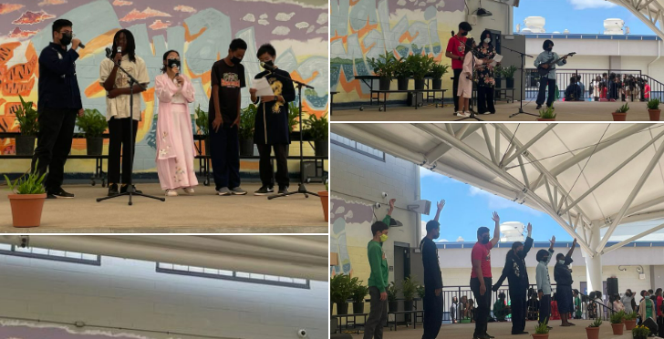

- Digital Media We Created as our Chinese Yearbook
EMMS Chinese Class Yearbook (canva.com)EMMS Chinese Class Yearbook (canva.com) ( PDF Edition)

