School: Thomas Edison language Institute

Teacher: Abdelilah El Alaoui Grade level: 6th _8th

Lesson title: Body parts in Arabic

Step 1—Desired Results
By the end of the lesson, students will be able to:
- Communication:
- Recognize body parts in Arabic
- Describe their hair. Eyes’ color in Arabic
- -Ask and answer questions about their body shape .
- Cultures:
- Students will know about thnic groups in Morocco .
- Communities :
- Students use ‘Classroom screen’ to draw an avatar and name its bodyparts
Vocabulary :
Eyes. Head, face, mouth, nose, legs, feet, chest, shoulders in Arabic
Structure
My eyes are blue etc My hair is black etc
I am tall/ short etc

Step 2—Assessment Evidence
- Students will say the body parts s correctly
- She students will ask /answer questions about their body parts
- Students will do the bing game
- Students will answer questions of the jeopardy game
- Students will watch a video and answer the questions ( handout/worksheet)

. 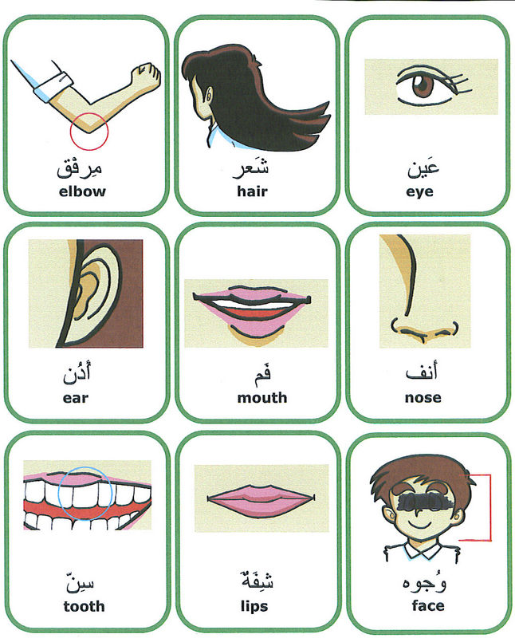

Step 3—Learning Plan
- Preparation and materials:
- A laptop to play a /video
- Flashcards of body parts
- Datashow
- Internet for videos on youtube
Warm-up: (5 mins)
- T writes the lesson topic and the learning objectives .
- T begins the lesson with an ice breaker : a Moroccan dance ( move your legs etc)

Activity 1: presentation ( 5min)
- T shows the SS photos of three strange creatures
T asks SS to elicits the topic of the lesson
T presents the words of the body parts in Arabic
T asks the students to repeat the words
SS repeats the words silently to feel confident
Activity 2 (practice 10min)
T displays photos of body parts
T asks SS to say the words if they can
T goes over all the words again to make sure that the students know them
Activity 3: (production 15)
T asks students to step out in pairs .
T asks SS to use their chrome books and log in
SS use ‘CLASSROOM SCREEN’ application to draw body parts
SS ask each other questions about their eyes and hair using the
Is your hair black ? What color are your eyes

Activity 4: ( 15 min )
T draws avatars on posters and hangs them on the classroom wall.
T divides students into teams and asks them to benchmark the posters( each member of the team will have a role such as leaders , reporter etc )
T competes to gain the points to be the winners and the group with high points will be awarded tickets for ice cream /drinks
T assigns a mini project to students and explains the objectives
T and SS makes an outline for the mini project
SS will know about different ethnic groups in Morocco other Arabic country they like .

Step 4—Reflection

