Lesson Plan

Teacher: Abdelkrim HAYAB Grade level: High School Language level: Novice
School: Twinfield Union School, Plainfield, Vermont

Lesson: Body Parts

Step 1—Desired Results
Lesson goals
What should students know, understand, and be able to do as a result of the lesson?
By the end of this lesson, students will be able to: answer orally the question “How are you?”, in Arabic, at a doctor’s visit by pointing at one of the five body parts and naming it.
Also, ss will talk to a doctor about how they feel and where they feel pain.
Essential Questions
What leading questions can you ask of students to get them to understand the Big Ideas?
How to express your pain in Arabic to a doctor?
Lesson Objectives:
By the end of the lesson, students will be able to:
- identify body parts by pointing at them.
- pronounce 7 body parts in Arabic (رأس – وجه – عين – انْف- فم – أذن – شعر –أسنان).
- roleplay a conversation of a doctor and a patient at the office using the aforementioned question and body parts.
- answer orally the question of “how are you?” using the former body parts ( كيف الحال؟ )
- students tell the doctor that they feel pain in one body part.
Step 2—Learning Plan
Materials needed
flyswatters, Flashcards, speakers, computer,
Learning activities
1- Prepare the class for the lesson and activities by making groups. [ 1,2 مجموعة]
2- Greeting with the response in Arabic using modeling ( سلام ) (مرحبا)
Warm-up:
-Students listen to a song.
3- Guessing game: using pptx to show a cropped image leading the students to guess which part is it by pointing at it.
Presentation:
Teacher write the target words on the white boards with transliteration. Teacher will also put a flashcard above each word.
4- students listen to a song to learn some body parts.
5- students do more drilling to master the words.
Practice:
6- Body parts song: (6 mins) we will rock you instrumental musical background - teacher will model the song with the class using TPR twice, then each group will sing it while the other group is providing the rhythmic beats for them.
Step 3—Assessment Evidence
Fly Swatter:
A pair of students get to the board while the others take turns in providing body parts. The quicker to hit the body part flash card, will get one point.
Roleplay: teacher model doctor- patient interaction as the following:
هناك ألم في/ هناك مشكلة ب:  عيـنـي / فـمـي/ وجهي/ رأسـي/ انــفـي / أذني/ أسناني/ شعري | كيف الحـــال؟

Performance task — What will students do to show what they have learned?
- identify the words once they hear their sound.
- pronounce the words accurately.
- Be able to tell a doctor what is wrong with what part

Performance criteria — How good is good enough to meet standards?

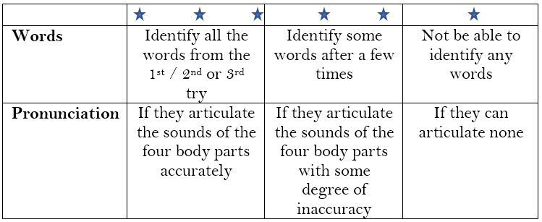
Step 4—Reflection
What happened during my lesson? What did my students learn? How do I know?
What did I learn? How will I improve my lesson next time?

-Devote more time for drilling.
-The following session will be devoted to review. Students also will be given clay and revise colors. (Students will create their own monsters and then describe what color is every part)
Images from the lesson:
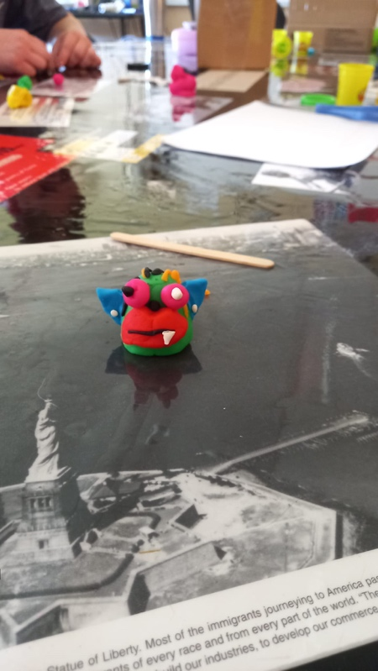 | 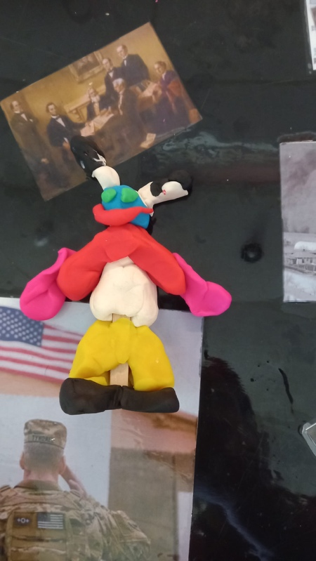 | 