Capstone about the Olympic Theme Song
By Zhang Xiaolin
Wiggs Middle School, Texas
Project Description
February 2022 is the most memorable month for all the Chinese people because traditional festivals such as the Spring Festival, the Lantern Festival and also the grand worldwide sporting event, the Olympic Games, took place successively this month this year. And also in March when the district would have their spring break then, the traditional Tree-Planting Day would fall on that day. When hearing the Olympic Theme Song Together for a Shared Future, I had an idea of filming a video about the song with all the elements about the Spring Festival, the Lantern Festival, the Olympic Games and Tree-Planting Day inside. After communicating with my mentor and my colleague who is a choir teacher, we began to co-work for a whole month for the video with Chinese and Choir club students. In my class and my Chinese club, my students and I did the following things. Firstly, we made tiger lanterns because 2022 is the year of the tiger. We cut out some cards , wrote down some riddles on them and stuck the cards below the lanterns. Secondly, we made some glutenous rice balls in the school cafeteria because they are the traditional food during the Lantern Festival and presented them to school staff. After finishing the riddle tiger lanterns and the glutenous rice balls, we began to decorate our school lobby with the permission of our principal with the lanterns and announced all the students to enjoy the lanterns and guess the riddle below them to win gifts. After these projects, we began to make Tree-Planting Day, also called Arbor Day here flyer to notify everyone to protect our environment and draw Olympic mascots. At the same time, after school every day, students from Chinese and Choir clubs, five teachers including me practiced the theme song in Mandarin for half an hour or sometimes longer. After three weeks’ practice, we finally finished filming all the small videos. We spent the whole last week of February to edit it before publishing it to the public! It got an immediate success!

Project Procedures
Project1 Lantern Making
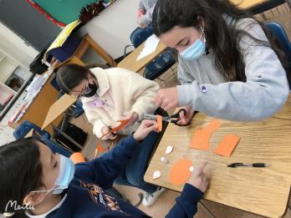
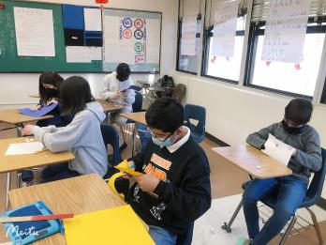
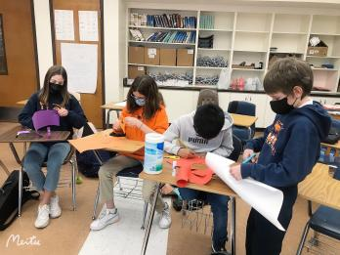
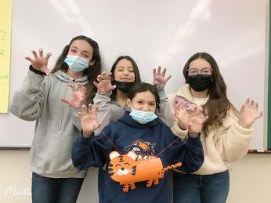
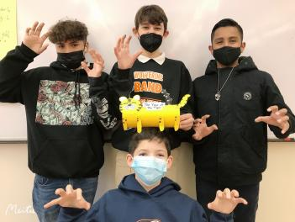
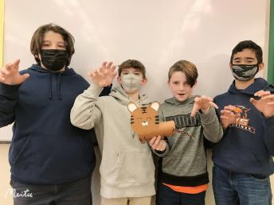

I showed students a video about how to make the tiger lanterns step by step in Mandarin and explained to them in English if necessary and students followed the steps to make these cute lanterns. How happy they were!

Project2 Rice-ball Making
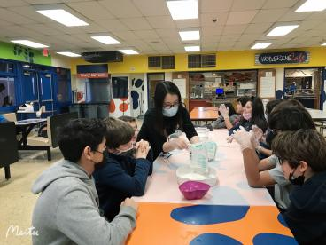
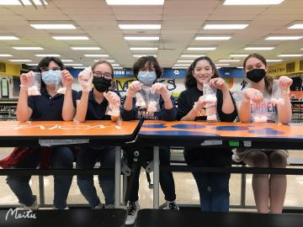
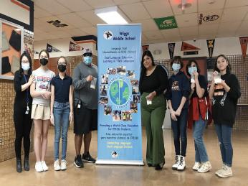
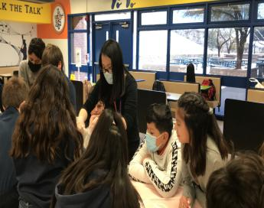
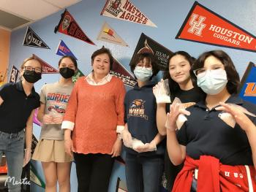
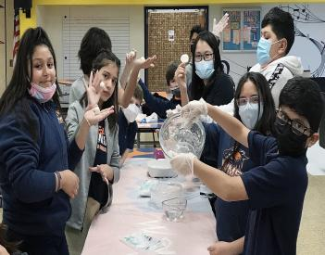

Students were glad to make glutenous rice balls according to the steps by me in Mandarin. After finishing the glutenous rice balls, students presented them to our principal and school staff! We were taking a picture in front of the Dual Language Program flyer!

Project3 Lobby Decoration,Lantern Enjoying and Riddle Guessing
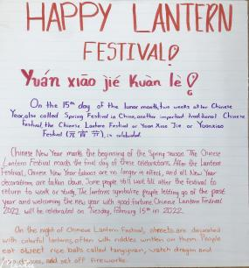
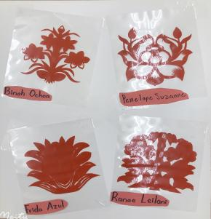
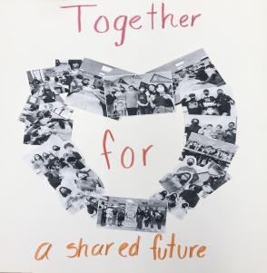
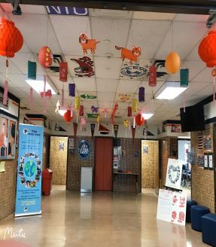
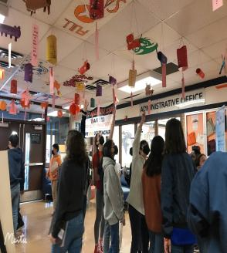
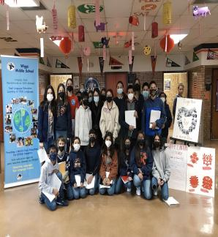

After we finished decorating our school lobby with the permission of our principal with the lanterns, Lantern Festival flyer and some traditional flower paper-cutting, we put an announcement to all the students and teachers to tell them to enjoy our lanterns, guess the riddles below the lanterns and win gifts from our program. After we finished doing this, my students and I took a picture in the lobby! How happy and proud we felt!

Project4 Arbor Day Flyer Making and Olympic Mascots Drawing
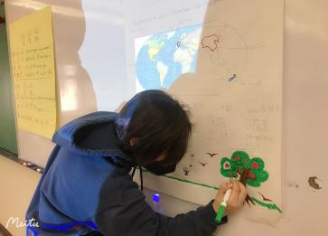
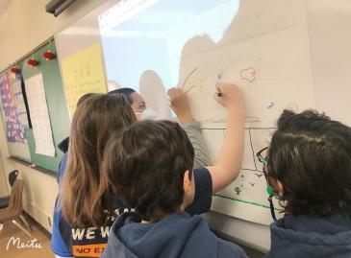
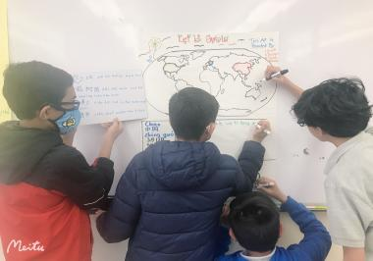
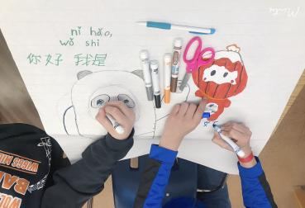
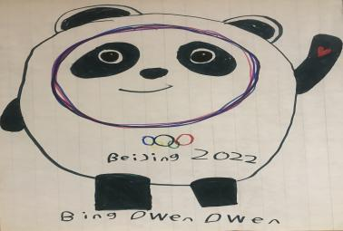
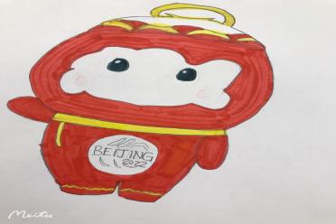

In class, after I gave students the instructions about countries that celebrate Tree-Planting day, different dates of each country to celebrate Tree-Planting day and how to plant tress in Mandarin, students began to make Arbor Day flyer with these elements and later they learnt to draw the Olympic mascots according to my instructions in Mandarin! How hard-working and gifted they were!

Project5 Olympic Theme Song Learning and Filming
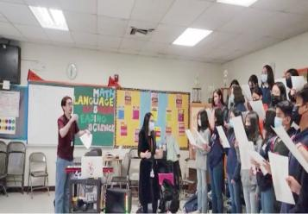
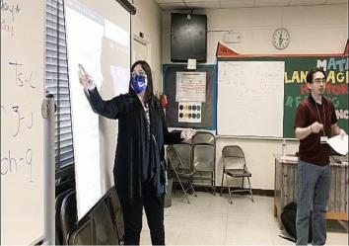
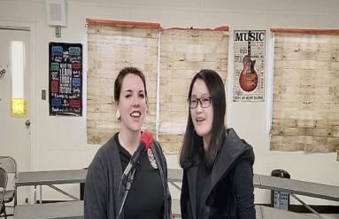
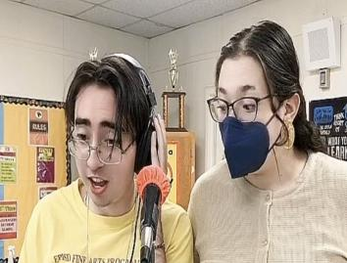
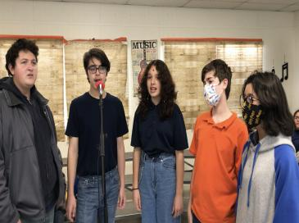
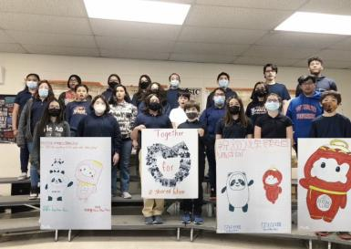

At the same time when we were doing the projects above, we started to learn the Olympic Theme Song Together for a Shared Future in Mandarin every day after school. Students and teachers practiced singing it in Mandarin following me! After three whole weeks’ practice, we finally began to film. After finishing the filming, we edited it three times, sent it to school faculty through emails and posted it through YouTube, Facebook and my WeChat Moment. We got thousands of views! I felt so proud and appreciated to all students and teachers engaged in this great collaboration!

Project Impact
The whole collaborative process and the video impressed everyone deeply.
Thoroughly, as I mentioned before, we got thousands of viewers through various channels both in America and China and we will get more. For American viewers, they will see various traditional Chinese cultures and how well American kids behave in this TCLP program, which is a great chance for them to know more about what our program tries to do for their kids and the importance of broadening their kids’ world by learning something new and knowing the world outside. For Chinese viewers, they will also know what an American classroom is and how American kids learn at school, which will make them think more about education nowadays in my country.
Particularly, for students who were engaged in our activity, they will know the Chinese culture, the language in much detail. For students who were not engaged in the activity, they will be active in learning something new next time. For teachers who were in this song, we had a great chance to collaborate for such a long time, which made us know the differences of language teaching methodologies, classroom management and education systems in two countries.
These are all what TCLP tries to do exchange for: Exchange the world, Expand the reach!

