Backward Design Lesson Plan

School: Ewa Makai Middle School

Teacher Wu Ning Grade level Novice

Lesson title countries and nationalities

Step 1—Desired Results
Standard Outcomes for Learning (ACTFL Standard 1.1)—Answer’s the question, what should students know, understand, and be able to do as a result of the lesson?
By the end of the class, students will able to
- say six countries: 中国，美国，英国，埃及，西班牙，澳大利亚
- say six nationalities中国人，美国人，英国人，埃及人，西班牙人，澳大利亚人
- use 2 sentence patterns: 我来自…… 我是……( I am from …(country). I am ..(nationality)… )
- use Google Translate to find the Chinese words and Pinyin for countries
- introduce a person, telling his/her nationality and the country he/she comes from

Step 2—Assessment Evidence
Performance task—What will students do to show what they have learned?

Students can say the names of six countries and nationalities.
Students can use the patterns to introduce a person, telling his/her nationality and the country he/she comes from.
Students can use Google Translate to find Chinese words and Pinyin for countries.

Step 3—Learning Plan
Learning activities - Answer’s the question, how do I teach it?

Step1. Warming up
(Put up a map of the world on the blackboard.)
Talk about what countries they are familiar with and point out the positions of the US and China.

Step 2. Presentation of the new words for countries
1. Ask students to find the countries on the map and show them the Chinese words and Pinyin.
中国，美国，英国，埃及，西班牙，澳大利亚
2. Tell students that I come from China and ask them to say where they come from using the sentence pattern 我来自…… (I am from ……)
3. Tell students that country+人=nationality, and teach them to say the six words of nationalities: 中国人，美国人，英国人，埃及人，西班牙人，澳大利亚人. Ask students to use the sentence 我是…

Step 3 Practice.
1. Show pictures of famous places of interest in the six countries and ask students to tell the names.
2. Show pictures of people from the six countries and ask students to tell which country he/she comes from and tell their nationalities.

Step 4 Show students how to use Google Translate to find the Chinese words and Pinyin and ask students to find Chinese words and Pinyin for 7 countries and finish the worksheet.
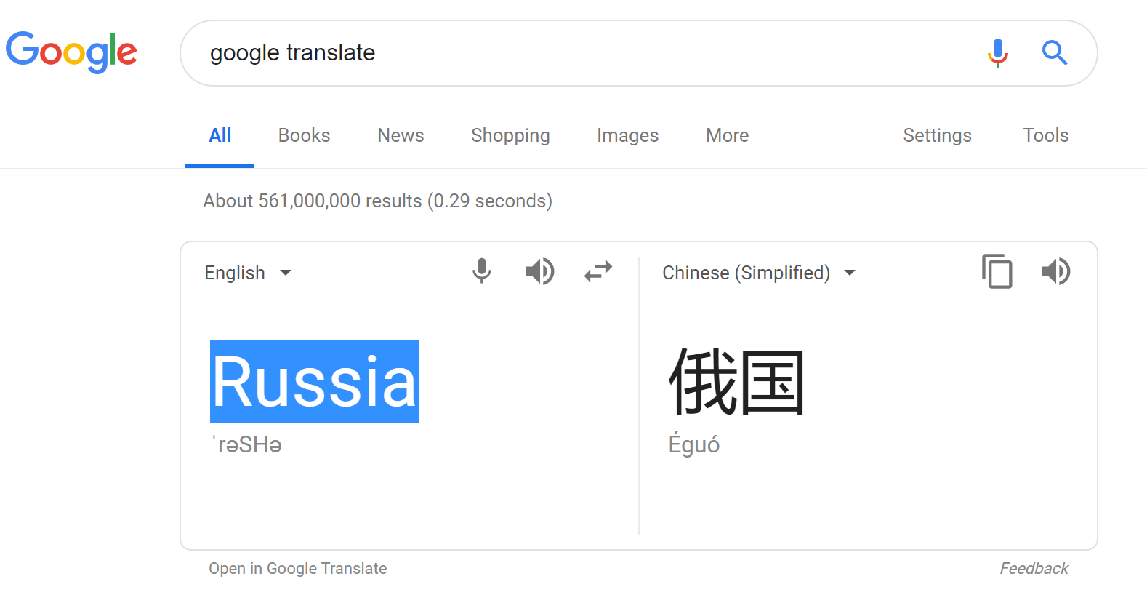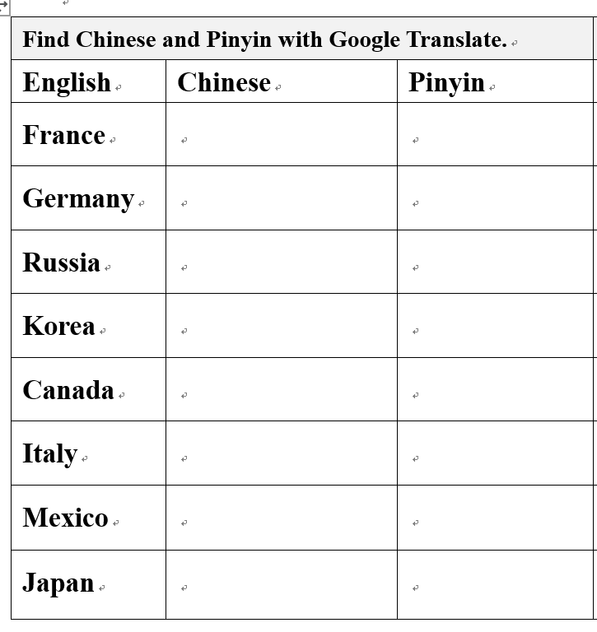

Step 5 Ask students to find a person they like to introduce and make oral presentation
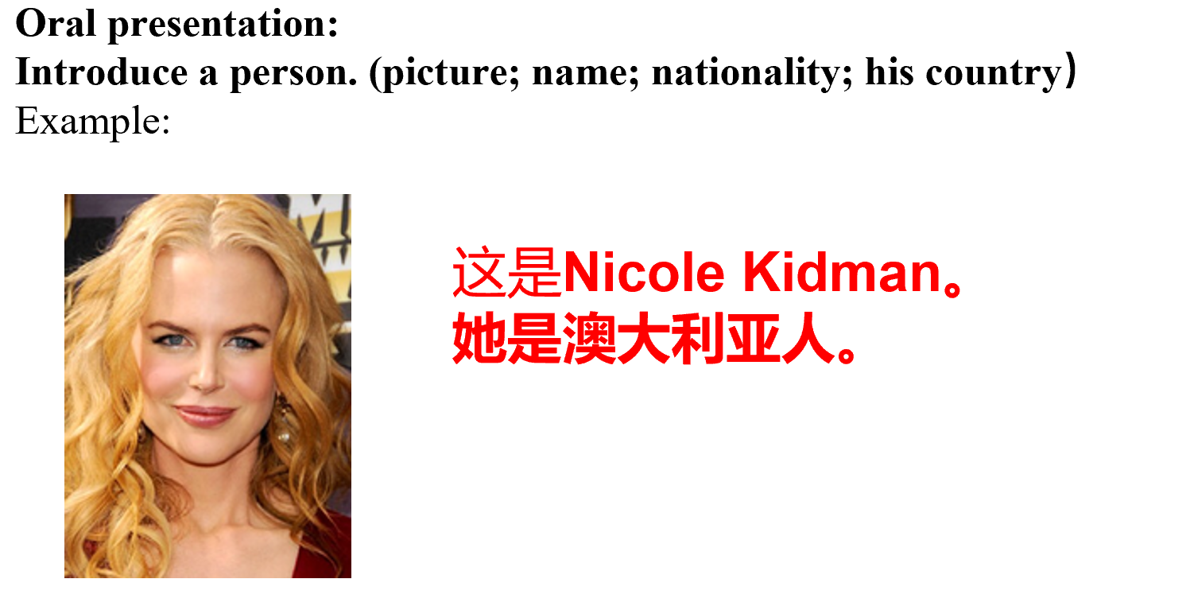

Step 4—Reflection
What happened during my lesson? What did my students learn? How do I know? What did I learn? How will I improve my lesson next time.

Since there are too many countries in the world and it is not practical to teach every country in class. Therefore, it is a very good idea to teach students to use Google Translate to find the Chinese words and Pinyin for the countries they want to learn. They were excited to find the words they wanted. Some even typed in a sentence! With Google Translate, they can also hear what the words and sentences sound like.
Adapted from Tomlinson and McTighe, Integrating Differentiated Instruction + Understanding by Design, ASCD,

