Backward Design Lesson Plan

School: Ewa Makai Middle School

Teacher Wu Ning Grade level Novice

Lesson title Fu 福

Step 1—Desired Results
Standard Outcomes for Learning (ACTFL Standard 1.1)—Answer’s the question, what should students know, understand, and be able to do as a result of the lesson?
By the end of the class, students will able to
- know the meaning of Chinese character “福Fu”
- Learn how to write 福Fu with calligraphy brushes
- Make a 福 hanging ornament

Step 2—Assessment Evidence
Performance task—What will students do to show what they have learned?

Students can recognize “福Fu” and tell its meaning.
Students can tell why people paste the word on the wall or door..
Students can write “福Fu”in the right order of strokes with calligraphy brushes.
Students can make a 福 hanging ornament.

Step 3—Learning Plan
Learning activities - Answer’s the question, how do I teach it?

Step 1: Introduce the meaning of 福 and how the word is formed
Meaning: happiness, good fortune, blessed. Placing the character upside down will cause the good fortune to literally pour out on the home, office or building.
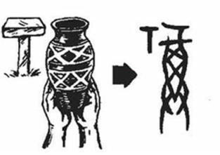
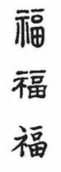
The whole character originally referred to wine that had been blessed by the gods and was used in religious ceremonies. The idea of "blessed by the gods" broadened, and 福 came to mean "blessed" or "fortunate" in general.
Radical示 represents a primitive altar (T) with drops, perhaps of blood or of sacrificial wine. The ancient Chinese eventually added a horizontal stroke on top to indicate a sacrifice or item placed on the altar. The character 示 primarily means "to show," a definition that came from the idea that whatever resulted from a sacrifice showed the will of the gods. The left radical means "altar" or "of the gods." and the right side means “full”, deriving from a pictograph of a “full wine jar”.
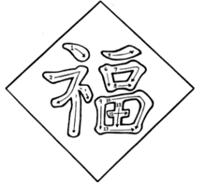
Step 2: Display the strokes of the word and model writing with brush
Show the strokes of the character and teach students to write in with calligraphy brushes on writing cloth or paper, familiarizing its strokes and order and feeling the effect of the ink writing.
https://www.youtube.com/watch?v=3airfIHHWak
3. Write 福on student’s sheet and make a Fu hanging ornament
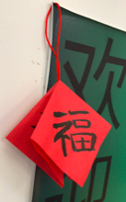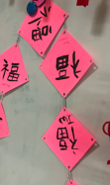

Step 4—Reflection
What happened during my lesson? What did my students learn? How do I know? What did I learn? How will I improve my lesson next time.

The Fu福is a sign of Chinese New Year. Students are interested in writing a Fu 福with calligraphy brush. The experience to control the brush is very fresh to students. We had practiced the order of strokes first and then wrote with the brush but still it was not easy.
So next time, I can print some hollow words of Fu and have students to write it by filling the hollow part, which I think will make it easy to write a good-looking word of Fu.
Adapted from Tomlinson and McTighe, Integrating Differentiated Instruction + Understanding by Design, ASCD,

