 **COMPREHENSIVE EXAMINATION IN ARABIC**

**Name: ……………….…………. Date: ………………… الاسم: ..............................**

*Directions* (1–6): For each question, you will hear some background information in English *once.* Then you will hear a passage in Arabic *twice* and a question in English *once.* After you have heard the question, the teacher will pause while you read the question and the four suggested answers in your test booklet. Choose the best suggested answer and write its *number* in the space provided in your answer booklet. Base your answer *on the content of the passage, only.*

1- When is Mary’s birthday? 4- Where does this conversation happen?

(1) In January (1) in a movie theatre

(2) In March (2) in a school

(3) In May (3) in a bank

(4) In August (4) in a restaurant

2- What does Samy like to eat ? 5- What language does this teacher teach?

(1) meat and rice (1) English

(2) chicken and rice (2) Arabic

(3) fish with rice (3) Spanish

(4) chicken and bread (4) French

3- What are they talking about? 6- What doesn’t she like to drink?

(1) a movie (1) coffee

(2) the weather (2) tea

(3) food (3) orange juice

(4) a class (4) milk

*Directions* (7–12): *For each one, look at the picture and write the name of the picture IN ARABIC. Writing in any other language won’t be counted. The spelling of the words should be correct.*

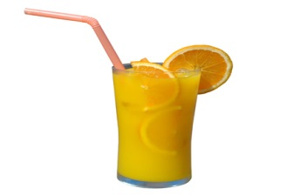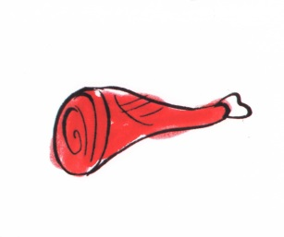

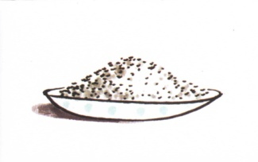

(7)…………………..…. (8) ……..……………… (9) ………….....………

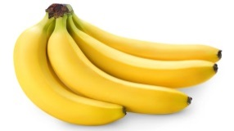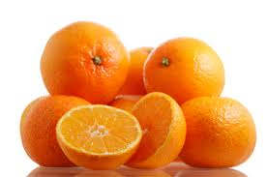

(10)………………….…. (11)……..……………… (12) ……………..………

*Directions* (13–17): After the following passage, there are five questions or incomplete statements in Arabic.

For *each*, choose the word or expression that best answers the question or completes the statement *according*

*to the meaning of the passage.*

أَنَا اِسْمي سَارَة. أَنا أَسْكُنُ مَعَّ أُسْرَتي في مَدينَةْ نِيويورْك. نَحْنُ نُحِبُ أَنْ نَذْهُبُ إِلَى مَطْعَمْ عَرَبي يَومْ الجُمُعَة. أَنا أُحِبُ أَنْ أًّكُلُ لَحْمْ و أُرْز. أَبي يُحِبُ أَن يَأْكُلُ سَمَكْ و سَلَطَةْ. أُمِي تُحِبُ أَنْ تَأْكُلُ دَجَاجْ و خُبْزْ. أَخي يُحِبُ أَنْ يَأْكُلُ بيتْزا. نَحْنُ نُحِبُ أَنْ نَشْرَبُ شاي عَرَبي. المَطْعَم جَميلٌ جِداً و الطَعامُ لَذيذ و رَخيصْ جِداً. نَحْنُ نُحِبُ هَذا المَطْعَم كَثيراً جِداً.

16

أَيْنَ تَسْكُنُ سَارَة مَعَّ أُسْرَتِها؟ مَاذا يُحِبونَ أَنْ يَشْرَبوا؟ 13

(1)

مدينة فلادلفيا قهوة (1)

(2)

مدينة نيويورك حليب(2)

(3)

مدينة واشنطن ماء(3)

(4)

جزيزة ستاتن شاي عربي(4)

17

مَاذا تُحِبُ سَارة أَنْ تَأْكُل؟ الطَعَامُ لَيْسَ ................. . 14

(1)

دجاج و خبز رخيص(1)

(2)

بيتزا غال(2)

(3)

سمك و سلطة لذيذ (3)

(4)

لحم و أرز جميل(4)

مَاذا تُحِبُ الأُم أَنْ تَأكُل؟ 15

بيتزا(1)

لحم بقري(2)

دجاج و خبز(3)

سمك(4)