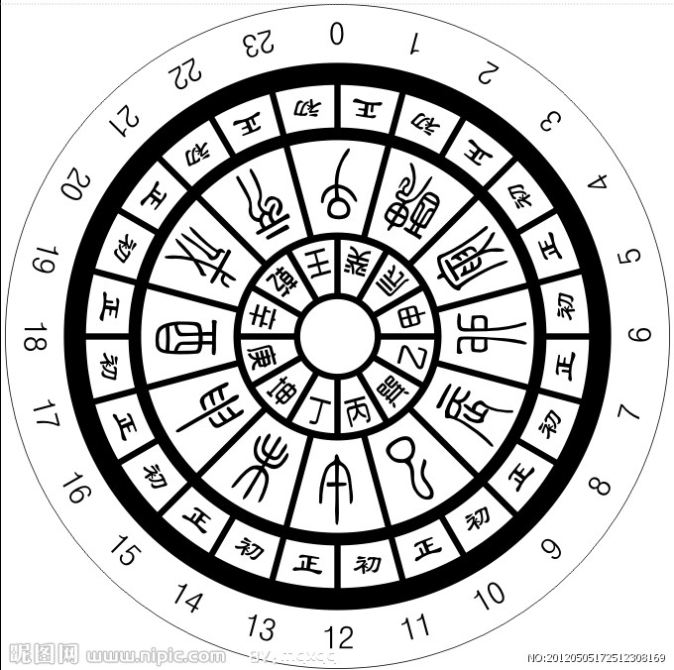

Period:

Points:

Name:

Make Your Sundial

1. What is the function of Sundial?

_______________________________________________________________________.

1. Our class will be divided into 2 groups. One do the decoration for the sundial first; The other one do the paper cutting. And then rotate.
2. How to make a Sundial? One will be invited to come up to tell us! The one invited will get prize.

You should tell us: 1. What parts do we need to make the Sundial?

2. What is the function of each part in the Sundial?

3. Tell us how to make it step by step.

11

10

9

8

7

6

5

4

3

2

* 
* 
* 
* 
* 
* 
* 
* 
* 
* 



1

12