Backward Design Lesson Plan Template
School: Madison East High School
TCLP teacher’s name: Mahmoud Hegazy
Course: Arabic Grade level: 9-12

Step 1—Desired Results
Lesson Goals:
What should students know, understand, and be able to do as a result of the lesson?

- Students learn about the similarities and differences between celebrating birthdays in The USA and (Eid Al Melad) party in Egypt.
- Students understand why some families in Egypt have different ways of birthday celebration and what types of gifts are expected to be presented in such a celebration.
- Students learn how the Egyptian have fun while celebrating the birthday parties compared to the US by watching videos in English and elaborate by answering some follow-up questions collaboratively.
- Listen to 2 birthday songs in Arabic and try to identify the words that repeat and then learn meanings.
- Have fun by celebrating birthday (the Egyptian way) and doing a cross word puzzle about birthdays in the US.
- Have a chance to create a Tellagami animated video and upload it to Seesaw.me.

Essential Questions
What leading questions can you ask of students to get them to understand the Big Ideas?

- How do people celebrate the birthday in the US?
- Have Did your parent(s) celebrate your birthday party last year? (I ask my students to bring some birthday photos on that day.)
- Have you ever attended a birthday party in an Arab country such as Egypt, Morocco or Jordan? What was it like?
- Do you have any games played in this occasion in the US? Could you describe one? What are the most popular songs people play on that day?

Lesson Objectives
Identify General Learner Outcome (GLO)

Students will be able to:
- Compare and contrast American birthday party with the Egyptian one.
- Exchange some birthday photos and comment on them.
- Watch a video and answer follow-up questions.
- Write a 2 paragraph composition about: the similarities and differences between celebrating birthdays in the US and Egypt.
- Do a word puzzle based on birthday celebration.

Step 2—Assessment Evidence
Performance task — What will students do to show what they have learned?
A performance criterion — How good is good enough to meet standards?
By the end of the lesson, student will be able to:
- Mention the main similarities and differences between celebrating birthdays in The USA and (Eid Al Melad) party in Egypt.
- Answer questions based on their understanding of songs in Arabic (one of the songs mixes between Arabic and English for more convenience).
- Discuss and answer questions based on videos in English.
- Write a 2 paragraph composition about: similarities and differences between celebrating birthdays in The USA and (Eid Al Melad) party in Egypt.
- Do a word puzzle based on birthday celebration.

Step 3—Learning Plan
Please be prepared to demonstrate at least one of these activities during your workshop presentation. You will have 15 minutes for your demonstration
Materials needed

IQ board – sheets - realia related to birthday celebration such as colorful ribbons or paper hats - PPT- videos- songs, etc
Links :
https://www.youtube.com/watch?v=P9di198-0Tc
https://www.youtube.com/watch?v=3UYUz1ma0nc
https://www.youtube.com/watch?v=zEwE8aqunPY
https://www.youtube.com/watch?v=lWGeAn89dyw
https://www.youtube.com/watch?v=Rtfg4BCwMhs
https://www.youtube.com/watch?v=Zc4p91D6I8Y

Learning activities
Step by step instructions from start to finish (including amount of minutes needed per activity), and detailed enough for another teacher to follow. What teaching methods/activities will you be using?

Activity one 15 mins
( Pre listening ) Think, pair and share
I write these three questions on the board or show them on ppt:
- How do people celebrate the birthday in the US?
- Have Did your parent(s) celebrate your birthday party last year? (I ask my students to bring some birthday photos on that day.)
- Have you ever attended a birthday party in an Arab country such as Egypt, Morocco or Jordan? What was it like?
Every student finds answers, discuss them with a partner and them share them with the class. Next, students can exchange the birthday photos and have some time to comment on the photos.

Activity two: 15 mins
Watch this video/ these videos and answer these questions:
- What is the video about?
- What is the biggest difference between birthday celebration in Egypt and here in the US?

Activity three (group work) 7 mins.
- Students work in groups of threes to find at least three similarities and three differences between birthday celebration in Egypt and here in the US?

No. | Similarities | Differences
1
2
3
Optional
Optional

I draw the same table on the whiteboard and ask students to add new items. Every new item added is a credit to the group. If it is repeated, a credit is deducted.

Activity four : 7 mins
Students can work individually or in groups to complete this puzzle and then check in pairs
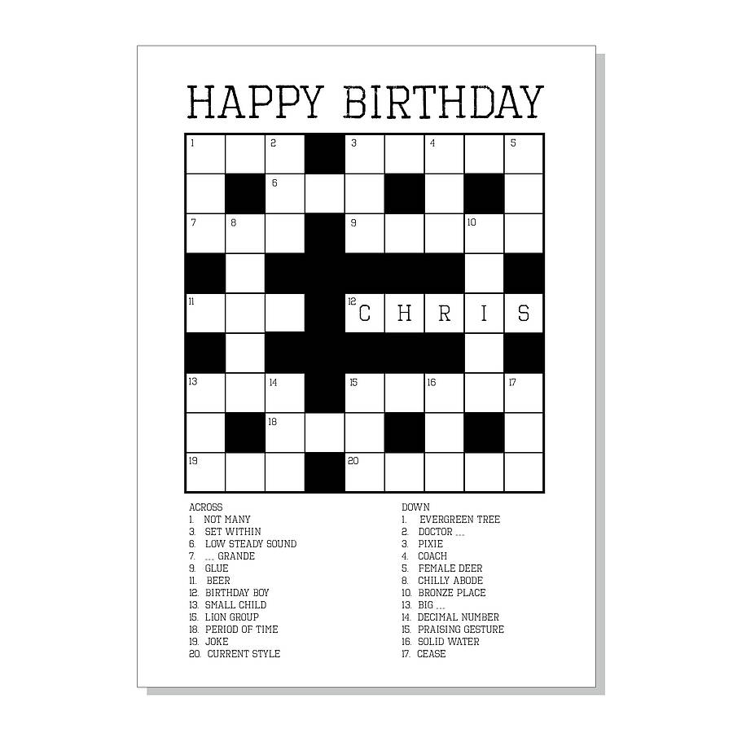

Activity five: 8 mins
Now, it is time to have fun: my students and I celebrate the most approaching birthday of a student in the class (the Egyptian way). I play the most popular Egyptian song for birthdays, students have to congratulate their classmate using the Arabic phrase (Eid Melad Saied) and then we may have a circle dance as the Egyptian do in birthday celebrations.

Home assignment:
- Students are asked to either write a 2 paragraph composition about: the similarities and differences between celebrating birthdays in the US and Egypt.
- OR: make a tellagami animated video (4 minutes) and upload it to Seesaw.me

Step 4—Reflection
What happened during my lesson? What did my students learn? How do I know?
What did I learn? How will I improve my lesson next time?
…………………………………………………………………………………………………………………………………………………………………………………………………………………………………………………………………………………………………………………………………….

